
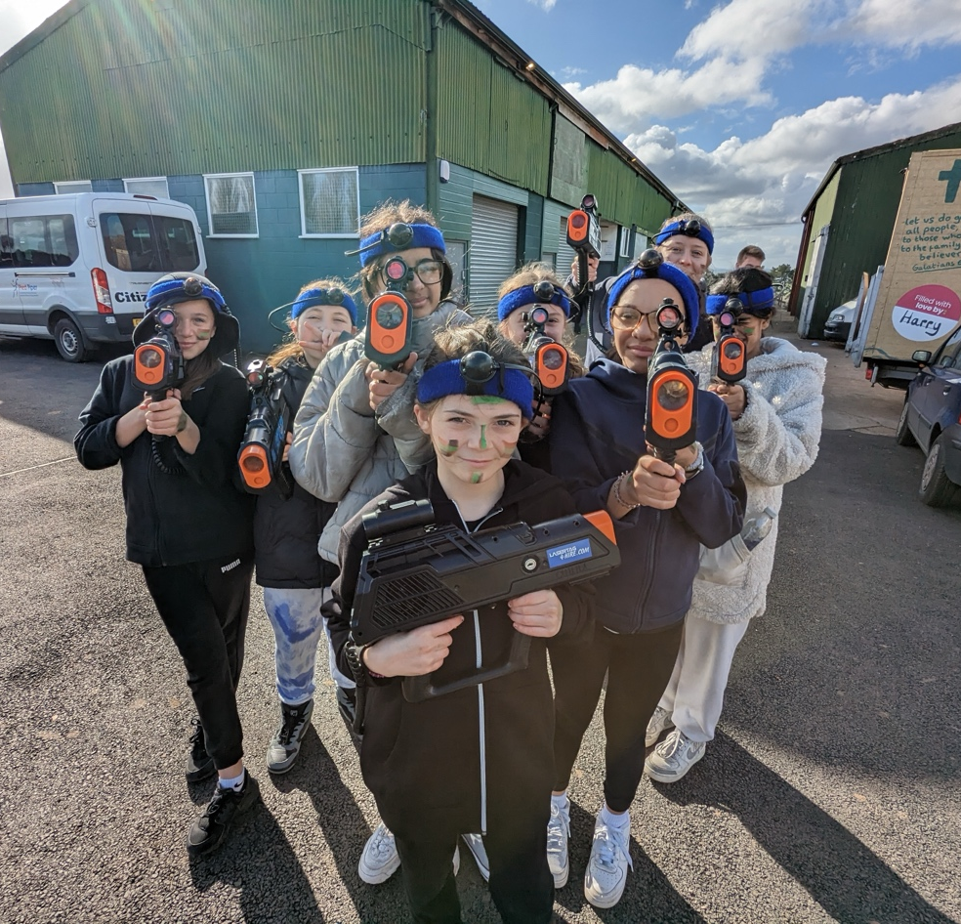
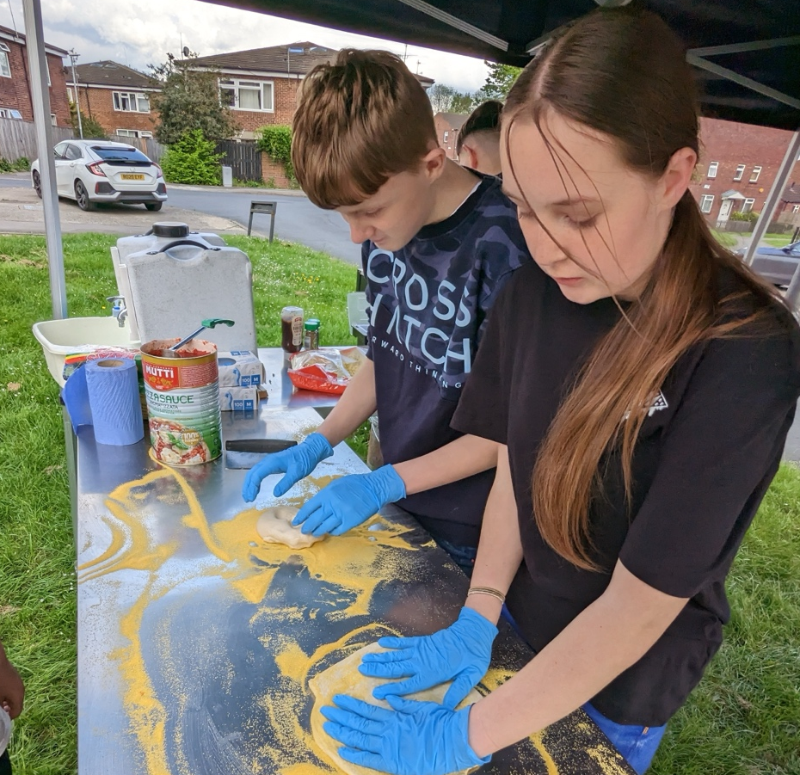

Youth & Children’s Pioneer
APPLICATION PACK

Thank you so much for your interest in joining Shine. This information pack provides information about who we are, the roles available and some further background.

Introducing Shine
‘Helping people and places sparkle’ is what we do. Through a wide range of programmes and projects we seek to help support children, young people and their families to thrive and know that they have something to give back – even when life is tough! We believe that by giving young people time, support and encouragement they can make a massive difference to their community and the wider world.
We also believe that this should be something enjoy able to in all our programmes and projects there is a huge amount of fun and laughter and Shine believes in the transformative power of ‘play’ and that by participating in play and getting involved in working together it is a really positive way to build integrated communities and help address societal issues such as poor health and wellbeing, social isolation and loneliness delivering holistically healthier futures for all, whilst also providing opportunities for exploring the Christian faith.

Shine is a Bishop’s Missional Order, located in Pinehurst, Swindon. Started in 2010 it has a vision to be ‘Youth-full’ – full of children and young people but also following the traits of exploration and risk taking that being youthful entails. Shine has a real commitment to working with local people to explore what church in our community might look like rather than doing it to or for. Therefore, all of what we do is building on the strengths and ideas of local people – led by local people for local people.

We also have a focus to working with those most at risk of ‘exploitation’ – e.g. county and local drug lines, youth violence etc. So, shine has a whole range of activities including Wednesday night ‘Youthie’ (which attracts about 60 young people), Friday night football, detached youth work across three neighbourhoods, a community pizza project – the ‘Wonky Pizza Crew’ giving out free pizza to local residents; school holiday projects including HAF (Holiday Activity Funding) and trips/residentials. We also work closely with other agencies and much of our work is done in partnership including a cooking project with the local Police and Parish Council.

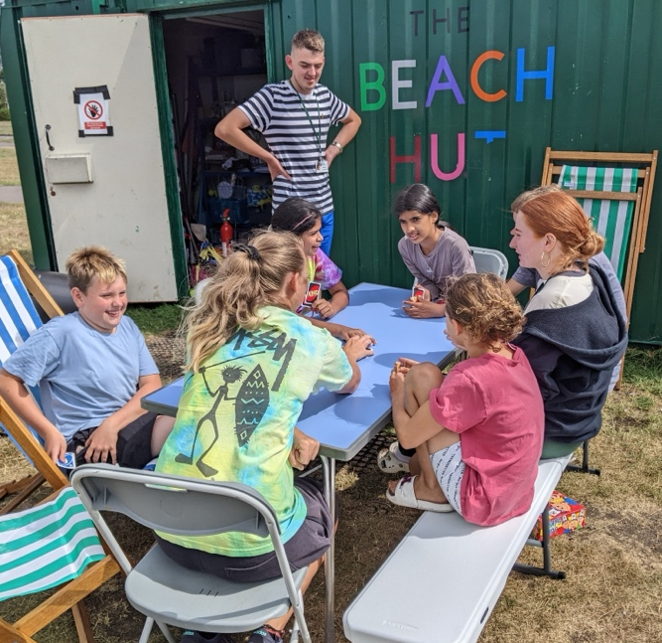
Shine also has a ‘chaplaincy’ to two large local secondary’s and two Primary / All-through schools who are part of the same cluster. We work with the schools to deliver the Social, Moral, Spiritual and Cultural (SMSC) development so working with the students to run cultural days, awareness events, special events inc. Charity events or key events like Remembrance.

We also offer pastoral support to students, staff and parents including bereavement and practical support, mentoring and involvement in some of our community projects.

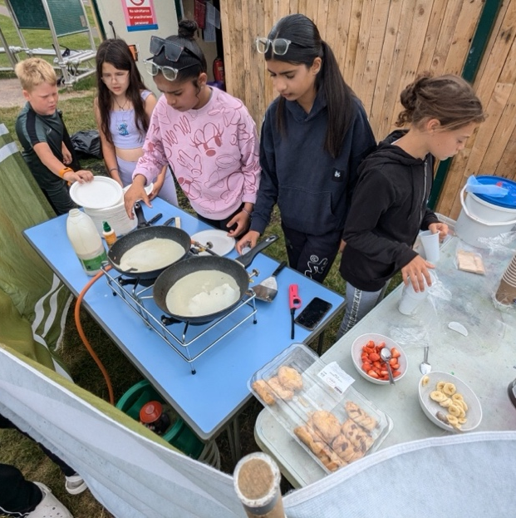
Much of our work is based out of a shipping container on the central green, known as The Beach Hut - started as a pop-up response during the first Covid lockdown. Every other Sunday late morning the worshipping community meets outside on the green for ‘Shine Breakfast’ exploring what ‘church’ might look like for local people that is sustainable through, and empowers, local leadership. Average attendance is around 12-15. Shine also has ‘Messy Saturday’ attracting 50 – 100 local people of all ages each month.

Shine is an independent registered charity and attracts external funding for youth work which allows us to recruit local people – many 19 or under – as sessional workers and recently we have taken on one of the young people as an Apprentice for the next 18 months and has funding to recruit a second apprentice in the coming months.
You’ll join us as at an exciting time as we grow our staff team significantly with funding from the Priority Communities Network of Bristol Diocese alongside new funding from the National Lottery. There a loads of new opportunities arriving all the time and we are really excited to be able to invest in the lives of many young people for many years ahead.

If you have questions about Shine, the roles with us and what it might they might look like, what you’ll get out of it and how it might set you up for future employment, please contact us as we’d love to have this conversation with you.

Shine is part of the Church of England in the region providing opportunities open to all. You do not need to be a Christian or a member of a Church of England church to work with us unless there is a genuine occupation requirement stated in the job description, but you do need to be sympathetic to the Christian values and ethos of the organisation.

We are striving to see:
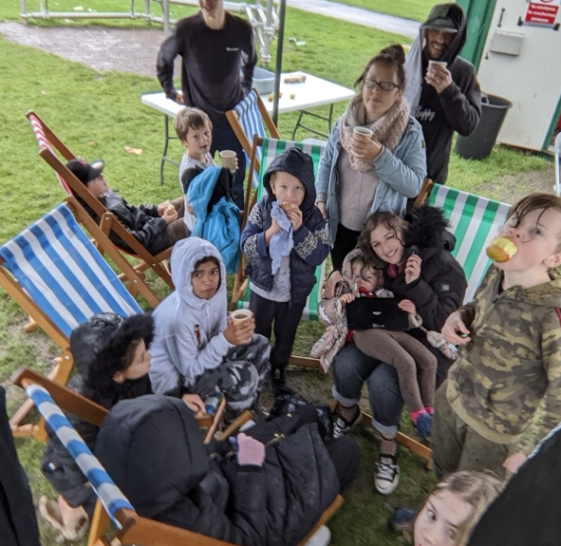
  - Children and young people’s lives, and their communities transformed by having child-first approaches to all our activities and that young people are involved in all areas of decision making
  - Leadership gifts and vocational calling identified, nurtured and invested in;
  - People of all ages, invited to explore and encounter the Christian faith;
  - New expressions of church established, for the younger generations, with participation at their core
Within this Shine is committed to providing the best quality youth work with fun and joy being at the heart of all the sessions.

Shine is committed to increasing the diversity of participation in and recruiting and developing a team that reflects the communities we serve.

What you’ll be like
We are seeking someone who is passionate about building meaningful connections and sharing the Christian faith in imaginative and innovative ways outside the boundaries of traditional church settings. Someone who can see beyond ‘challenging’ behavior to the incredible value and potential of the young people we have the privilege of working with.
You’ll work hard but love creating an environment where children and young people can flourish by getting involved, developing new skills, building friendships, and feeling safe to share their thoughts and experiences. With passion, creativity, and ambition, you’ll inspire and support them to lead healthy and fulfilling lives.
You’ll be someone who really enjoys working with others and brings the energy that gets people moving and approach everything you do with a fantastic sense of fun.
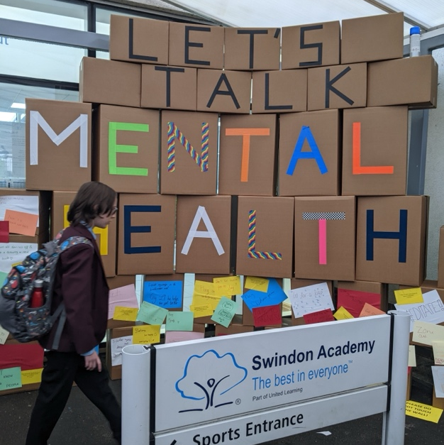
The job description that follows is intended as a guide of the main tasks of this job however we want to build on the strengths and experiences of the individual recruited, alongside the priorities of the organisation. If you like the sound of Shine and the role, but aren’t sure you’ve got everything we’re looking for, please get in touch as we’d love to discuss things with you. Who knows where that conversation might lead. We understand that a multifaceted role can seem daunting, especially when laid out in a job pack. Our expectations are realistic, we are not looking for a super-human. You’ll work as part of a supportive team which will ensure you have sufficient resources to make a tangible difference across the role, without feeling stretched too thin.

How we’ll support you
We are proud to provide excellent opportunities for everyone who serves with us as employees and volunteers, investing in training and development and doing all that we can to ensure everyone in our team is able to use fully utilise their gifts, skills and potential. You’ll be able to make a real difference
We run an ongoing programme of CPD which includes accredited options, and we invite all employees to identify training, and development needs specific to them.
You’ll be supported in your role by the Pioneer Minister, who will be your Line Manager, our new Operations Manager, sessional workers and other full-time youth workers including our People Development Worker, Rosie, and our apprentice Youth Support Workers. You’ll also work with a fantastic team of local volunteers as well as workers from other partner agencies and organisations. Working together is really important to ensure that no-one feels isolated.
You’ll work from a warm, safe and well-equipped office space, right at the heart of the community but also with flexibility to work from home where possible.
Shine is a Living Wage employer committed to ensuring that individuals receive appropriate remuneration for the work they undertake and their performance within their role. Salaries are reviewed annually.
We believe that periods of rest and restoration are important and provide full time employees with 28 days annual leave per year, with bank/public holidays in addition to this.

Job Description
Youth and Children’s Pioneer
Location:
Shine office (Pinehurst) and various locations around North Swindon.
Normal Hours of work:
37.5 hours per week, to be worked flexibly but the role will require some evening and weekend work. 36 days (inclusive of bank holidays) annual leave. Part time working would be considered (minimum 0.75FTE).
Salary:
£28,840 - £30,900 (subject to experience) + pension.
Context
This post is funded as part of the Bristol Diocese Priority Communities Network (PCN)- a project to intentionally invest in supporting the churches there to flourish, thrive and make a significant, transformative social impact in their local communities.
What you’ll do
This is an exciting and innovative role for a highly motivated, experienced individual to join our creative and evolving expression of church. This role provides an opportunity to develop and deliver creative face-to-face children’s, youth and community work in an outer urban estate context, which reaches out to and works with the children, young people and communities we serve; growing new Christian Communities and supporting other churches in their mission to children, young people and their families.

- Lead and grow an effective school, children’s, youth and family’s ministry that reaches into the wider community.
- Develop the children’s and youth ministry and activities that engage with children, young people and their families in a pre- Christian landscape and provides a pathway to active faith through the development of creative new Christian Communities.
- Increase Shine’s capacity for all age faith-based outreach by leading and co-ordinating programmes and events.
- Lead, develop, encourage, and coordinate a team of volunteers and part time staff to accomplish these goals.

Key relationships:
The Children’s and Youth Pioneer will help lead a team of full/part time staff/volunteers and will be line managed by the Pioneer Minister and will be responsible to the Trustees of shine.
The Children’s and Youth Pioneer will work closely as a peer with the Youth Worker.
See Appendix 1 Organisational Chart for more information about our structure.

Requirements:
This role carries an occupational requirement that the postholder is a practicing Christian within the provisions of the Equality Act 2010.
Shine is committed to safeguarding and promoting the welfare of children, young people and vulnerable adults. All post holders and volunteers are expected to share this commitment, to work within the policy and procedures of the relevant safeguarding policy and are required to attend all relevant safeguarding training.
This post is subject to an Enhanced Disclosure and Barring Service Check.
Shine will appoint under the Church of England safer recruitment national framework.

Main tasks / accountabilities:

Working with children and young people
- Lead our work in the outreach and discipleship of children and young people - helping them to explore the Christian faith; praying for the young people and working with them to identify calling, skills and gifting and releasing them into leadership (regardless of age) within our work.
- Pioneer and establish new relevant forms of church with our younger generations.
- Develop safe, positive relationships with young people, other youth workers, partner agencies and members of the wider community, including parents.
- Work directly with young people and the wider community to develop, undertake and maintain a programme of engaging opportunities including in-school, after-school, & holiday programmes.
- Help lead and develop our work in schools inc. detached work, assemblies, lessons, pastoral support etc. and maintaining great relationships with school staff.
- Exercise active pastoral support for the young people developing support programmes / mentoring where appropriate.
- Provide opportunities for, and actively participating in, residential weekends / weeks and social action projects.
- Work to challenge inappropriate and oppressive behaviour such as bullying, racism, homophobia and sexism throughout our work.

Planning, Organisation and Leadership
- Ensure the safe running of all our work and the safeguarding of the young people and vulnerable adults we work with.
- Be responsible for the effective delivery, outcomes and evaluation of our projects, including, but not limited to: managing programs and equipment; ensuring policies and procedures are in place and followed; gaining feedback from young people and the community; managing a budget.
- Help recruit, coordinate, motivate and support the team of staff/volunteers inc. providing appropriate training and together identify and develop their gifts and talents.
- Work with the Pioneer Minister and Trustees to help work towards financial sustainability including raising funds and completing grant applications for projects.
- Keep registers, write evaluation reports and input data into our management information system.
- Play an active part in the PCN Network as required, inc. attending meetings, sharing learning, capture metrics and measurements across agreed areas of activity
- Provide support and encouragement to other churches working in Estates contexts in Swindon.
- Be active in the promotion of events via Website/Social Media etc. to increase participation.
- Ensure that all activities undertaken with the Young People are compliant with Health and Safety Legislation and best practice guidance.

Staff Management responsibilities
- Help recruit, coordinate, motivate and support the team of staff/volunteers inc. providing appropriate training and together identify and develop their gifts and talents.
- Facilitate, and lead as appropriate, regular staff and supervision meetings.
- Organise rotas to ensure safe levels of staffing at events, sourcing cover or cancelling events as required.

Person Specification
Please ensure that you read the person specification carefully as this will be used to assess candidates as part of the shortlisting and interview process.

ESSENTIAL
Experience, skills and knowledge
Experience:
- Ability to inspire, support and encourage children and young people aged 8 to 18 and develop fun and relevant activities and programmes with and for them.
- A high level of understanding and experience of safeguarding children and young people and able to maintain appropriate professional boundaries.
- Experience in helping young people encounter and grow in faith

Skills:
- Can empathise with young people and relate to young people and adults in a positive way
- Can demonstrate ability to work in a team and on his/her own
- Well organised with the ability to prioritise effectively and manage expectations
- Have an imaginative and enthusiastic approach.
- Has good communication skills and is able to relate to young people and adults in a positive way.
- An excellent understanding of, and commitment to, equality and diversity with the ability to challenge discriminatory behaviour.
- Organised, with good IT and administrative skills, e.g. Microsoft 365 etc.

Personal Qualities:
- Actively investing in growing as a disciple of Jesus Christ and participating, in good standing, in the life of a worshipping community either Anglican or affiliated to either Churches Together in Britain and Ireland or the Evangelical Alliance
- Friendly, cheerful, positive and self-driven, able to work independently and as part of a team.
- Positive about embracing challenge and change, open to experimenting, new ideas and reflective practice.
- Confident and able to remain resilient and calm when things are challenging or difficult.
- A commitment to continuous professional development.
- Able to maintain confidentiality within the parameters of Shine and with other agreed agencies e.g. Schools, Police and Children’s Service etc.

DESIRABLE
Knowledge/Qualifications:
- Hold a qualification in children’s work, youth work or related fields
- Safeguarding training (Level 2 equivalent or above)
- Qualification in mental health support or engagement
- First aid certificate
- UK Driving licence
Experience
- Diverse experience of delivering and leading high-quality children’s or youth work in a schools and/or community setting in
- Experience of supervising staff and/or volunteers
- Experience of working with young people from an ‘outer estates’ / disadvantaged context / ‘hard to reach’ young people
- Understanding of Adverse Childhood Experience’s (ACE’s) and their effect on young people and trauma informed approaches to working with young people
- Experience of guiding young people in the Christian Faith / church-based youth work

Skills / Abilities
- Able to inspire, support and encourage youth workers and volunteers in their roles and responsibilities.
- Has skills and expertise which can be usefully utilised in the youth work programme, e.g. music, arts, sports, outdoor activities, health awareness, and street culture.
- Understanding and appreciation of the importance of monitoring and evaluation in a youth work setting.
- Excellent interpersonal and communication skills, with the ability to quickly establish positive relationships with adults, children and young people.
- Able to organise own time and work on own initiative including making decisions under pressure.

What next
We know that this information pack and the process of completing an application form may seem daunting and scary. Perhaps you’re thinking that this all sounds amazing, but you’re still a little confused about what this could look like for you and whether or not it’s the right step for you to take.
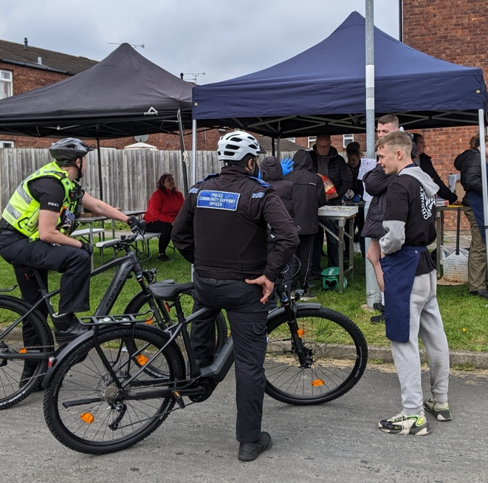
If that’s you, please get in touch for an informal chat about it or apply anyway. Tell us what your strengths and passions are and why you’d love to work for us and let’s explore together if this is the right fit for you. We really would love to hear from you, you’ve got nothing to lose from getting in touch for a chat.

For more information or to talk further contact Simon on 07973736531 or simon@shinepinehurst.co.uk

Closing date for applications: Friday 20th March 11.59pm

Appendix 1 ORGANISATIONAL CHART

