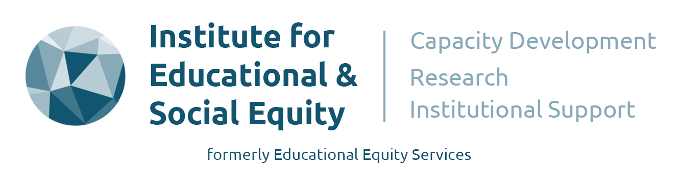

Participant Information Sheet and Consent Form – 10/01/2024

Understanding UKME/GMH Participation in the Church of England’s Ministry and Leadership

Introduction:
This research project, commissioned by the Racial Justice Commission, aims to understand, articulate, and evidence the participation of UKME/GMH (United Kingdom Minority Ethnic/Global Majority Heritage) individuals at various levels within the Church of England's ministry and leadership. The research project is structured around five key themes, each addressing specific research questions (RQ): Theme 1 focuses on establishing baseline data, examining differences in representation across regions, roles, and demographic factors. Theme 2 delves into Human Resource Management policies, exploring their identification, implementation, and impact on processes, particularly in terms of Equality, Diversity, and Inclusion (EDI). Theme 3 aims to identify and contextualise 'good' HRM practices at various levels. Theme 4 anticipates exploring the experiences of UKME/GMH employees, including themes related to networks, HR, mentoring, self-help networks, and retention. Finally, Theme 5 centers on aspirations and ambitions, investigating factors influencing participation and potential barriers to clergy engagement among UKME/GMH individuals, both internal and external.

Methodology
This research project employs a mixed methods approach, involving the analysis of quantitative datasets alongside the concurrent collection of primary data through a series of interviews and 'Facilitated Conversations' with diverse stakeholders. In-depth interviews are anticipated to last 45- 60 minutes, while facilitated conversations are scheduled for 60 minutes. Both interviews and ‘facilitated conversations’ will be digitally recorded, ensuring participants' views are treated with strict confidentiality. A ‘Facilitated Conversation’ could include between 8- 20 participants. Project data will be securely stored and backed up in compliance with the Data Protection Act 2018. The research adheres to the ethical code outlined by the British Educational Research Association (BERA). Participants in this study are guaranteed the rights to no harm, confidentiality, anonymity, and the right to withdraw, even after the interview has been conducted but before the final report's publication.

For further details please contact: Professor Paul Miller, Principal Investigator at p.miller@instituteforequity.ac.uk or Louisa Robinson at l.robinson@instituteforeequity.ac.uk

By signing and dating this Participant Information Sheet, participants give consent to participate in this study.

Name of Participant: ________________________________________

Signature: _____________________________________ Date: _____________________________

