A Month of Ikons

Background
Ikons originate in Eastern Orthodox Christianity. They represent a different way of looking at life and the Universe from that which we are used to as Enlightenment Protestants. They are not pictures, they are “windows into eternity”. They are not ‘worshipped’. They do not represent the human form as in western art, but portray an eternal reality, a theological statement, a glimpse of meaning beyond the earth-bound. Figures and scenes are written in two dimensions, showing the limit of human perspective. A third dimension (from front to back) is reserved for God the Holy Trinity, who is shown in many ikons as ‘breaking into’ the human scene from the eternity beyond this Universe using the device of a ‘nimbus’ (a sort of whole body halo). You can see this is the ikon of the Nativity (top and centre) pointing to the Christ in human form (shown by the haloed head labelled ‘Son’). Mary and Joseph (and attendant angels) have similar but unlabelled halos.
Spend time understanding this as it will help enlighten what follows.
Now contrast the rich narrative of the ikon with the entirely human artwork. What theology (understanding of God) you discern in each of them?
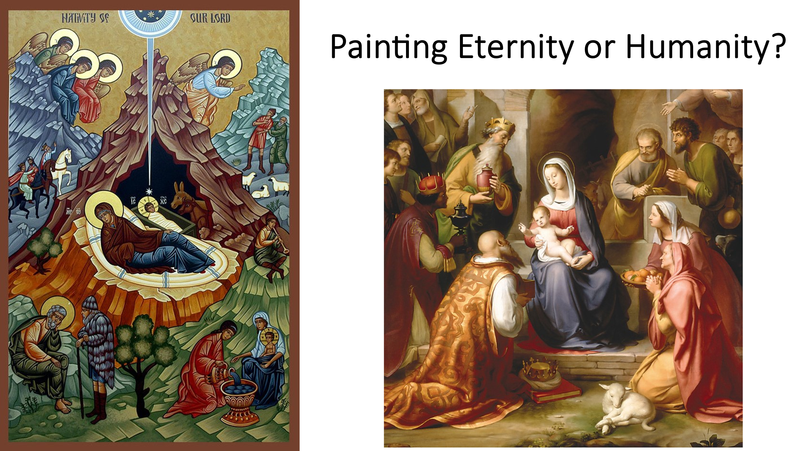

Week 1 Realism
We live in a Universe of mystery beyond human understanding. We believe in a creator God who made heaven and earth and who must exist beyond both, beyond the constraints of time and space in this Universe. The Orthodox assert that God’s essence (core of God’s Being) as the Holy Trinity is beyond the Universe and that we perceive God through his energies (activities or revelations) in this world. [A decent analogy is an old-fashioned cathode ray TV, where beams of yellow, red and blue light are beamed onto the screen and mix to create the image we see – their source (essence) is beyond our seeing, but we perceive the energies of the coloured beams]. There is none of this eternal realism in the renaissance artwork above.
As ikons are windows into reality beyond time and space, past present and future can be depicted in the same ikon. You can see this in the ikon of the Nativity. The same is true of the ikon of the Transfiguration.
Spend time this week, in separate sessions, absorbing the ikons of the Nativity, the Transfiguration and Gethsemane. What do each of them say to you? How do respond in prayer?
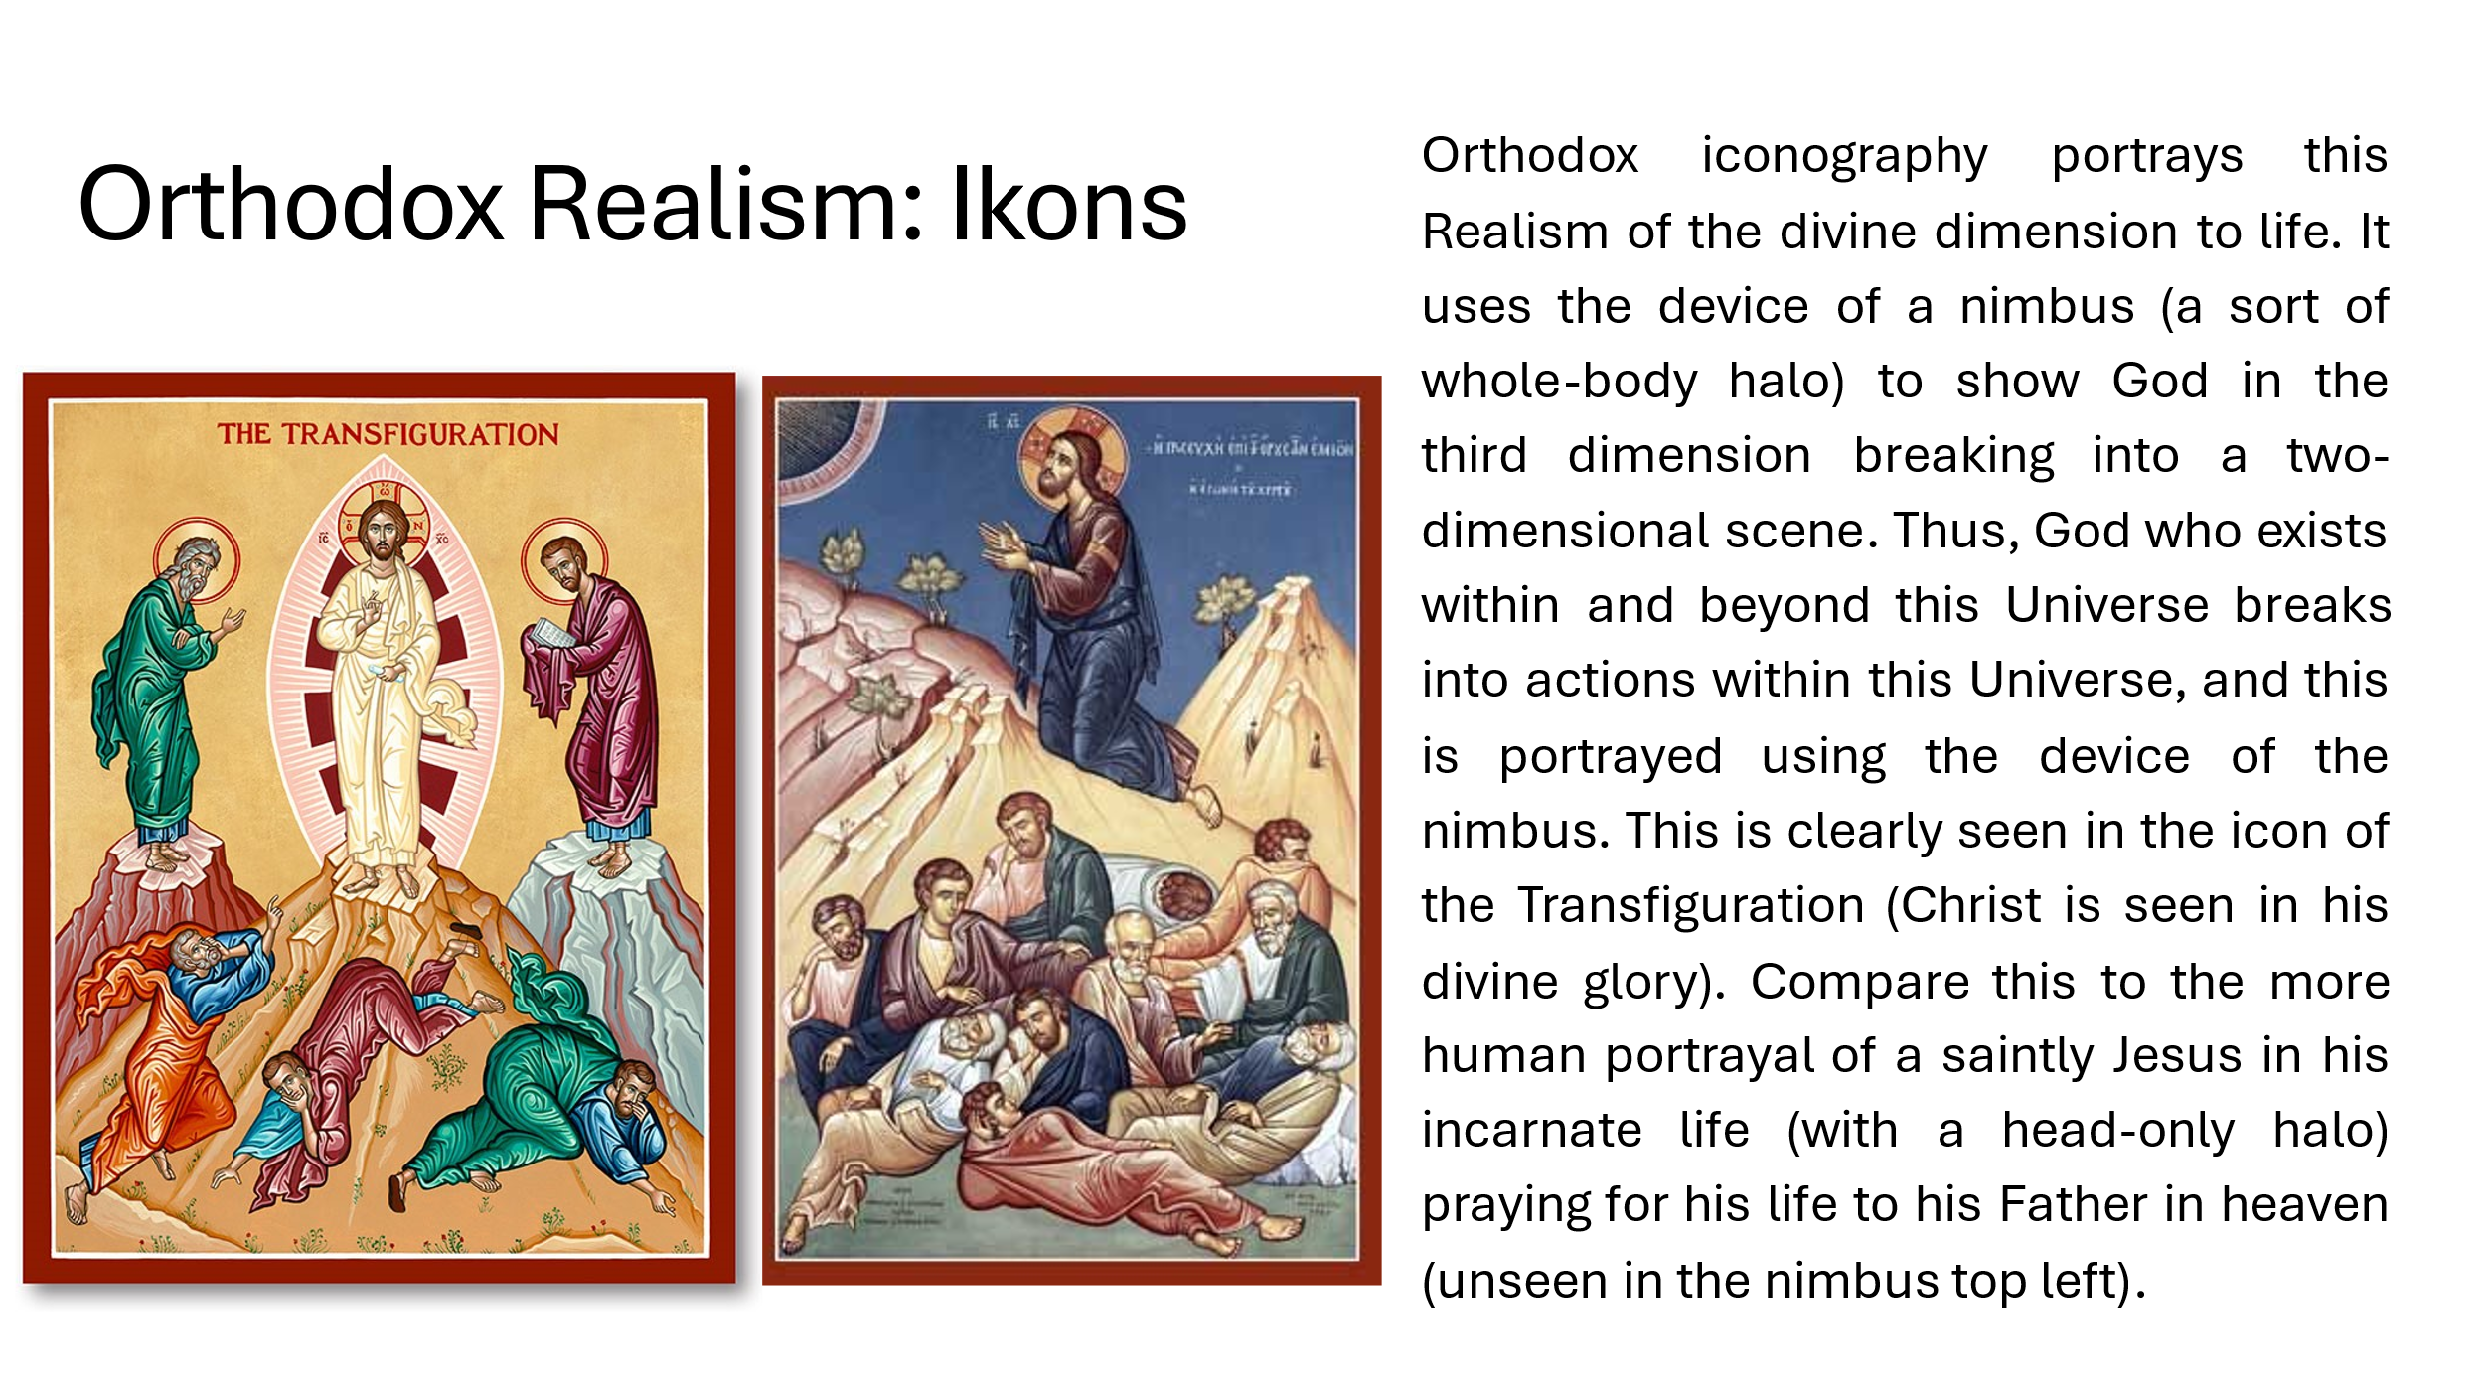

Week 2 Ikons of the Holy Trinity
This week we shall be looking at two ikons which reveal God as Holy Trinity: the Theophany (Baptism of Christ) and the Metamorphosis (Transfiguration).
Spend a session or two meditating on the ikon of the Theophany. What does it say to you about Jesus? Sacraments take place in Divine Reality, not merely in a rational, human cut-down version of Reality: God acts in them from both beyond and within time and space. They are a living counterpart of ikons. So, what does this ikon say to you about your own Baptism?
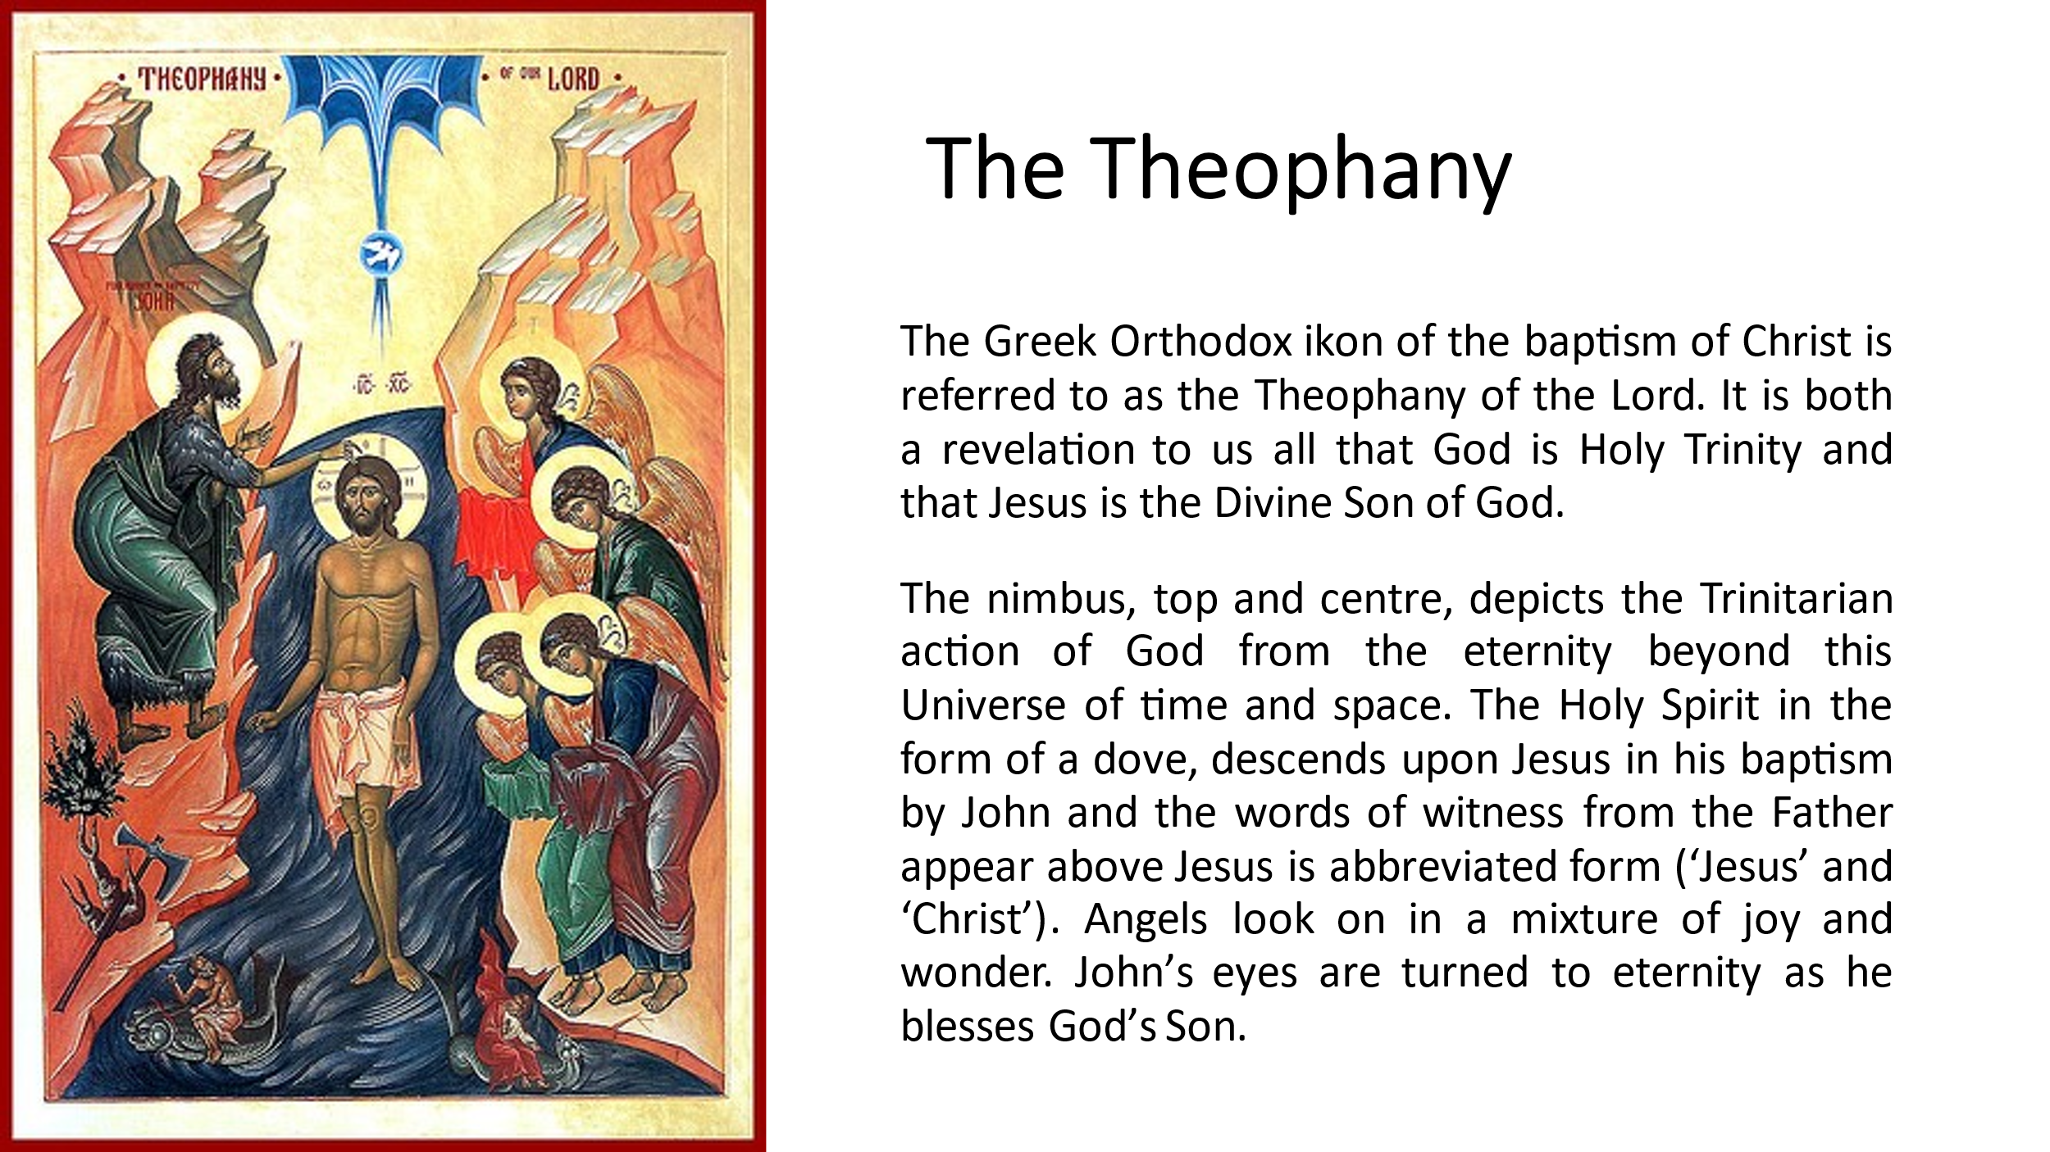

In another couple of sessions, consider the Ikon of the Metamorphosis. What does the ikon say to you? Consider Jesus shepherding the disciples up and down the mountain to experience this Divine revelation. What does this say to you about his shepherding of you to mountain-top experiences.
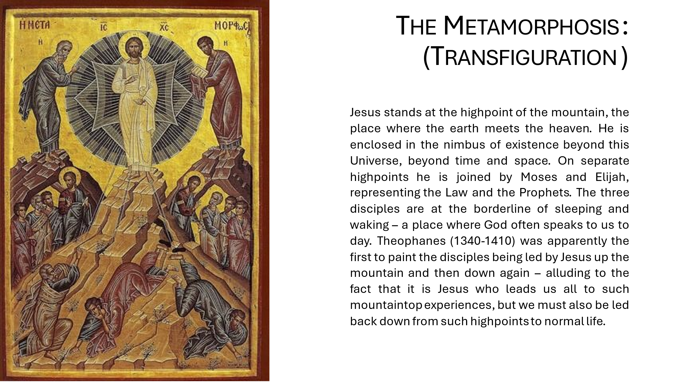
Human beings are “in the image and likeness of God” (Gen 1v27). The Orthodox say that this means we have the raw material in us (God’s image) to grow more like God (into God’s likeness), and that this is our life’s work. This potential is our Original Blessing: “God saw all that he had made and it was very good” (Gen 1 v31). What do these ikons say to you about your own journey of transformation into God’s likeness, as seen in Jesus? Ponder this in a couple of sessions.

Week 3 Ikons of Salvation
“God became what man is so that man might become what God is”
(St Ireneus).
We become healed and whole persons through the action of God in our salvation. We might say today that we become whole persons, we become our True Selves, through the abiding Presence of God within us; we are “In Christ”, with “Christ in us” (John c14-16). Orthodoxy asserts that we share in the Divine nature in Christ, which they call called ‘Divinization’ or ‘Theosis’. Christ’s death and resurrection makes this possible.
This week, we shall look at the ikons of the Anastasis (Resurrection) and Pantocrator (the all-powerful Christ in Judgement).
In a couple of sessions, ponder the ikon of the Anastasis. How does this ikon inform your view of the resurrection? What does it say about your own resurrection to eternal life in Christ? Does this image of Christ’s intervention give you confidence?
In other sessions this week, appreciate the ikon of Christ Pantocrator. Do you think of judgement as receiving Christ’s blessing? This is an ikon of power and compassion. How are these qualities reflected in your own life, as you grow in Christ-likeness?
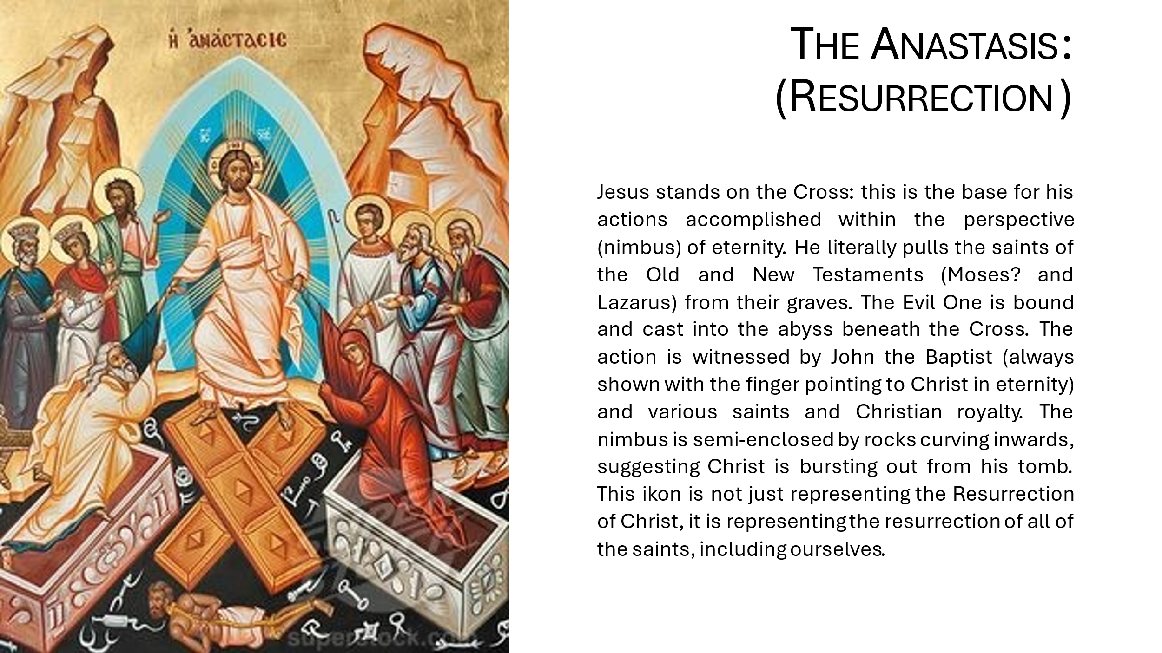
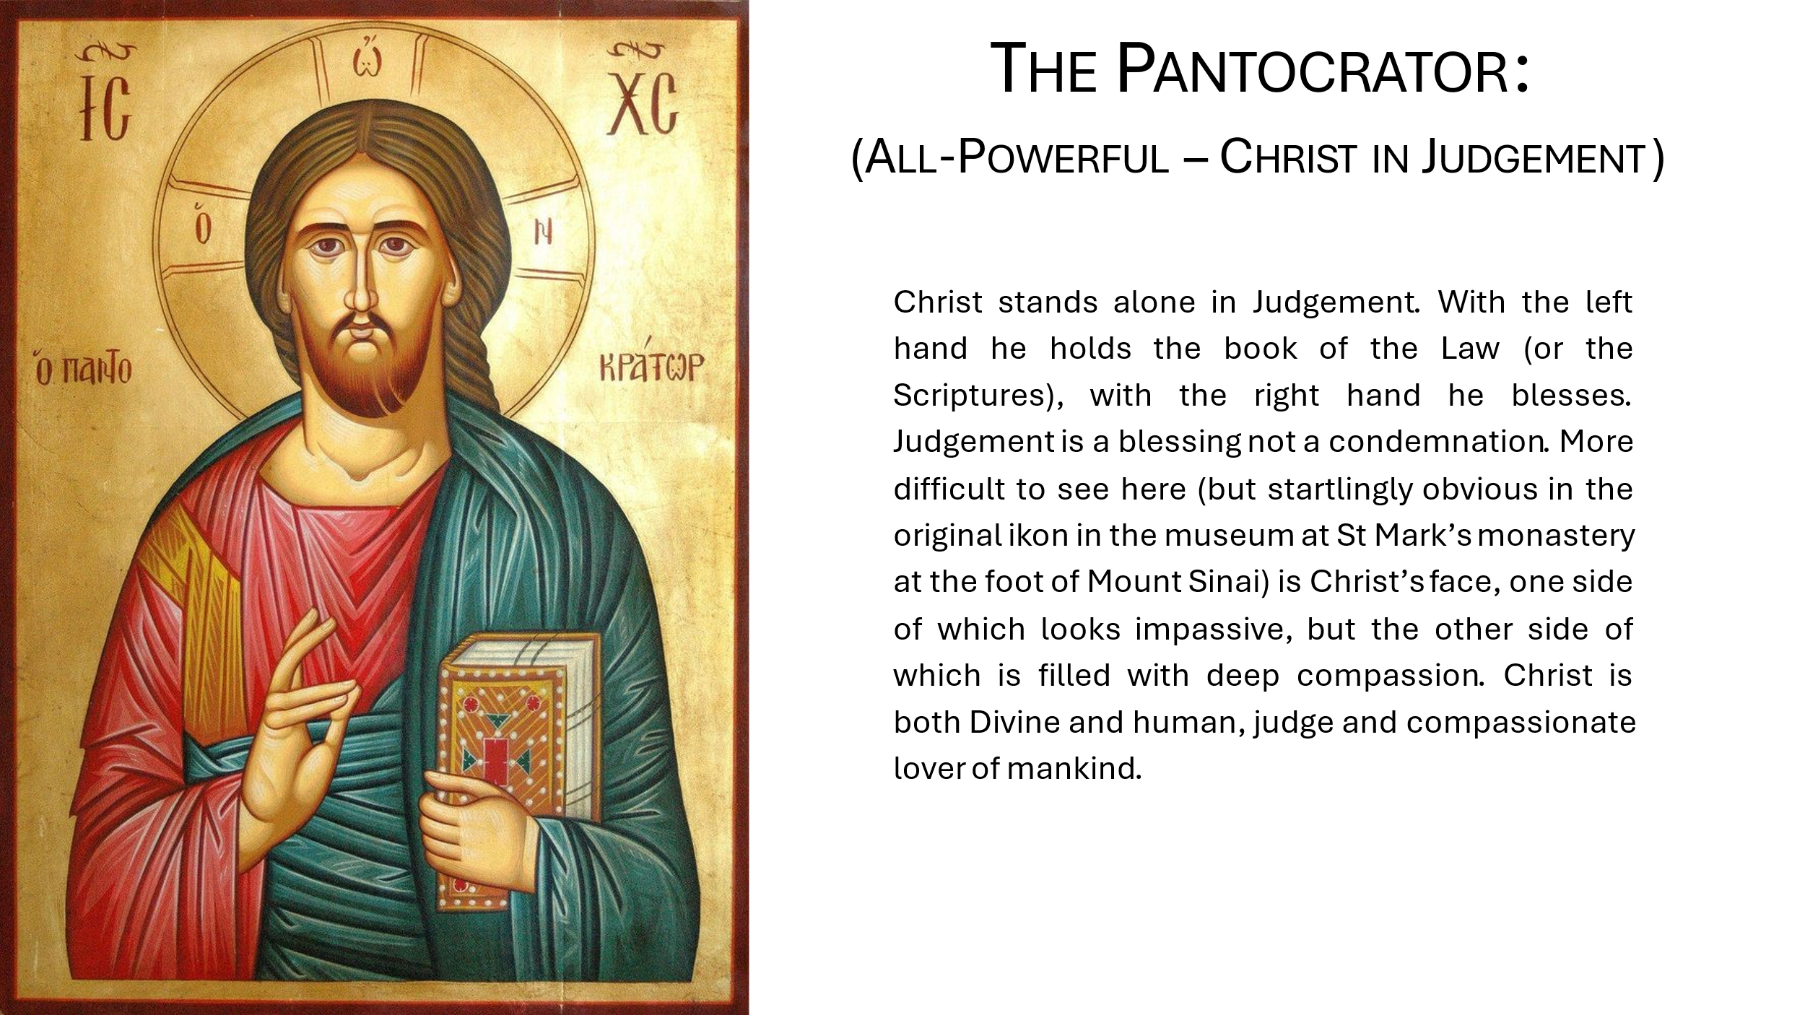

Week 4 Ikons of Working with God (Synergy)
Part of being human is the possession of ‘Free Will’. In our daily lives, we are free to work with God and in doing so we become more like Christ. This week we will consider two ikons of Mary the mother of our Lord, which depict her free choice for co-operation or synergy with God’s will.
In a couple of sessions, ponder the ikon of the Annunciation in which her choice to co-operate with God’s will, as revealed by the angel, is depicted: “Then Mary said, ‘Here am I, the servant of the Lord; let it be with me according to your word.’” (Luke 1 v38). What personal qualities might have assisted Mary in this decision? How might you practically increase your own co-operation with God in his work in the world?
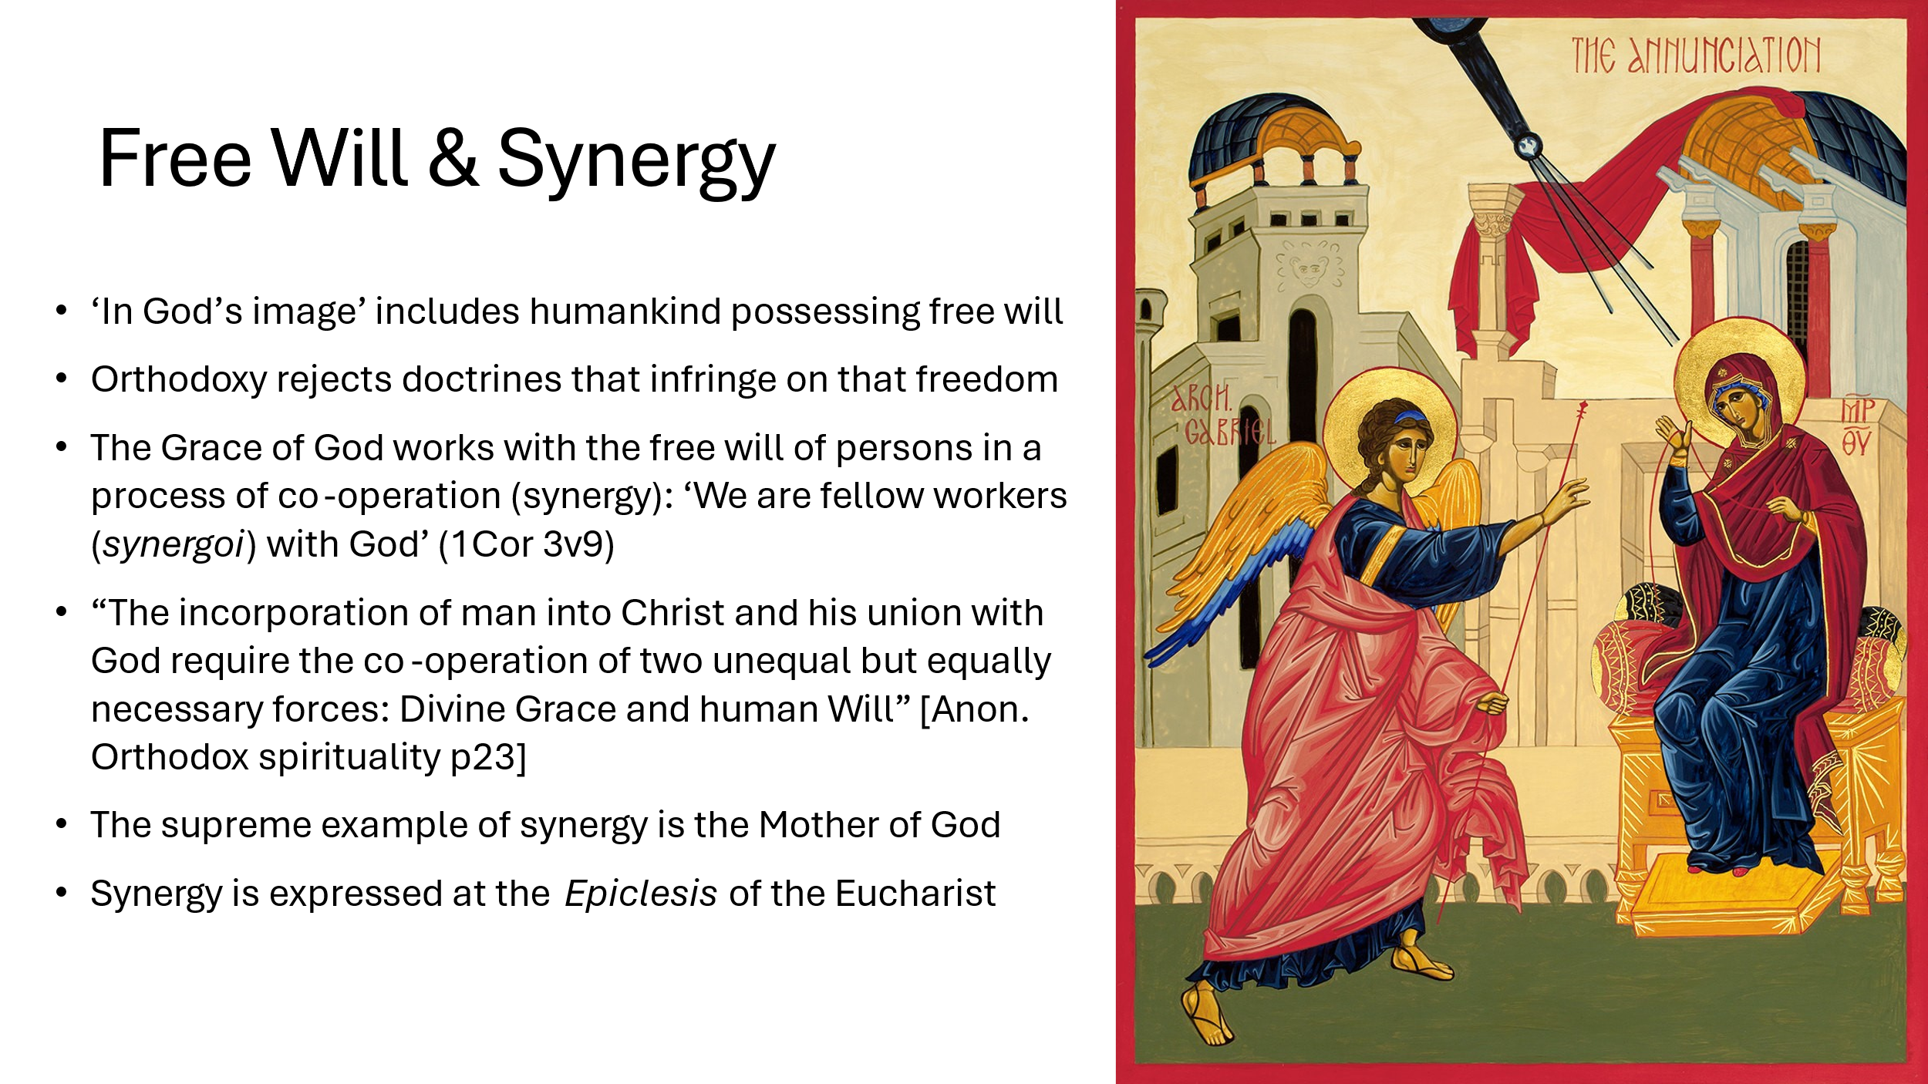

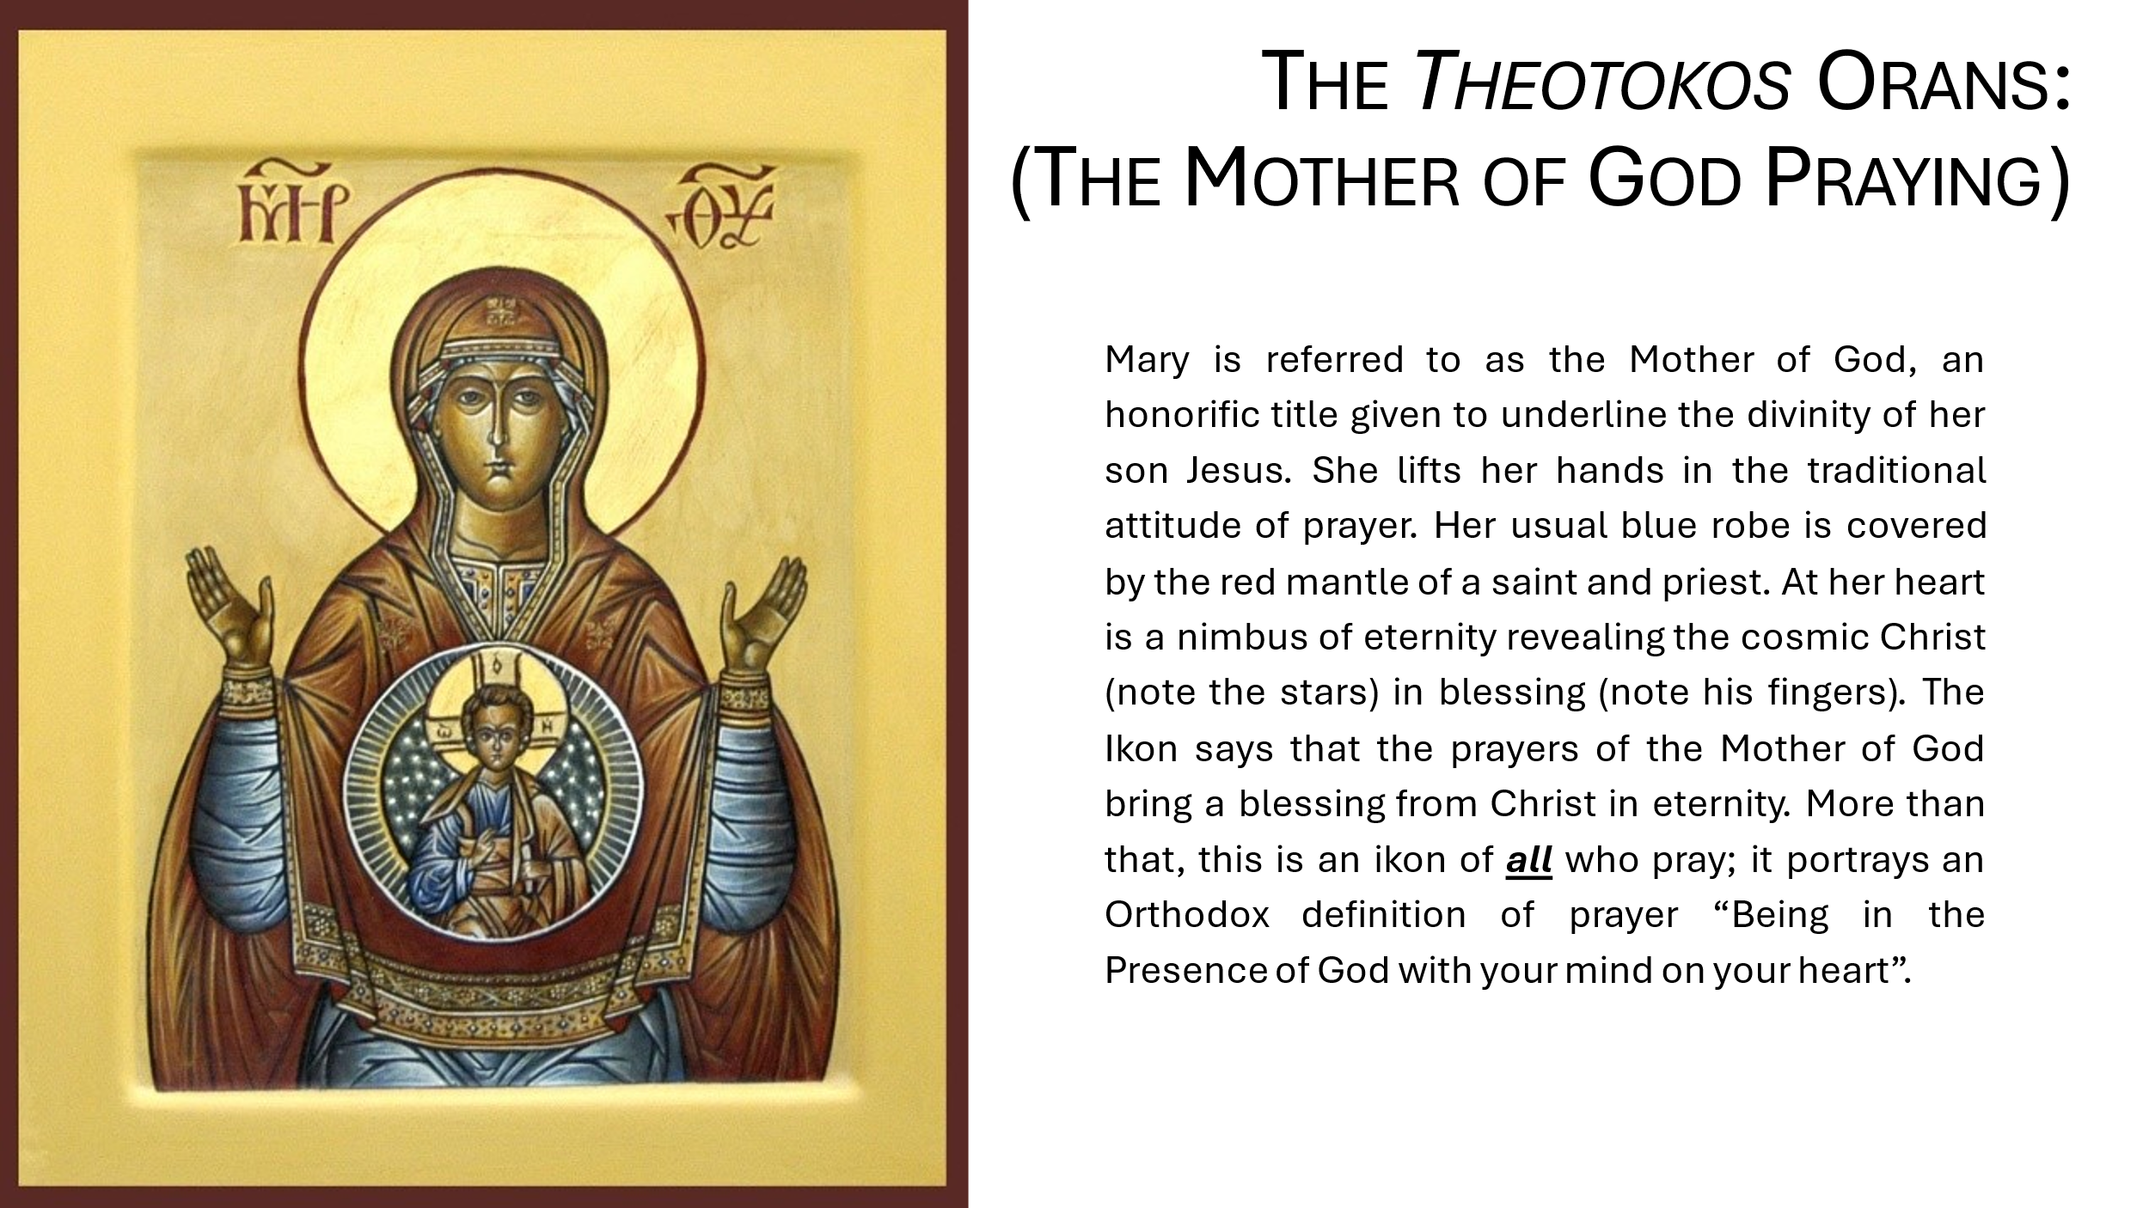
In a couple more sessions this week, consider the ikon of Mary praying. It depicts both her own and our own praying: prayer reveals Christ’s blessing from eternity. What does the ikon say to you? Study Mary’s face; she seems serene not troubled, calm rather than fervent. What is this ikon saying about your own praying?
In a final session review what effect this month’s work with ikons has had on you. How might you take this forward?

Follow-up Resources
- Ware T (1963) The Orthodox Church Pelican
- Russel N (2009) Fellow Workers with God. SVS Press
- Williams R (2002) Ponder These Things, Canterbury Press
- Williams R (2003) The Dwelling of the Light; Praying with Icons of Christ, Canterbury Press
- Icons: Windows into Eternity | St Andrew's Greek Orthodox Theological College (sagotc.edu.au)
- https://www.youtube.com/watch?v=M9lTwlRd1Po
- https://www.youtube.com/watch?v=AAvu6rPocMs
Iab/2/10/24 VF

