**A Month with Ignatius of Loyola**

# **Background**

Ignatius of Loyola (1491-1556) was a Spanish catholic priest, now famed for his Spiritual Exercises (which require a specialist guide) and for founding, with six of his companions, the Jesuit Order (SJ = Society of Jesus). Noble by birth and a soldier by profession, his conversion to Christ was prompted by a life-threatening leg wound. During his recovery he experienced many of the practices which he later recommended in his teachings. We will look at some of these this month. His spiritual guidance (summarised below) remains both practical and relevant to people in general today.

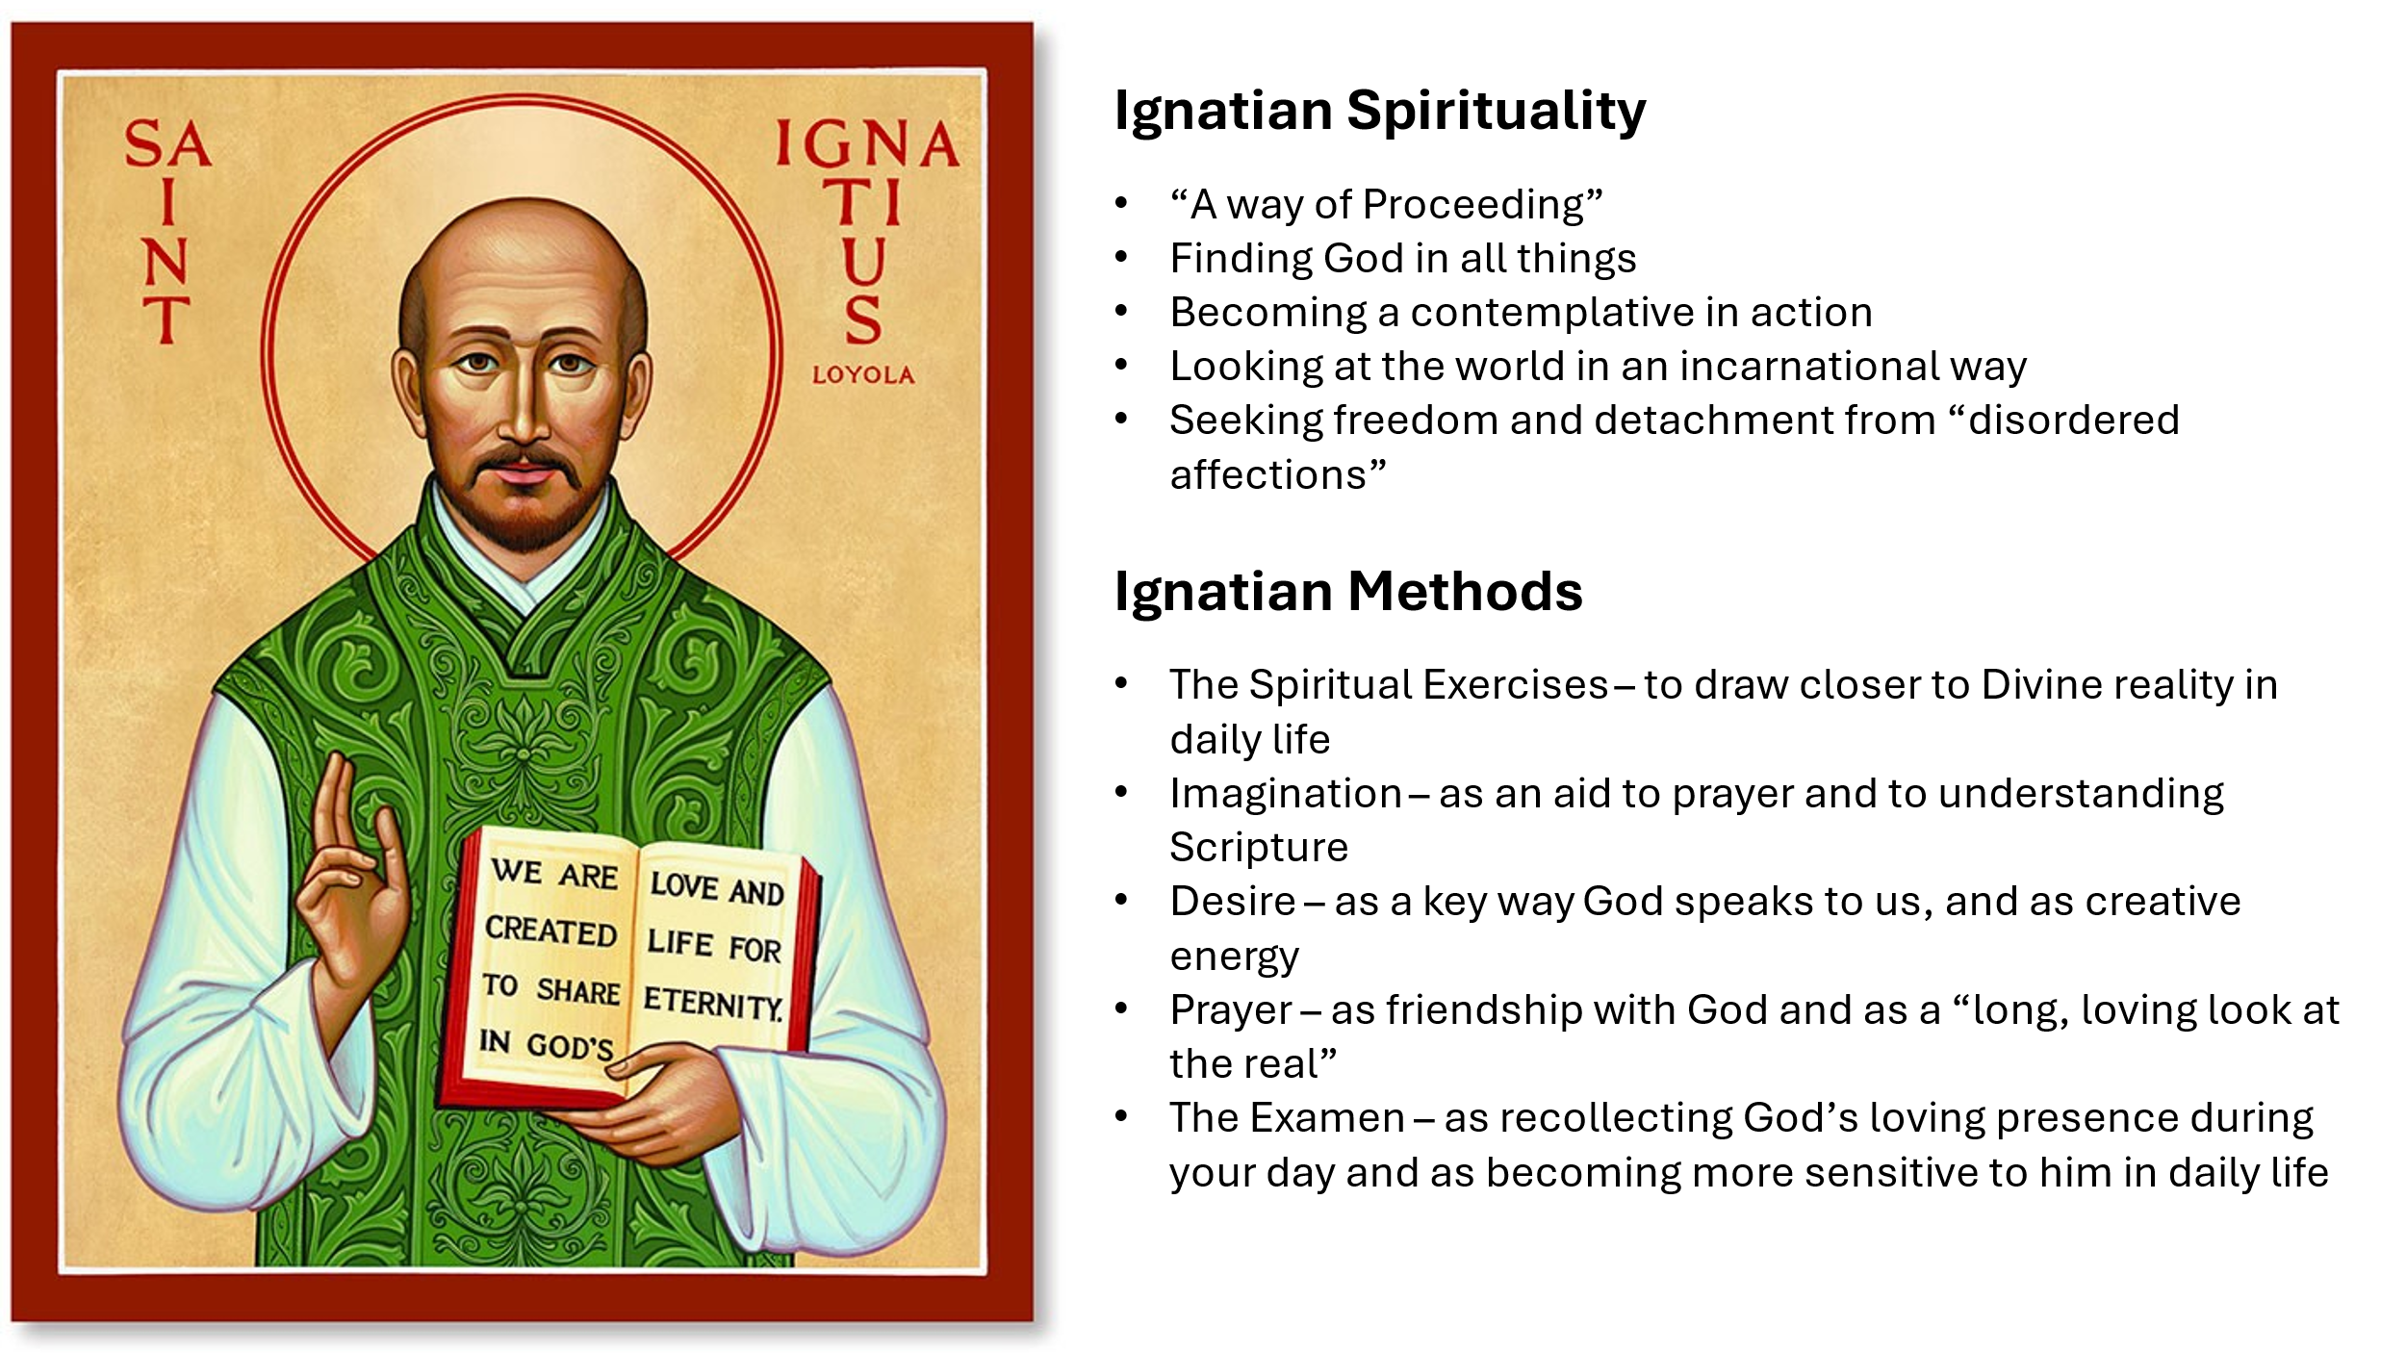

# **Week 1 The Examen**

“And what does the Lord require of you? To act justly and to love mercy and to walk humbly with your God” (Micah 6 v8)

There are many forms of the Ignatian Examen. All are a slow, grateful and non-judgmental review of your day, usually performed in the evening in silent prayer. The aim is to become more sensitive to the Presence and promptings of God in your daily life by discerning his action in the day that is past and to walk more closely with him in the day to come. Try this form preferably daily, throughout the month. Sessions take 15 - 20min.

**Step 1:** Begin by praying that your life may always be a close walk with God

**Step 2:** Review your day slowly. Recognise the moments for which you can be grateful: Thank God for them

**Step 3:** Recall your inner moods and feelings during the day and what prompted them. Ask God to show you the attitudes which underlie them. Avoid self-analysis or self- judgement.Thank God for the times you have walked closely with God and ask for forgiveness for the times you have wandered away.

**Step 4:** Look briefly at the day ahead and ask for God’s guiding Presence.

# **Week 2 Discernment**

Ignatius taught that choosing the right way forward in the Christian life is a matter of whole-being discernment rather than mental decision-making. We would say it arises from our living in Christ rather than from our own Ego drive.

Ignatius discerned two extremely useful pairs of concepts to help us: He called one pair Consolation and Desolation, and the other Drawn and Driven.

**Consolation** is like swimming with the tide; while **Desolation** is like swimming against the tide. Times of Consolation are like walking in the sunshine where there is no shadow in front of you; while Desolation is like walking away from the sun and seeing only your own shadow. If we are honest, we can all recognise that there are times in our spiritual life, and in a church’s life, when we feel as if you we walking joyously towards God (Consolation); while there are also times when we feel your individual or corporate back is turned to God and all we can see is ourself, or your church, in shadow (Desolation).

Just like a barge on a river, we can never change course successfully when we are in a tunnel of Desolation. We have to travel through life’s dark tunnels until we come to an open space (of Consolation) in order to change direction successfully. Good discernment and good decisions are best made in periods of Consolation not Desolation; so don’t put off discernment until things get too bad!

Identifying times of Consolation and Desolation is key to Ignatian discernment. In a couple of prayerful sessions, think through the month just passed and identify periods of personal consolation and desolation. Does a pattern emerge?

The second pair is **Drawn** and **Driven**. Again, we need to become sensitive to their action in our lives.

It is important to ask yourself if you are Drawn or Driven to take a particular action.

*“*The action of God in our lives is always, at its heart, experienced as a drawing. If we are feeling driven, then the promptings that gives rise to it is not from God, but from the force-fields of our own (or other people’s kingdoms)” (Margaret Silf)

Again, in a couple of sessions, think through the month just passed and identify when you felt drawn or diven to make particular commitments or to take particular actions. Does a pattern emerge? Are there things you feel the need to change?

Ignatius also taught that weighing up actions through discernment should be an unbiassed process; he said we should be **Indifferent** to the outcome. By this he meant that we should not be tipping the scales in favour of one particular outcome, but be open to all possible outcomes; that is what Ignatius meant by discerning the outcome with indifference. In practice, this is probably the hardest thing to do! We will look at ‘deepest desires’ later.

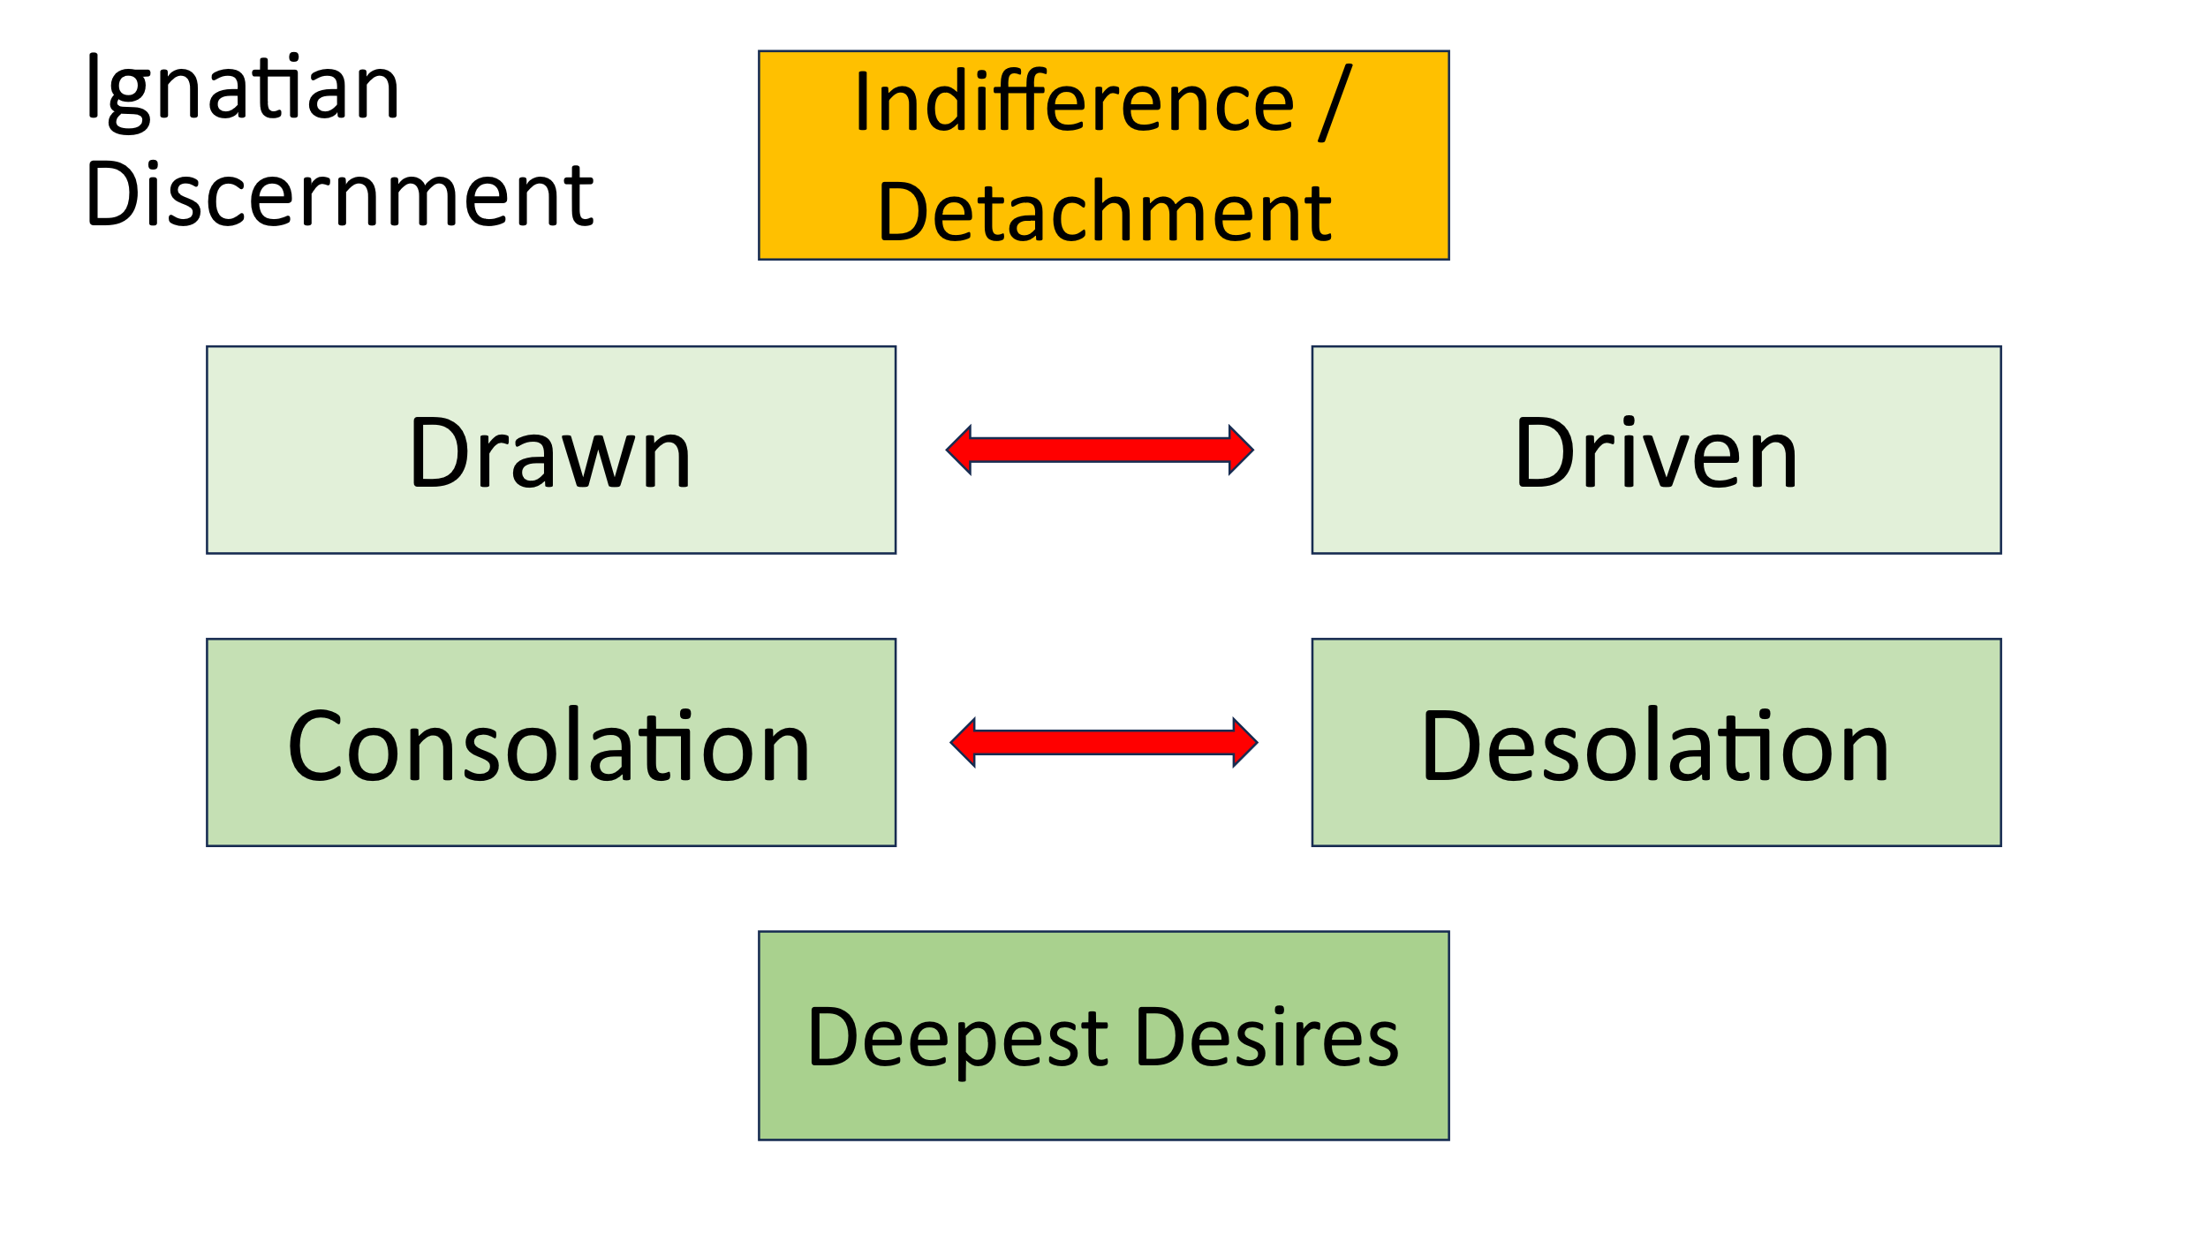

# **Week 3 Imagination**

Ignatius encourages us to use our imagination to explore stories in the Bible in the first person. For him, imagining himself at the birth of Jesus, using all of his senses, was a revelatory experience.

This week we will be imagining ourselves as different characters in two Bible stories, examining our thoughts and feelings as the action proceeds, and reflecting on our experience afterwards. Using all of your senses within the stories makes them much more real, so take time in the scene to feel the sun or to smell the sea etc.

* In three separate sessions, imagine yourself as one of the characters in this story: Luke 10 v30-35 only. Choose to live the story as a different character each time! After each session, ask yourself what insight you have had about the character and about yourself.
* Do the same for different characters in John 8 v1-11.

Has this approach delivered new insight for you about the stories and about yourself?

# **Week 4 Deepest Desires**

Ignatius believed that our Deepest Desires are planted within us by the Holy Spirit to shape our lives and help us to realise our full potential and gifting. They are the deepest, long-term longings of our hearts. He repeatedly advises us to pray for our desires “for what I want and desire” and for *“*the desire to have the desire for…”.

“Desire is a key part of Ignatian spirituality because desire is a key way that God’s voice is heard in our lives. And ultimately our deepest desire, planted within [all of] us, is our desire for God*”* (James Martin SJ).

Discovering our Deepest Desires and acting on them are important parts of our spiritual development. Spend most of the sessions this week thinking and praying about your own deepest desires and where they might take you now.

James Martin identifies several characteristics that will help identify our Deepest Desires:

|  |  |
| --- | --- |
| **Incompletion** | There is something missing in life. ‘In the echoes of our restlessness, we hear God’s voice’ |
| **Common Longings and Connections** | We feel we are on the brink of something important. We experience, when our defences are down, God’s desire for us. We may fear accepting these moments as a signs of the divine call – they may be too close for our comfort! |
| **Uncommon longings** | Sometimes we feel an almost mystical longing for God. Maybe we feel filled with God’s presence; or lifted up from the normal; or overwhelmed with a sense of God. Mystical experiences are not as rare as some would believe. A sense of awe. Awe is an insight into a meaning greater than ourselves. |
| **Exaltation** | One feels lifted up; or exalted and happy; or the warm satisfaction of being near God. |
| **Clarity** | It suddenly all makes sense. This is right where I should be…etc. |
| **Desire to follow** | An explicit desire to follow Christ / God. |
| **Desire for holiness** | Attraction to examples of holiness, which may be in the past or present. Holiness in others calls out to the deep parts of ourselves; deep calls to deep (Ps 42v7) |
| **Vulnerability** | Many people feel drawn to God in times of suffering. God is able to reach us because our defences are lowered. “Dying is about becoming more human.” Perhaps recognising our inborn connection to God or becoming more loving. ‘Paradoxically, the more human we become, the more divine we become.’ |

Review your spiritual development this month. How enabling has the approach of Ignatius been? How will you follow this up?

# **Follow Up Resources**

* Silf M (1998) *Landmarks: an Ignatian Journey.* DLT
* Martin J (2010) *The Jesuit Guide to Almost Everything: a Spirituality for Real Life.* Harper One
* Helm N (2014) *Ignatius of Loyola: a Guide for Spiritual Growth and Discipleship* Grove Booklet S130
* O’Brien K (2011) *The Ignatian Adventure: Experiencing the Spiritual Exercises of St Ignatius in Daily Life* Loyola Press
* Lonsdale D (2000) *Eyes to See, Ears to Hear: an Introduction to Ignatian Spirituality* DLT
* <https://www.beunos.com/>
* <https://www.youtube.com/watch?v=-7j9DC4jL5w>
* <https://www.youtube.com/watch?v=cAFbD5jCGNI>
* <https://www.youtube.com/watch?v=m_DFG2oACkE>

iab/2/10/24 VF