A Month with Heschel

Background
Rabbi AJ Heschel was professor of Jewish Ethics and Mysticism (1946-1972) in New York, and probably one of the greatest theologian-philosophers of the twentieth century. In his book Between God and Man he meticulously builds a case for the progression to Faith in God through Wonder, Mystery, Awe and Worship.
ex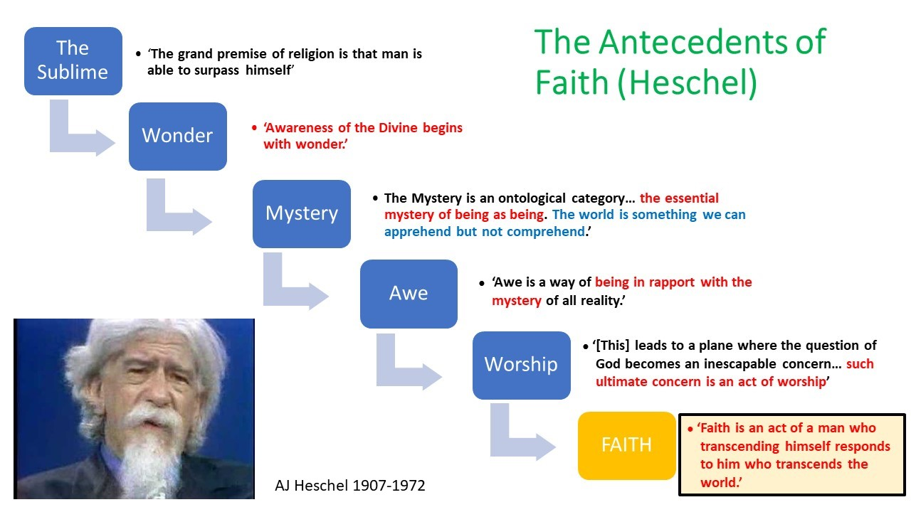
This month we will trace this pathway experientially as a route to deepening our own faith in God, and to appreciate its potential help to those with no faith in God.

Week 1
WONDER: “Awareness of the Divine begins with wonder”
Psalm 8 speaks of the wonder engendered by pondering the heavens and the earth. Modern technology has provided fresh impetus to that wondrous beauty. Ponder the beauty, the immense distances involved, and the origins of the images from the James Web telescope Webb Home | Webb (webbtelescope.org) . Spend time this week relating what you see in those images, and the feelings they engender, to Psalm 8.
The Bristol artist Luke Jerram creates that sense of wonder in some of his works. Spend time this week allowing his work to inspire you, notably through ‘Gaia’, ‘Glass Microbiology’ and ‘Museum of the Moon’ available on his website lukejerram.com . Imagine yourself at those installations. Museum of the moon has been to Bristol Cathedral, and Gaia (and associated events) will be there in late October 2024.
Consider also the amazing complexity of human foetal development by watching this Imperial College animation Imperial College - Human Embryo Development (youtube.com) – and the live choreography of cell division in an in vitro embryo https://www.youtube.com/watch?v=V6-v4eF9dyA&t=1s . You went through that process in your making in the womb, determined by your unique combination of genes and your chemical interactions with your mother. Now ponder Psalm 139 v13-14
Spend a session meditating on the words of the well-known hymn ‘O Lord my God, when I in awesome wonder’ https://www.youtube.com/watch?v=p-hvI1nbS80.

Week 2
MYSTERY: “…the essential mystery of being as being. The world is something we can apprehend but not comprehend”.
In this vast and beautiful universe (all of space and time and its contents), in this complex choreography of human development, you became uniquely you, your Being was crafted. Statistically, you are highly improbable! Ponder how that makes you feel.
We know and understand so little. Science tells us that only about 4% of our Universe is the ‘normal’ matter we might see or touch; about 21% is ‘dark’ matter, which we have only recently become able even to detect; and about 75% is formless ‘dark energy’. We know so little about that 4% which is most available to our study. What Humanity does not know vastly outweighs what it knows. Yet you, yourself, personally, are beloved of God (see Romans 1 v7, Galatians 2 v20, 1 Thessalonians 1 v4).
Modern psychology has tried to understand what drives us as individuals. Personality profiles and ‘compatibilities’ abound in the modern world. Counselling, Psychology and Spiritual Direction are available to us to help us to understand ourselves better and to live life to the full. Yet we remain mysteries even to ourselves. Take plenty of time to think about your own experience of Being, its vulnerabilities, its joys, and its mystery.

Week 3
AWE: “Awe is a way of being in rapport with the mystery of all reality”
The Universe is a mystery. My coming into being is a mystery. I am a mystery. Does that resonate deep in your Being?
Heschel writes:
“Awe is an intuition for the creaturely dignity of all things and their preciousness to God; a realization that things not only are what they are but also stand, however remotely, for something absolute. Awe is a sense for the transcendence, for the reference everywhere to Him who is beyond all things. It is an insight better conveyed in attitudes than in words.”
What is your reaction to this?
Heschel also writes:
“In a sense, awe is the antithesis of fear. To feel The Lord is my light and my salvation’ is to feel ‘Whom shall I fear?” (Psalm 27 v1) … Awe precedes faith; it is at the root of faith. We must grow in awe in order to reach faith. We must be guided by awe to be worthy of faith… The loss of awe is the great block to insight.”
How do you react?
What place has awe in your own life?
What generates awe in you?

Week 4
WORSHIP: “…a place where the question of God becomes an inescapable concern… such ultimate concern is an act of worship.”
Worship is giving worth to someone or something: worth-ship. It is a expression of the ultimate value we place on someone or something.
Are human beings the pinnacle of worth in this vast Universe? Or is there something of greater value, greater worth? What do you think is of greater worth than humankind, if anything?
What is of greater worth than yourself? For what deserves worth-ship higher than my own? If I can conceive of any such thing, it deserved my value, my giving of worth, my worship. Spend two sessions pondering this carefully. Think of what you presently give worth to above or beyond your Self. Do you rest content or disturbed by what you discover?
Our being is in Christ, the eternal Son of God (see John chapters 14-16). In Christ, our entire being is created afresh (2 Corinthians 5 v17). What does this mean for your life from now on?
FAITH: How has your own faith in God responded this month?
Is it any easier for you to “transcend [your]self [in response] to him who transcends the world”?
How might you further these experiences?
Now spend time meditating on Psalm 139. What stands out for you?

Follow Up Resources
- AJ Heschel (1997 Edn) Between God and Man: An Interpretation of Judaism. Simon & Schuster NY
- Jerram L (2019) Art, Science and Play Sansom & Co
- https://fulleryouthinstitute.org/blog/walk-and-pray-in-awe-and-wonder
- https://cac.org/daily-meditations/awe-and-amazement-weekly-summary/
- https://kinginstitute.stanford.edu/heschel-abraham-joshua

iab/5/8/24 VF

