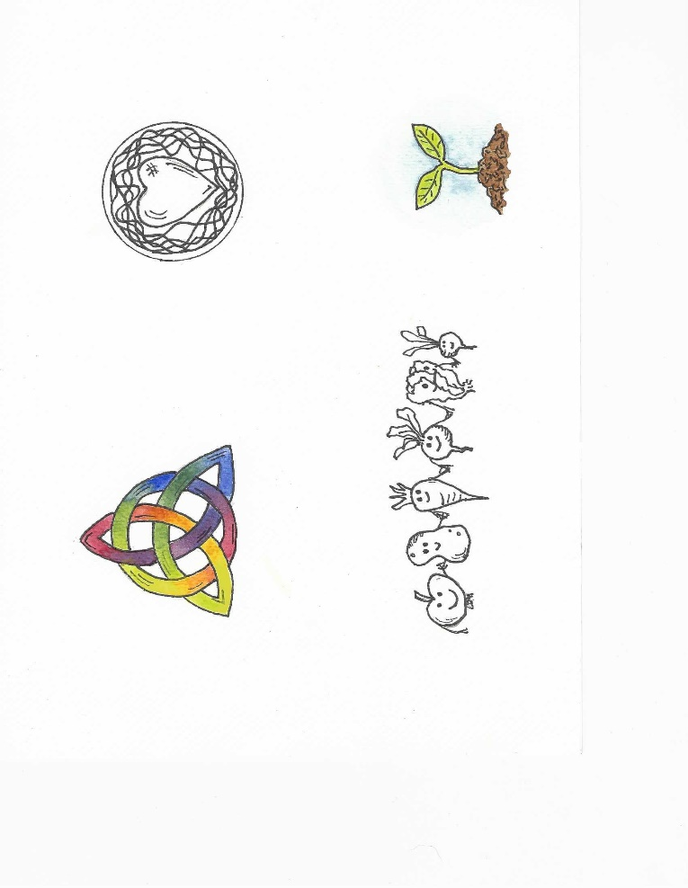

**BEING DEEPLY ROOTED**

**Prayer & worship**

* Making time to encounter God in land, nature, the Bible, silence and one another.
* Developing patterns of prayer which help us to reflect and draw close to God.
* Practising gratitude and developing our sense of wonder at the world around us.
* Recognising the whole of life as the place we encounter God, pray, serve and worship.

**Balance & Rest**

* Echoing the rhythms and seasons of the natural world by trying to live lives that are balanced and value rest, relaxation and play as well as work.
* Taking care of our minds and bodies, recognising they are precious to God.
* 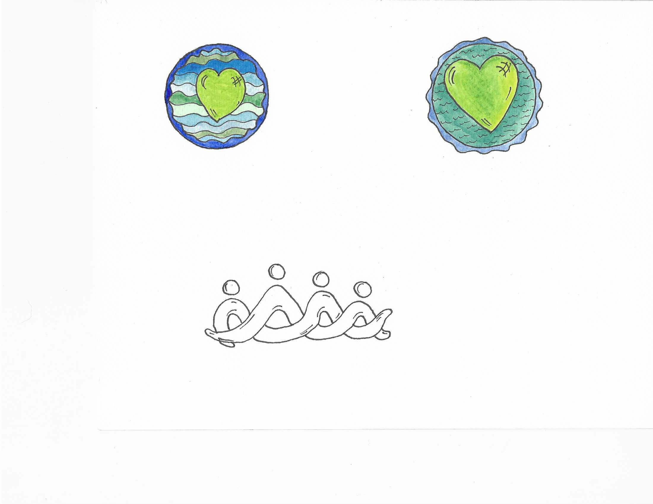Discerning the things that are ours to do (our calling) and being content to let go of the rest.

**LOVING THE EARTH**

**Caring for Earth**

* Recognising our dependence on and responsibility towards the natural world, of which we are a part.
* Valuing and caring for our small patches of land (the Hazelnut Garden, our own gardens and land in our communities) by creating gardens that are beautiful, peaceful, productive and respect nature.
* Making connections with those of different faiths, cultures and backgrounds who share our love of earth.

**Living sustainably**

* Reducing our impact on the earth by finding gentler ways of living and being mindful of how our food is produced.
* Encouraging each other in the hard task of change.

**Seeking Justice & Peace**

* Working with others to address the climate emergency in small ways and at a local level.
* 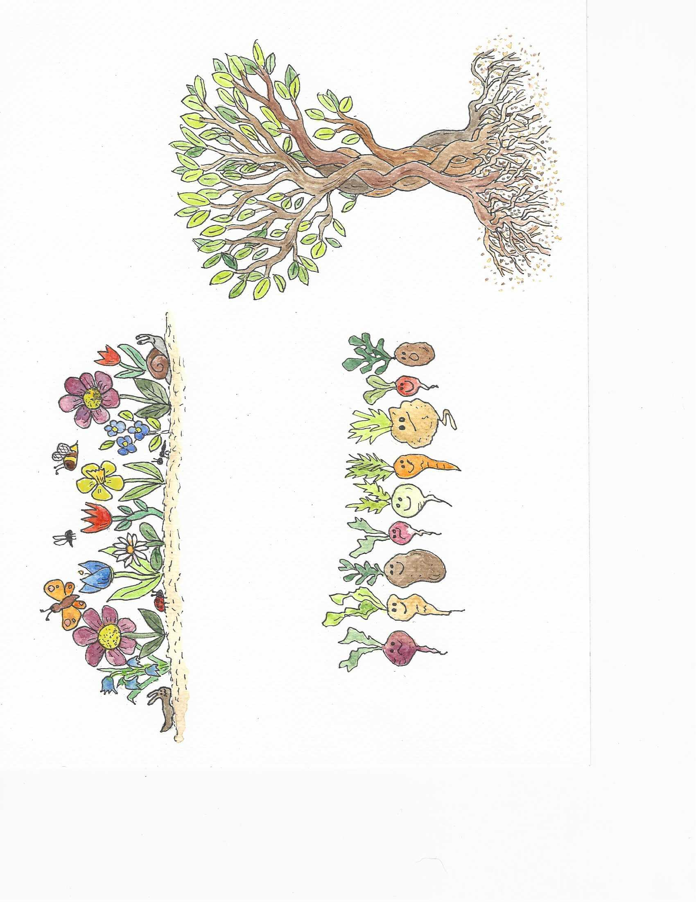Campaigning for change nationally and internationally.
* Showing concern for those most impacted by ecological breakdown, poverty, discrimination and isolation.

**GROWING COMMUNITY**

**Practising Community**

* Sharing our lives, struggles and dreams; supporting each other through hard times and celebrating together in good.
* Being willing to be real, honest and vulnerable. Accepting others for who they are and being open to those who are different from us.
* Taking time to enjoy being creative, having fun and eating together.
* Being willing to invest our skills, imagination, time, energy and money in our Hazelnut Community. Remembering that everyone has something to offer.

**Welcome, Hospitality & Collaboration**

* Making Hazelnut a place that is welcoming, open and inclusive.
* Connecting with others beyond Hazelnut, sharing our stories and understandings of faith, our resources, learning, hopes and dreams together.

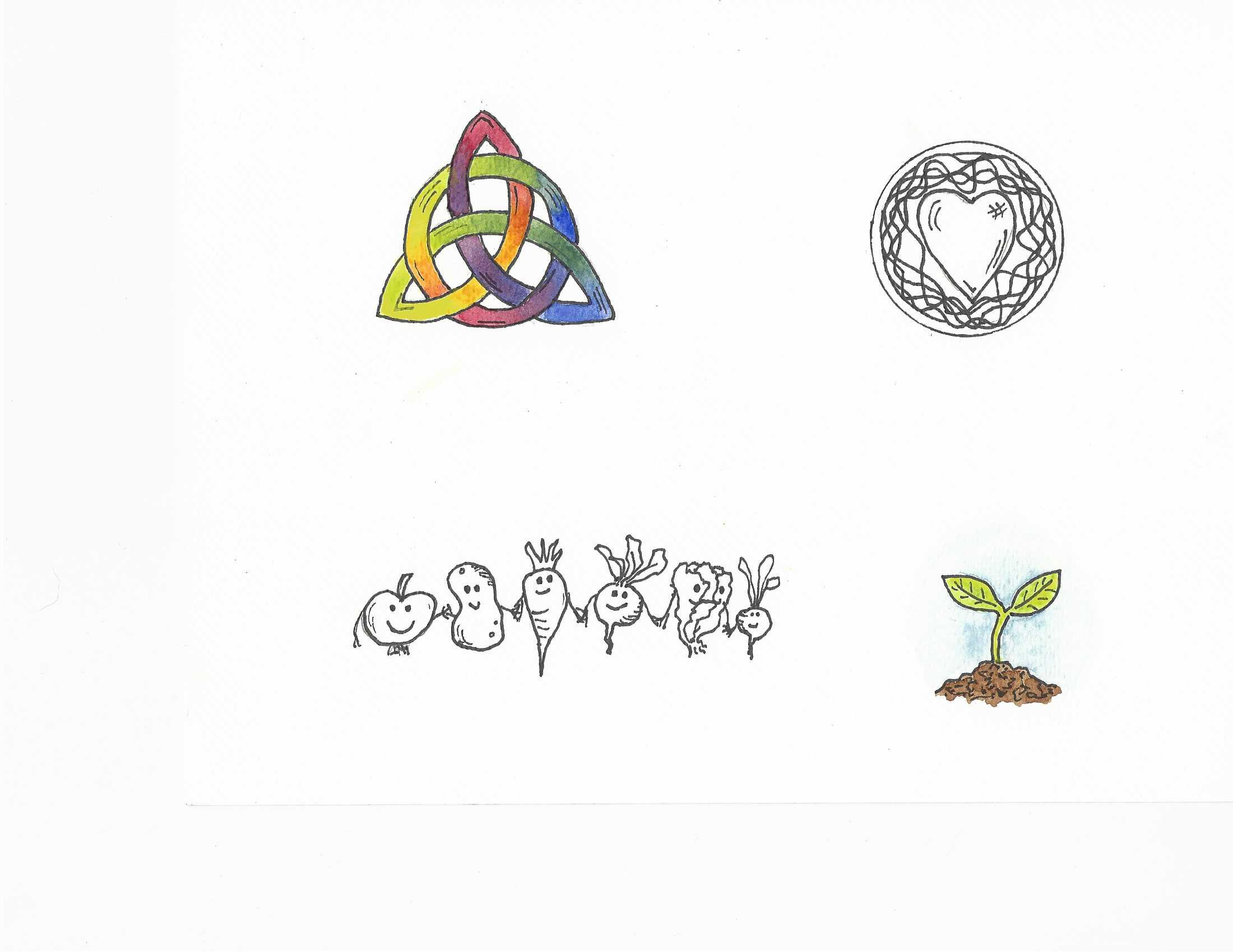

**CULTIVATING WISDOM AND HOPE**

**Searching for Wisdom**

* Learning to live faithful lives in a complex, changing world.
* Exploring scripture and learning from Christians through the ages and across the world.
* Being curious and not afraid to ask questions or to admit our ignorance.
* Learning widely - from each other, from the land and nature, from other cultures, faiths, disciplines, and from music and the arts.

**Cultivating Hope**

* Looking for ways that grow hope, motivation and resilience; moving away from the things that reinforce hopelessness, fear and anxiety.
* Encouraging each other to develop a deep sense of hope, rooted in God and our community, that is not eroded by circumstances or setbacks.

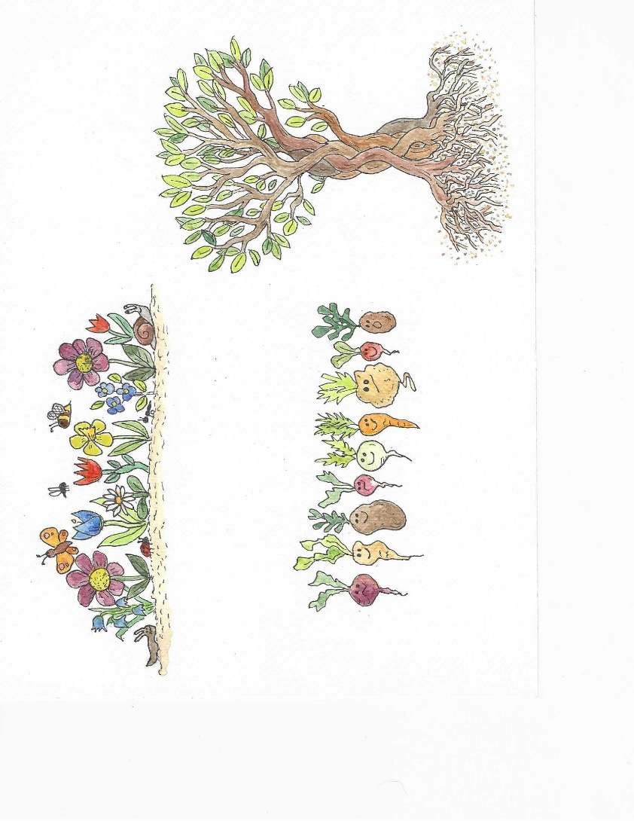

*© Bryony Davis ~ Hazelnut Community Bristol ~ 2024*

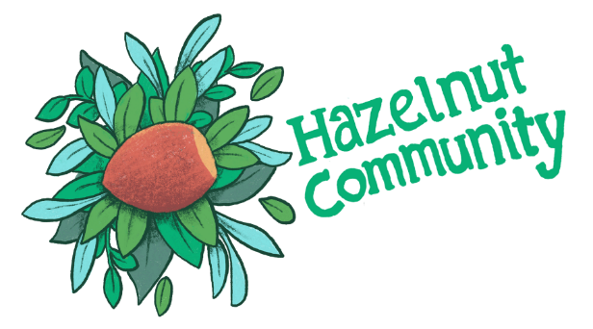

**Rhythm**

**Of Life**

**INTRODUCTION**

The idea of a rhythm of life finds its roots in the monastic tradition, from which Christianity grew within the UK. Their understanding of faith being lived out in the whole of life, with a balance between prayer, worship, work, rest, service and recreation, helps us to think about how we live out our own faith, in these complex and challenging times of ecological breakdown. This rhythm of life has grown out of Hazelnut’s values, looking to deepen our connection to Creator God, to creation, to each other and our community; and to find better ways of living in the face of climate breakdown. We will use it to help shape our individual lives and the culture, prayer-life and practices of our community. It recognises that our inner selves shape how we live and what we are able to offer to the world, and sees the whole of life as the place we encounter, worship and serve God.