Whistleblowing Policy

Issue Date: Month Year
Last review date: Month Year
Next Review Date: Month Year

Purpose
Whistleblowing is when an individual knows, or suspects, that there is some wrongdoing occurring within the Church/PCC and alerts the employer or the relevant authority accordingly.

The Public Interest Disclosure Act 1998 gives protection to individuals, casual workers, agency workers, and contractors who make a qualifying disclosure when they reasonably believe it is in the public interest for them to do so.

Please note this does not form part of the grievance procedure so if an employee has an issue with their treatment within the workplace, they may need to refer to the grievance policy.

Please note that making a safeguarding disclosure is different to Speaking Out. Safeguarding concerns relate to the possibility of abuse, harm or neglect of a child or of an adult at risk. If employees have such a concern, then they should raise their suspicion/allegation to the Parish Safeguarding Officer.

Scope
This policy applies to all employees of the Church but does not form part of an employees’ contract of employment and the Church/PCC may change this policy from time to time and employees will be notified of any such changes.
Volunteers, agency staff and contractors are outside the scope of this policy but are encouraged to raise concerns with the employee or worker that is providing supervision and support, or with a member of the PCC.

General Principles
If an individual knowns or suspects that some wrongdoing is occurring within the church, they should raise the matter immediately with their line manager or supervisor. If the individual feels unable to do this, they should raise the matter with XX.

For an employee to gain legal protection they must have made a protected “qualifying disclosure”. Employees are protected from the effects of making disclosures concerning breaches of legal obligations, which show that criminal offences have occurred, are occurring (or might occur) or that health & safety is compromised i.e. they should not be dismissed or be at a detriment as a result of the disclosure.

Although not exhaustive, examples of situations in which it might be appropriate for an individual to report a wrongdoing include:
- A breach, or potential breach, of health and safety legislation
- A breach of another legal obligation
- A miscarriage of justice
- Financial irregularities
- Damage to the environment
- The committing of a criminal offence
- An act of bribery
- Deliberate concealment of any of the above
The whistleblowing policy addresses concerns where public interest is at risk, which includes a risk to the wider public, customers, employees or the Church/PCC itself. The employee does not need to have firm evidence before raising a concern, but would need to explain, as fully as they can, the information or circumstances which have given rise to their concern.

Anonymity
If an employee wishes to keep their identity confidential then, as far as is possible, it will not be disclosed without their consent. If the situation arises where the concern cannot be resolved without revealing their identity, then whether and how to proceed will be discussed with them. Confidentiality cannot be maintained if the manager or person to whom the concerns are expressed considers that there is an immediate risk to safety and that, therefore, the matter must be addressed immediately or if the PCC is required by law to break that confidentiality. In such circumstances the employee would be informed of this course of action, and a support plan would be mutually agreed.

The individual who has made the allegation will be kept informed of any investigation that is taking place. The individual will also be informed of the outcome of the investigation. It might not always be appropriate to tell the individual the detail of any action that is take, but the individual will be informed if action is taken.

Altering Outside Bodies
An individual should always, in the first instance, talk to their line manager about a potential wrongdoing. If the individual is not satisfied with the response, they are entitled to contact a relevant external body to express the concerns. In doing this, the individual should:
- have a reasonable belief that the allegation is based on correct facts
- make the disclosure to a relevant body
- have a reasonable belief it is in the public interest to make the disclosure

A “relevant body” is likely to be a regulatory body e.g., Health and Safety Executive.

Contacting the media
The media is not a relevant external body, and individuals should not contact the media with allegations about the local or area meeting, except in extraordinary circumstances where neither the Church/PCC not the relevant regulatory body would be appropriate.

Protection against detriment
Any individual who takes action under this policy will be protected from suffering any detriment in relation to the allegations that are made, including victimisation by a member of the congregation or by a colleague.

If the individual does not follow the procedure set out, the protection against detriment may not apply. Disclosing information in an inappropriate way e.g., contacting the media, could result in disciplinary action being taken against the individual, which could include dismissal.

Malicious or vexatious reports may be dealt with as misconduct under the disciplinary procedure and may result in the dismissal of those concerned.

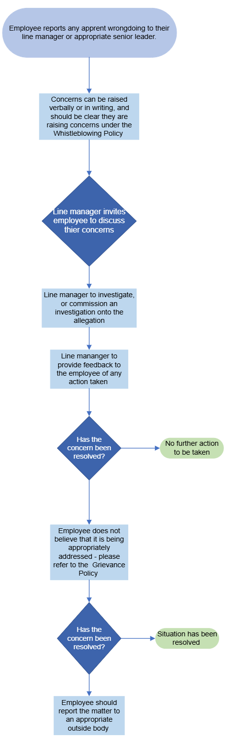
Whistleblowing Flowchart

