Grievance Policy and Procedure

Issue Date: Month Year
Last Review Date: Month Year
Next Review Date: Month Year

Purpose
It is our policy to ensure that all employees have access to a procedure to help deal with any grievance relating to their employment fairly and without unreasonable delay. We aim to investigate any formal grievance raised, hold a meeting to discuss it with the employee, inform the employee in writing of the outcome, and give the employee a right of appeal if they are not satisfied.

We think and hope that our open and honest culture should give employees the confidence to resolve any issues they might have informally - simply making people aware of their concerns is usually enough to resolve any differences.

This policy does not form part of an employee’s contract of employment and the Church/PCC may change this policy from time to time and team members will be notified of any such changes.

Scope
The policy applies to all temporary and permanent employee.

This policy should not be used to complain about dismissal or disciplinary action. If you are dissatisfied with any disciplinary action, you should submit an appeal under the Disciplinary procedure.

Issues that may cause grievance include (but are not limited to):
- Terms and conditions of employment
- Health and safety
- Work relations
- Bullying and harassment
- New working practices
- Work environment
- Organisational change
- Discrimination

This policy should be used in conjunction with the Dignity at Work Policy and Equity, Diversity & Inclusion Policy.

General Principles
Right to be accompanied
Apart from the informal stage, employees will have the right to be accompanied by a work colleague or Trade Union representative to all formal stages of the process. Other third parties, including solicitors, are not permitted as witnesses/representatives/ companions as a grievance hearing is an internal matter. However, if the employee is under 18 years of age, a family member may be permitted as a witness or a companion. The employee must tell the person holding the grievance meeting who the chosen companion is, in good time before the meeting.

No-one has to accept an invitation to act as a companion. If they agree to do so, they will be allowed time off from duties without loss of pay to act as a companion.

If an employee’s chosen companion is unavailable at the time the meeting is scheduled and will not be available for more than 5 working days afterwards, we may ask that you find someone else.

The Church/PCC regards the role of a companion to be a supportive role and to take notes on the employee’s behalf. A companion may address the hearing to put the employee’s case, to sum up the case or to ask questions but not to answer questions on the employee’s behalf. You may talk privately with them at any time during the meeting.

Outsourcing
The Church/PCC reserves the right to outsource appropriate support at any stage of this procedure if it is deemed necessary, including holding, attending and/or facilitating grievances and/or appeals.

Procedure
Please see Appendix A with a flow chart for the Grievance Procedure.

Informal Resolution
The Church/PCC encourages employees to resolve any concerns which arise in the workplace at the earliest opportunity. Employees are encouraged to discuss their concern(s) with their line manager in the first instance. Line managers will attempt to address their concerns appropriately and promptly.

Where a concern has been resolved as a result of such discussions the line manager should confirm their understanding in writing to the employee to ensure that there is a common understanding of the outcome.

The expectation is that where possible the informal route is exhausted before referral to a formal grievance, but we recognise for example if the concern is about the line manager this is not always possible. When raising a formal grievance, the employee should outline the steps that they have taken to resolve the grievance informally to demonstrate that all informal options have been explored prior to raising a formal grievance.

Stage one: Statement of grievance
An employee should formally write to their Line Manager (or the next senior level of management as appropriate if the grievance is about their line manager) setting out the problem and confirm the actions they have taken to date to resolve the situation and stating how they would like the grievance resolved. They should also state that it is a formal grievance. The Church/PCC will investigate the situation, consulting with other employees where appropriate.

Stage two: The meeting
The employee will be invited to attend a meeting with their line manager (or the next senior level of management) to discuss their grievance. The meeting will be arranged as soon as possible on receipt of their grievance statement. A note taker may also be present.

The employee must take all reasonable steps to attend the meeting. If they or their chosen companion is unable to attend the meeting at the time proposed, they should suggest an alternative date and reasonable steps will be taken to rearrange the meeting. However, the alternative date must not be more than 5 working days after the original proposed date.

If required, the line manager may adjourn the meeting to investigate the background facts, or any allegations made.

The Church/PCC will advise the employee when they will get a response if one is not provided at the meeting and write to confirm the decision after the meeting, normally within 10 working days of the meeting. The employee will also be advised that they can appeal against the decision within five working days to the person nominated on the outcome letter.

The line manager will determine the outcome of the grievance. They may reject the grievance or may uphold the whole, or parts of the grievance and indicate what steps have been or should be taken to resolve it.

Stage three: Appeal
If the employee is still dissatisfied with the outcome of the meeting, they have a right to appeal the Church/PCC’s decision. The employee must notify the Church/PCC of their appeal in writing within ten working days of obtaining the written communication of the outcome of Stage Two.

They should send their letter to the PCC Secretary, together with copies of any correspondence that they want a reply on, setting out the grounds of their appeal and how they would like it resolved.

The PCC will then arrange a meeting as soon as practical to discuss the problem and the action taken so far. Again, this will be with a view to reaching an agreement on how the problem can be resolved. Appeals will be considered by a manager, normally more senior, who has had no prior involvement in the case. The employee must take all reasonable steps to attend the meeting.

After the meeting the PCC will write to the employee informing them of the decision.

All decisions arising from the meeting will be final and there is no further right of appeal within the PCC.

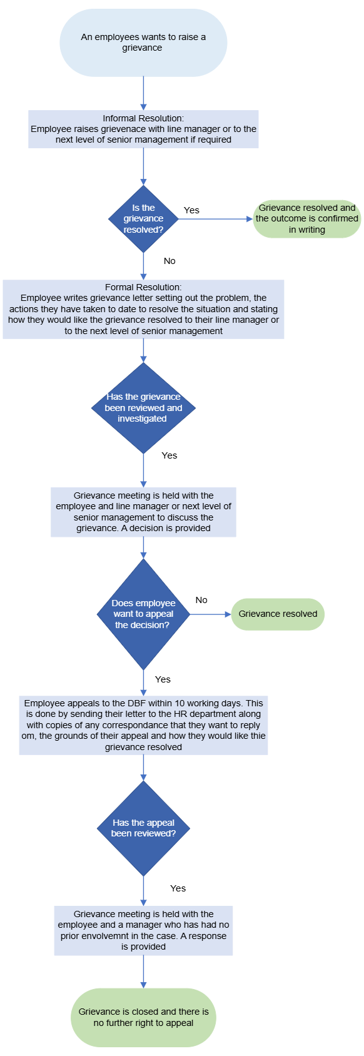Appendix A – Grievance Flowchart

