Dignity at Work (Bullying and Harassment) Policy

Issue: Month Year
Last Review Date: Month Year
Next Review Date: Month Year
Approved by: [insert name] Parochial Church Council (PCC)

Purpose
The church/PCC believes in harmonious working relationships and respecting each other. It is the responsibility of everyone working or interacting with the church to work at and maintain this; bullying and harassment at work (including at work-related events for example work related social events and business trips) will not be tolerated. This policy details what is meant by bullying, harassment and victimisation and what procedure should be followed in the event this happens.

This policy does not form part of an employee’s contract of employment and the church/PCC may change this policy from time to time and you will be notified of any such changes.

Scope
This policy applies to all employee’s; for the avoidance of doubt, all positions detailed below are included:
- Senior Leaders
- Volunteers
- Parish Council
- Congregation
- Employees (Home workers, Permanent, fixed term and temporary, casual seasonal workers)
- Consultants
- Sub-contractors/Freelancers
- Trainees/Apprentices
- Seconded employees
- Third Party employees working on the Parish’s behalf
List as required

All of the listed employees and anyone performing services on or on behalf of, or with, the church must comply with this Policy. Failure to comply to any aspect may result for internal employees in disciplinary action up to and including termination. For external colleagues, the matter would be reported to their employer. For anyone, a criminal offence may be registered.

Third parties are covered later in the policy.

This policy should be used in conjunction with our Equity, Diversity and Inclusion Policy and Grievance Policy.

General Principles
- Everybody has a right to work in an environment which is free from harassment, bullying and victimisation.
- Everybody has the right to have allegations of harassment or bullying investigated, and to be confident that their complaint will be dealt with promptly, sensitively and in strict confidence.
- Nobody will be penalised for making allegations of harassment or bullying, unless these are found to be malicious or deliberately untrue.
- Any instances of victimisation of a colleague for making allegations of harassment or bullying will be dealt with in accordance with the church’s disciplinary policy.

Harassment is described as unwanted conduct, which violates an individual’s dignity or creates an intimidating, hostile, degrading, humiliating or offensive environment. This can be persistent action, or an isolated incident involving one or more individuals. Harassment might include (but is not restricted to) comments, jokes, suggestions, physical contact or violence.

Bullying and harassment will not be condoned at work, or outside work if it is linked to or has a bearing on the working relationship. Harassment and victimisation are unlawful and will not be tolerated.

What is Harassment?
Although it is often referred to separately, harassment is just a form of discrimination involving unwelcome comment, contact or other conduct connected to a person’s:
- Age
- Disability
- Gender reassignment
- Marriage, civil partnership
- Pregnancy and maternity
- Race
- Religion or belief
- Sex
- Sexual orientation
which has the purpose or effect of violating someone’s dignity or creating an intimidating, hostile, degrading, humiliating or offensive environment for that person.

Harassment takes many forms from relatively mild banter, offensive language, to actual physical violence. The following examples are not exhaustive but are provided as a guide:
- Derogatory or persistent remarks, insensitive jokes and pranks – especially involving physical characteristics, lifestyle, disability, colour, faith, personal choices, sexuality etc.
- Substituting menial tasks for responsible ones or vice versa
- Unnecessary bodily contact or physical violence
- Showing pictures or photographs of a sexual or generally offensive nature which offend
- Making unwelcome obscene or offensive remarks, gestures, to/about the recipient
- Assault or touching in an indecent or sexually suggestive manner
- Seeking or demanding sexual favours as a condition of some employment benefit e.g. promotion or a day off
- Withholding necessary information
- Setting unrealistic deadlines
- Public criticism

The church/PCC will take all allegations of sexual harassment seriously and will take all and any reasonable steps to eliminate sexual harassment in our workplace, whether by fellow employee or any third party. If an employee believes or feels they have been sexually harassed, either by a fellow colleague or a third party, we would ask them to raise a grievance using the Grievance Policy to enable us to investigate the matter and deal with appropriately.

See Appendix A – types of harassment.

Everyone is different in their interpretation of ‘harassment’ and what may be acceptable to one person may not be acceptable to another. It is defined by how the person feels and not by what the alleged harasser intended. The critical test is whether the conduct causes distress to the recipient, not whether it might be offensive. Each employee is entitled to be treated in a manner acceptable to them, and all employees have a responsibility to respect the feelings and sensibilities of others.

What is bullying?
Bullying is offensive, intimidating, malicious or insulting behaviour involving the misuse of power that can make a person feel vulnerable, upset, humiliated, undermined or threatened. Power does not always mean being in a position of authority however can include both personal strength and the power to coerce through fear or intimidation.

Bullying can take the form of physical, verbal and non-verbal conduct. Bullying may include, by way of example:
- physical or psychological threats
- overbearing and intimidating levels of supervision
- inappropriate derogatory remarks about someone's performance
- legitimate, reasonable and constructive criticism of a worker's performance or behaviour, or reasonable instructions given to workers in the course of their employment, will not amount to bullying on their own.

The following examples are not exhaustive but are provided as a guide:
- Threatening (including threats of physical violence)
- Persistent non-productive and/or unjustified criticism
- Public criticism and/or condemnation
- Ridicule/demeaning comments
- Public or private humiliation or insults
- Name-calling
- Unreasonable exclusion from professional opportunities or information
- Setting impossible standards, targets, or deadlines
- Continual unjustified undervaluing, fault-finding or revision of work. The work is never quite ‘good enough’
- Unjustifiably removing areas of responsibility and assigning trivial tasks instead
- Unreasonable refusal of reasonable work or leave requests
- Criticising the victim’s appearance, manner of dress, height, weight, etc.
- Personal jokes, giggling, laughing or mocking the victim
- Spreading lies, rumours, gossip, slander, or innuendo
- Ignoring or isolating the person
- Cyber-bullying - Bullying, harassment and victimisation conducted through social media such as blogs or social networking. Examples of cyber-bullying include posting offensive or threatening comments directed at specific people, posting inappropriate photographs, or the posting of sensitive personal information of or about specific people.

Some examples of what does not constitute bullying behaviour and the key differences between fair firm management and bullying can be found at Appendix B.

What is Victimisation?
Victimisation is detrimental treatment and/or retaliation directed towards someone who has made, or is believed to have made or supported, a complaint about discrimination under the Equality Act.

It includes situations where a complaint hasn't yet been made but someone is victimised because it's suspected they might make one.

Third Party Harassment/Bullying
Employees who experience harassment or bullying from third parties (for example, suppliers, visitors, parishioners) should report this to their line manager. The church/PCC will take all reasonable steps to prevent third-party harassment or bullying.

The Responsibility of the Organisation
Whilst church/PCC has overall responsibility for the content of this policy, it is the responsibility of management at all levels to ensure that the policy is effectively applied, and that all employees understand their responsibilities in this respect.

The Responsibility of Line Managers
It is the duty and responsibility of all line managers to: -
- Not harass or bully anyone while at work or condone any other person doing so.
- Make all colleagues aware of the policy, and expected standards of behaviour, and ensure their compliance with both.
- Undertake personal development in handling harassment and bullying in the workplace, as required.
- Treat each allegation of harassment or bullying seriously and sympathetically and with an open mind.
- Maintain confidentiality when dealing with cases and ensure that a written record is kept of all informal and formal meetings and discussions.
- Take steps to eradicate all incidents of harassment or bullying which they become aware of.
- Ensure they do not take detrimental action against colleagues who have alleged harassment or bullying.
- Contact the PCC for assistance in handling all cases of harassment or bullying.
- Be responsible for encouraging and protecting employees who do not want to be identified.
- Provide support for individuals.

The Responsibility of all Employees
Each employee is responsible for their own actions while at work, which includes the responsibility to:
- Not harass or bully anyone while at work or condone/support anybody else doing so.
- Ensure that they treat fellow employees, and others with respect and dignity remembering for example the joke they find funny, others may not.
- Report incidents of harassment or bullying immediately to the line or senior manager.
- Preserve the dignity of those involved in any claim of harassment or bullying maintaining confidentiality. This means that, in all cases, groups and/ or individual colleagues will refrain from open discussions whilst investigations and remedies are being sought.

Support
Anybody who is concerned about harassment or bullying can access support from their own manager or another senior manager.

Support should be offered to both the individual experiencing the harassment or bullying and the employee accused of harassment or bullying.

There are occasions when, despite no formal complaints of harassment and/or bullying being received, there are concerns about relationships in an area. The church and its line managers reserve the right to investigate and address any behaviours which come to their attention, and which are objectively unacceptable to the organisation and its values.

Monitoring and Review of Policy
The impact of the Bullying and Harassment Policy will be reviewed by the Church/PCC every three years or in line with changes to legislation, whichever is sooner.

Incidents of harassment and/or bullying brought to the attention of the [insert as appropriate e.g. Clerk to the Parish Council] will be recorded and monitored to ensure the effectiveness of the policy and consistency and fairness of employment practices.

Data will be analysed and used to identify trends and interventions needed to address any problem areas. Data relating to any cases that have been reported will be shared on an anonymised basis quarterly with the [insert as appropriate e.g. Parish Council].

Procedure

Where a Complaint of Bullying or Harassment is Received and Found
Bullying, harassment and victimisation is regarded as a disciplinary offence, and serious or repeated instances may constitute gross misconduct, which will result in summary dismissal. Less serious offences will be dealt with at an appropriate level within the disciplinary procedure.

Informal Remedy
If bullying or harassment occurs, whether in a work situation or a work-related social event, employees have a responsibility to make it clear to the perpetrator that their behaviour is unacceptable and must stop. This action alone, in less serious situations is often sufficient. If it continues, or the employee concerned does not wish to speak to the offender directly, they should seek advice from their line manager.

The line manager will discuss the situation with the complainant. Then, with the complainant, speak to the harasser and.
- ask them to stop the behaviour
- explain the impact of their behaviour
- advise that their behaviour is contrary to the organisation’s bullying and harassment policy
- confirm the required standard of behaviour expected of employee
- advise the likely consequences of continuing the bullying or harassment
- explain that the situation will be monitored and that the discussion being held is informal and confidential

Formal Procedure
- If an informal resolution is not appropriate, or is unsuccessful, the employee should make a formal written complaint under the Grievance Procedure, outlining the nature of their complaint, to their immediate line manager.
2. In this instance the Church/PCC will protect the employee against any attempt at victimisation or intimidation by other colleagues or management.
3. Complaints will be fully, promptly and sensitively investigated, and all parties will be interviewed before any decision is taken. A work colleague or a Trade Union representative may support the employee during these interviews. (See grievance procedure)
4. The investigation will be conducted by the manager who is responsible for hearing the first formal stage of grievance under the church’s grievance procedure. If this arrangement is unsuitable, an alternative manager (unconnected with the case) will be appointed. The Grievance Procedure will be used as the procedure to deal with any/all complaints of harassment.
5. Depending on the seriousness of the allegation, the alleged offender may be suspended on pay pending completion of the investigation and disciplinary procedures.
6. Where bullying or harassment is clearly established, disciplinary proceedings will be initiated within the church's procedure. (See disciplinary procedure)
7. If bullying or harassment is proved and the penalty is not dismissal e.g. written warning, but the victim and the offender would otherwise be required to work together, then, the organisation may separate the individuals (with any inconvenience being suffered by the offender) to avoid any recurrence or victimisation.
8. If neither separation nor continued working together is possible, the offender's employment may be terminated, in accordance with their contract.
- Any complaint(s) found to be false and malicious may result in disciplinary action being taken
against the complainant.

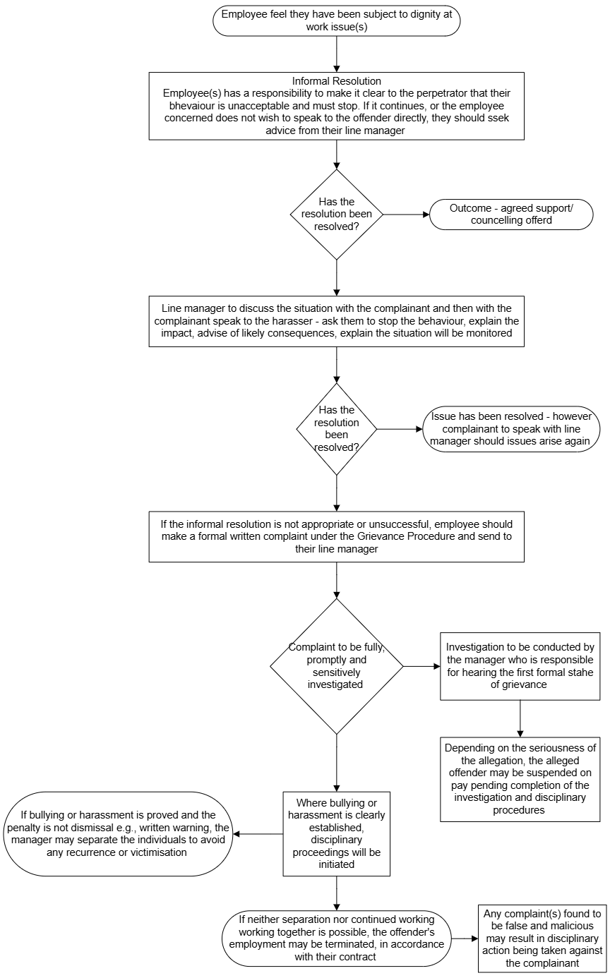Dignity at Work Flowchart

Appendix A

Types of Harassment

Racial Harassment may be any hostile or offensive act or expression by a person of one racial origin against a person of another, or incitement to commit such an act. Such behaviour includes derogatory name-calling, insults and racist jokes, racist graffiti, verbal abuse and threats, physical attack, and ridicule of an individual for cultural differences. Racial harassment occurs when any such behaviour creates an intimidating, hostile or offensive environment for employment, study or for social life. Differences of attitude or culture and the misinterpretation of social signals can mean that what is perceived as racial harassment by one person may not seem so to another. The important feature, however, is that the behaviour is offensive or intimidating to the recipient.
Sexual Harassment is unwanted conduct of a sexual nature. Sexual harassment occurs when any such behaviour creates an intimidating, hostile or offensive environment for employment, study or social life. Any behaviour that makes the recipient feel viewed as a sexual object may cause offence, even if the offence is not intended. Differences of attitude, culture and the misinterpretation of social signals can mean that what is perceived as sexual harassment by one person may not seem so to another. The important feature, however, is that the behaviour is offensive or intimidating to the recipient.

NB Harassment may also occur where:

- There is unwanted conduct of a sexual nature which is related to gender reassignment or sex.
- Someone is treated less favourably because they have either submitted to or rejected sexual harassment, or harassment related to sex or gender reassignment.

Disability Harassment may be behaviour against an individual or group on the grounds of disability, impairment or special need and which is offensive, patronising, or objectionable to the recipient or others; it creates an intimidating, hostile or offensive environment.
Harassment on the grounds of sexual orientation - homophobic harassment of individuals who are, or assumed to be lesbian, gay, bisexual, or transsexual is any behaviour pertaining to sexual orientation, directed at an individual or group; it is offensive or objectionable to the recipient or others, which creates an intimidating, hostile or offensive environment. It includes name-calling, stereotyping, assault, verbal abuse, derogatory comments or intrusive questioning about a person’s domestic circumstances.

Harassment on the grounds of age - the Employment Equality (Age) Regulations 2006 give protection against discrimination and harassment on the grounds of age. Harassment may be intentional or unintentional bullying. It may involve nicknames, teasing, name calling or other behaviour which is not with malicious intent but which is upsetting. For example, it may be about someone’s age or about the age of those with whom the individual associates. It may not be targeted at an individual(s) but consist of a general culture which, for instance, appears to tolerate the telling of ageist jokes.

Harassment on the grounds of Religion or Belief – may be defined as direct or indirect discrimination or behaviour, victimisation and harassment against an individual or group regarding any religion, religious belief or similar philosophical belief.

Appendix B

What is not Bullying?
Sometimes behaviours and actions which cause us to feel distressed are not examples of bullying, even though they are unpleasant and often require some action by an employer or line manager.

There are some common situations that can be confused with bullying:

Reasonable management action
It is important to differentiate between bullying and an employer’s legitimate authority to direct and control the way work is done. It is reasonable for employers to allocate work, and for line managers and supervisors to give fair and reasonable feedback on an employee’s performance.
This can include setting performance goals and deadlines, allocating work, deciding, on objective grounds, not to select a worker for a promotion or informing a worker about unsatisfactory work performance or inappropriate behaviour.

Examples of reasonable management action
(a) Mira works with six other people in a busy office. She regularly falls behind in her work. To help her to develop her administrative and time management skills and to improve her performance, Mira’s manager asks her to attend a two-day training course. Mira feels embarrassed and singled out even though her manager assures her that her job is not under threat.
(b) Tony works a fixed shift pattern. Recently his employer decided to implement rotating shifts for all colleagues and carried out a consultation, followed by notice, to implement this. Tony told his supervisor that he wanted to stay with the shift pattern he had previously worked but was advised that this was no longer an option and that he would need to move to the rotating shift pattern, along with everyone else. Tony is unhappy and feels hard done by.

Conflict at work
People are bound to have occasional differences of opinion, and these are a normal part of working life. Disagreements can leave people feeling upset, but they should not be confused with bullying behaviour. However, these should not be ignored - if left unresolved, conflict may escalate and/or develop into a bullying situation.

Single acts
If a person is subject to a single incident of unreasonable behaviour, it’s unlikely to be considered to be bullying. However, the incident shouldn’t be ignored as it may have the potential to escalate into bullying. Addressing the behaviour before it is repeated is the best way to manage the situation.

Other situations
Just as there are a broad range of behaviours that can be bullying, there are many that won’t be. For example, being abrupt with someone once, because you’re busy or not inviting someone to a non-work related social event.

Example
Paula approached her manager, Fiona, to complain about a situation where she thought she’d been bullied. Fiona asked Paula to tell her what had happened. Paula had been sitting in the lunch room when a work group (not her own) had been celebrating a colleague’s birthday. Paula was offended at not being asked to join the group and have some cake. Fiona explained that the group’s behaviour was not unreasonable and confirmed that this was not repeated behavior. Therefore, Fiona advised that this was not a bullying act.
What is the difference between fair, firm management and bullying?
The differences between a manager who is firm and fair and a line manager who is bullying and harassing colleagues can sometimes seem ambiguous. The table below, offers examples of the types of behaviour which distinguish both styles:

Firm and fair management | Bullying or harassment of colleagues
Consistent and fair | Aggressive, inconsistent and unfair
Determined to achieve the best results but is reasonable and flexible | Determined to achieve the best results but unreasonable and inflexible
Knows their own mind and is clear about their own ideas, but is willing to consult with colleagues before drawing up proposals | Believes that they are always right, has fixed opinions, believes they know best and not prepared to value other people’s opinions
Insists on high standards of service in quality of and behaviour in the team | Insists on high standards of service and behaviour, but blames others if things go wrong
Will discuss in private any perceived deterioration before forming views or taking action and does not apportion blame to others when things go wrong | Loses temper, degrades people in front of others, threatens official warnings without listening to any explanation
Asks for people’s views, listens and assimilates feedback | Tells people what is happening, does not listen
Shares credit appropriately. | Plagiarises, takes credit for other people’s work/ideas.
Respectful and considerate | Disrespectful and inconsiderate
Demonstrably values others and their contributions. | Devalues or ignores the contribution of others.

