******What is community audit and mapping?**

A community audit is researchthat helps you to understand your community better by gathering detailed information about it. Mapping is finding out what assets, facilities and provision are available in the community, where they are and who accesses them.

The purpose of carrying out this research is to help you explore what opportunities there might be to develop community engagement and to increase or diversify use of your church building as a community asset.

The information will help you explore things like:

* Who already has connections with your church and who doesn’t
* How to share information with and consult the community
* What community facilities and provision are available
* What organisations/groups there are who might be project supporters, partners, user-groups
* Who are the community leaders and how are things run
* Community needs and opportunities

Research like this is also an important building block for grant applications for projects such as to reorder your church building. The DAC and funding bodies will want to see evidence of how proposed use and/or development of the building will benefit the community by addressing an existing need or opportunity.

**Audit & mapping activity**

There are different ways to carry out a community audit depending on what you want to find out. In terms of developing engagement in and use of your church building, there are three aspects you can look at:

1. **Who is the community? How do people come together?**

A simple starting point is with facts about the community. You can start by looking at the profile of the population by age, ethnicity etc. Next, is to understand how the population is brought or comes together in groups, forming smaller communities.

1. **What is life like in the community?**

This involves gathering insights into community identity and wellbeing. Data sources can give an indication of positive and negative aspects of an area, as well as levels of deprivation. Local government plans will often set out things that need to be addressed or developed. Digging deeper you can ask different people or groups about what their views on the area, as well as the story of the community and its development.

1. **Who and what is there for the community?**

In order to develop engagement and use of the church building effectively and appropriately you need to know what facilities and provision already exists.

**Who is the community?**

**A. Demographics – who lives in the parish?**

Demographics are statistics that describe populations and their characteristics. Governments, businesses and non-government organisations use demographics to learn more about a population for a variety of purposes; for example, to make better policy decisions, to build a customer-base profile or to determine the best way to reach people through marketing.

Churches can use demographic information in similar ways, such as when considering priorities for activity or how to communicate most effectively with different people in the parish. Crucially, understanding the demographics of your community will help you think about how to be as inclusive as possible and strive to listen and talk to diverse people and groups.



**ACTION: Gather demographic information**

[The Church of England Interactive Parish Map](https://www.churchofengland.org/about/data-services) is a tool which gives you census and deprivation data for your parish. Click [here](https://www.churchofengland.org/sites/default/files/2024-05/parishmapsarcgis_userguide_april2024.pdf) for step by step instructions on how to use the tool.

[The Office for National Statistics census data](https://www.ons.gov.uk/) is a valuable source of very detailed information about the people who live in your parish. It covers many aspects of people’s lives in the following categories: demographic, economy, education and skills, health and wellbeing and housing.

You can explore census data using an [interactive map](https://www.ons.gov.uk/census/maps/) or by [building a custom profile](https://explore-local-statistics.beta.ons.gov.uk/). To do this, click on Explore Local Statistics and search your postcode. When you have the page for your area, scroll down and click Custom Profiles. The column on the left is a list of 38 characteristics of your local population. You can explore the data for each of these by selecting the ones you want to see, thus building your own custom profile.

**B. Community groupings – how do people connect and come together?**

Most parishes will be made up of smaller *communities*, people who come together, or who are linked by, things like geography, through an organisation, a common denominator or a special interest.

For example:

* Residential: different parts of the parish might have residential areas with a distinct identity or characteristics. They might have neighbourhood groups or a Facebook page.
* Education: there might be one or more school communities in the parish and a home-school group or network
* Economic: such a farming and/or a business community, and possibly a tourist ‘community’
* Leisure, health and social: clubs and societies for sport, hobbies, the arts, wellbeing
* Charity/action/support: don’t forget the worshipping communities, as well as other charity/ action/support groups
* Age-related: for example, groups for parents with young children or older people

These groups can be facilitated by committees, meetings, networks and communication channels. They will be able to tell you what is going well for them, as well as what needs they have or how they plan to develop.



**ACTION: Identify and summarise smaller ‘communities’**

As well as identifying the different groups and organisations in the parish, it can be helpful to note a few key facts and observations about them, covering who, what, where, when – as far as this is manageable. For example:

* 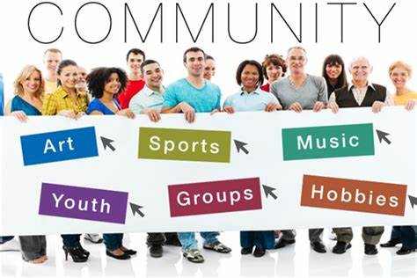For the school, how many classes per year? Where do children travel from to attend school? When do they come to the church & why? Who are they key contacts? Is there an active PTA/PSA?
* What sorts of businesses are there and where are they? Who are the people running them and using them? What are the issues or talking points? Is there a business forum?

This is why it is useful to identify these groupings and organisations. First you can see which groups the church already engages or has connections with, and who might be engaged in the future. Second, it breaks down ‘the community’ into more manageable sections which you can prioritise, build relationships with and consult etc. And it is a good way to explore potential needs and opportunities that might relate to your church.

**A question of priorities…**

Identifying the groups does not mean you have to engage and consult with them all. That might simply not be possible depending on the size of the parish. You will need to prioritise who and when you engage with people depending on the needs of your church and project. But this research is a way of being open to new engagement possibilities and to consider how to be more inclusive.

**What is life like in the community?**

**A. Positives and negatives**

You can ask the different people and groups you have identified about what is good about your community and what could be developed through community conversations and consultation. However, data and statistics can give an overview of the strengths and weaknesses of the area, and local and regional government, as well as other agencies, will have local plans to improve life in the community.



**ACTION: Explore the big picture**

[The Co-op Wellbeing Index](https://communitywellbeing.coop.co.uk/) is a tool where you can put in a postcode and find out what are the strengths and weaknesses are of that area based on a wide range of data sources. What is helpful about this tool is that the extensive number of categories give a broader picture of life. For example, an area might score low for Economy, Work and Employment, and be described as deprived, but might be high on Equality or Relationships and Trust.

You can also look up parish information around deprivation on the [Church Urban Fund Look-up Tool](https://cuf.org.uk/parish/340188)

Find out what local neighbourhood plans exist for your area. These are usually drawn up by, for example, the Parish, Town, City and County Councils, but they can be developed by a neighbourhood forum or community organisation. As you look through the plans, try to pick out what are the priorities and projects. The next step is consider how your church might support these, especially by additional use of the building.

[Grab your reader’s attention with a great quote from the document or use this space to emphasise a key point. To place this text box anywhere on the page, just drag it.]

**B. Community identity and cohesion**

There isn’t a single definition of community cohesion, but it is a concept that involves inclusion, respect and building good relations between different part of the community. This is seen as important as cohesive communities are regarded as healthier and more resilient to change, with people offering mutual support and showing kindness to each other. A phrase that was adopted to describe this positivity is abundant communities.

There are many suggested measures to assess community cohesion which are used by researchers. For your project you will most likely need a general sense of community cohesion in your area.



**ACTION: Think, discuss, research**

**Community history**: How has the present community been shaped by its past and changes over time — social, political, demographic, and otherwise? How has this story affected community cohesion?

**Physical layout**: What are the focal points of the community? Are they the same for everyone? Where do different sections of the community come together? Does infrastructure/development cut sections of the community off from each other or isolate parts from the rest?

**Community events**: What events or activities bring the community together? Who is working to bring your community together and how?

**Your church**: how does your church fit into the above considerations?

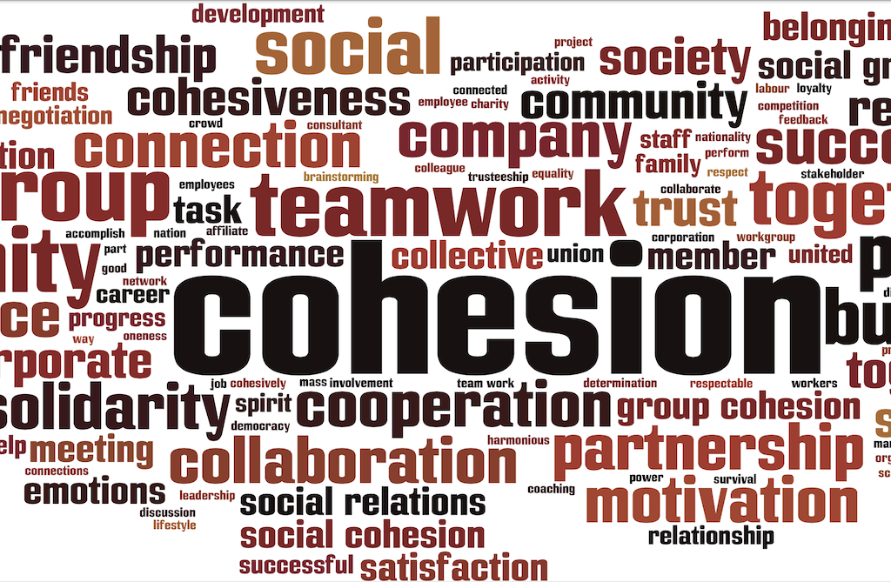

**C. Institutions**

Developing or maintaining good relationships with local government bodies and agencies working in your community are vital. The benefits can range from these being a source of general support and information, through to potential partnerships and grants.

There will be statutory and non-statutory organisations to be aware of at a *local and regional level* – for example the Parish Council and also the County Council.



**ACTION: Think and research**

Make a list of the local government bodies and non-government agencies working in your area. Find out who are the key contacts for each organisation and what their jobs are. Are there people in post whose role is particularly relevant to your project, for example, a tourism or community engagement officer?

Examples:

Parish, Town, City, County Councils – for the larger of these, who are the key contacts in different departments?

Local Enterprise Partnerships

Business Improvement District

Community development groups

Community Action Network

Tourism organisations – Visit West, Wiltshire, Dorset, as well as more local initiatives

Organisations dealing with a specific issue such as mental health, homelessness, drugs etc

**D. Communications**

You need to know how news and information is shared among residents and organisations. This is important to keep up to date but also for you to share news and communicate with people.



**ACTION: Think and research**

Find out as many as you can of the different sources of communication and get a sense of who and how many people they reach: meetings, paper/e-newsletters, newspapers, notice boards, leaflets/advertising, radio, social media.

**Mapping community facilities and services**

To develop your church as a community asset, it’s important to know what other facilities and services are available in the community.

Facilities refers to buildings and land used for the well-being or social interest of the local community, such as community halls, parks, leisure centres and libraries.

Services covers things that support day-to-day life of the general public such as public transport, pubs and cafes, shops, a post-office, a doctor’s surgery etc.



**ACTION: Think, research, assess**

List the facilities and services in the parish. It can be helpful to study a map and mark on it where things are in relation to the church if this is practical.

Look at existing community spaces and find out how well-used they are, and which groups they host. If other churches have halls or bookable spaces, what goes on there? If applicable, this might also be a good time to see how much venues charge for use of the space.

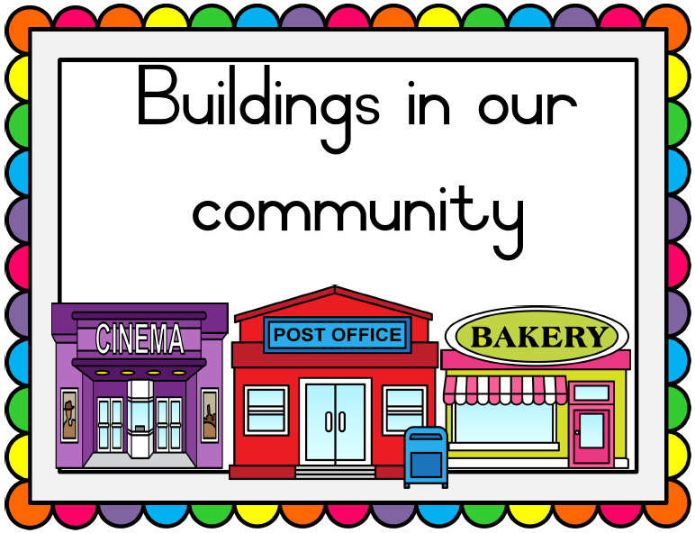

Next assess or evaluate the provision of facilities and services in your community. Is your community ‘asset rich’ with lots of facilities and services or is the opposite true?

Are there any obvious gaps in expected facilities / services for your type of community?

How far do people have to travel to access these facilities and services? Is this an issue?

Think about different age groups and people in the community with additional needs. Are there facilities and services for parents with young children, teenagers, older people, carers, people with disabilities?

Finally, consider if there are any facilities or services that would improve life in the parish, by making it easier or more enjoyable.