The walk begins at St Mary’s Church, Purton (SN5 4EB) and ends at Malmesbury Abbey (SN16 0AA). The first abbey was founded by St Aldhelm in the 7th century, and the current 12th century building is the third abbey to stand on this site.

The first half of the route is along footpaths and bridleways to Ravensroost Wood, which is a good place for a picnic lunch. The second half is mainly on quiet country roads, following the North Wessex Way (the historic route between Oxford and Bristol) through Garsdon and Milbourne, before walking through the historic town of Malmesbury to arrive at the Abbey.

Distance: 14 miles
Duration: 6 hours, not including breaks (depending on the ground conditions, as the bridleways can be very muddy at certain times of the year)
Level of difficulty: Easy, but long
Maps: Ordnance Survey Explorer 168, 169
Car parking: limited on street parking at Purton Church, long stay parking in Malmesbury at Station Road Car Park (SN16 9QY)
Public transport: see www.connectingwiltshire.co.uk/
Refreshments: cafés and pubs in Purton and Malmesbury, Malmesbury Abbey café. No amenities along the route, except for some benches in Ravensroost Nature Reserve.
Toilets: Purton Church, Garsdon Church (when open), Malmesbury Abbey, Malmesbury Town Hall.
Suggested websites:
St Mary’s Church, Purton www.stmaryspurton.org.uk/
Ravensroost Wood www.wiltshirewildlife.org/ravensroost
Garsdon Church www.woodbridgegroup.co.uk/garsdon/
North Wessex Way www.northwessexway.co.uk/
Malmesbury Abbey www.malmesburyabbey.com/

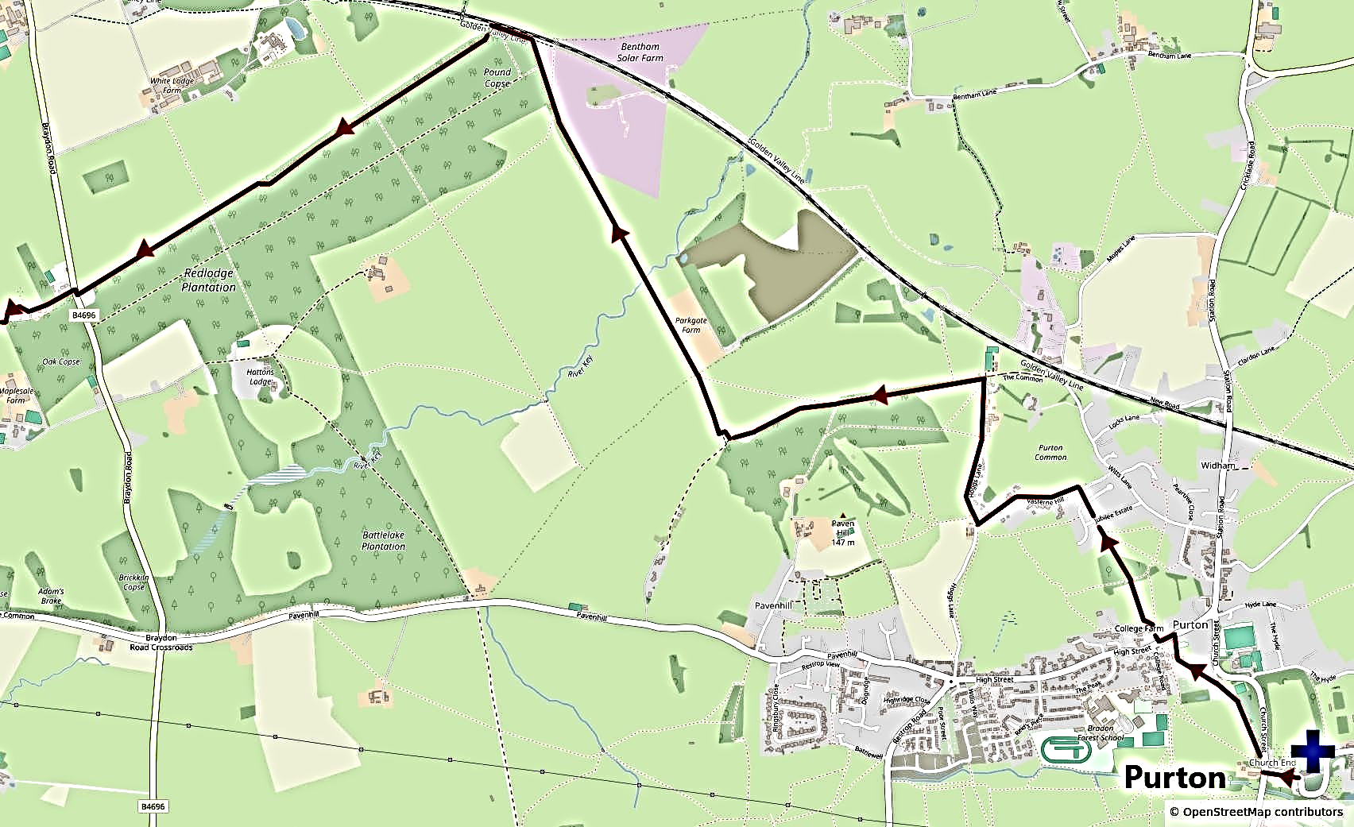
Purton
The current St Mary’s Church, Purton, was built between the 13th and 15th centuries, although it is likely that Christian worship has been celebrated on the site since Saxon times. The church formed part of the endowments of Malmesbury Abbey and is one of only three churches in England to have a western tower and a central spire.
Directions:
- Leaving St Mary’s Church, Purton, turn right along the road to the T-junction, with the large tithe barn on the right-hand corner.
- Cross the road with care and take the footpath on the opposite side, signposted to the cemetery.
- Follow the paved footpath alongside the cemetery. Where the path meets a road, continue along Church Path to reach Play Close, with Purton Methodist Church on the right-hand side.
- Walk down Play Close to the main road and turn left along the pavement. (Take care, as this is a busy road.)
- When you reach Purton Veterinary Surgery on the left, cross the road with care and follow the footpath signed on the opposite side.
- Walk into the field through a chain gate and, when the footpath splits, take the left-hand path, crossing over a stile
- Walk down through the field to the right-hand corner and cross over the stile and footbridge. Continue straight ahead over another footbridge and follow the path between the houses.
- Cross two roads and turn left at the T-junction along a tarmac lane.
- Follow the lane past Malthouse Farm on the right. At the T-junction, with High Hills Farm in front of you, turn right along the track. This is Hoggs Lane.
- At the next T-junction, turn left along the bridleway, via the gate or stile.
- Continue along the bridleway through woodland, passing through another gate, and then straight ahead to the right of the field edge.
- At the end of the field, turn right and then left through a wooden farm gate.
- Turn right immediately and follow this bridleway to the left of the hedge line.
- Continue along this bridleway in a straight line for around a mile. This passes through a gateway, over a bridge, through a field with a solar farm on the right, through another gateway and then through woodland, until you reach the railway line running parallel with the bridleway on the right-hand side.
- Just before the end of the woodland on the left-hand side, take the bridleway to the left which runs close to, and parallel with, the field. (This path is just before a wooden electricity pole in the field. If you pass this, or reach a bridge on the right over the railway line, then you have gone too far.)
- Continue along this bridleway, keeping parallel with the field edge, for around a mile, until you reach the B4696 road.
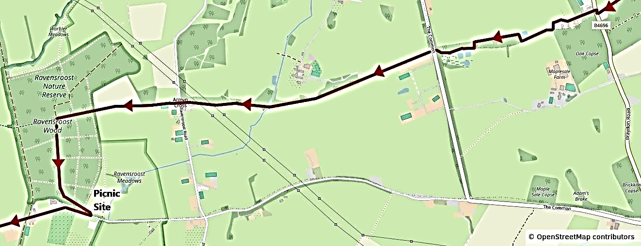
- Turn right along the roadside verge for a few yards, and cross over to the driveway of Gospel Oak Farm. (Take great care here, as there is poor visibility and very fast traffic.)
- Walk up the driveway and through the electric gate (opened via a push button). Continue along the drive and take the footpath to the right of the house, walking around the house following the fence line.
- When you reach the left-hand corner of the field, walk down the hill following the hedge line to reach the pond on your right. Turn right after the pond and then go left through the gates.
- Walk through the field, keeping the woodland on your left, until you reach a gate on the left. Go through the gate and after a few yards follow the bridleway on the right through the woods to reach a road.
- Cross the road with care and follow the bridleway ahead for around a mile to reach another road at Armyn Cross.
- Cross the road with care and follow the bridleway, which leads into Ravensroost Wood. After a few hundred yards, turn left along a wide gravel track. (If you reach the end of the woods, then you have gone too far.)
- Follow this track to the left, passing a wooden Shooting Lodge, to arrive at the Nature Reserve car park, where there is a small picnic area. If it is wet, the Shooting Lodge could also be used for lunch, although there are bees’ nests nearby.
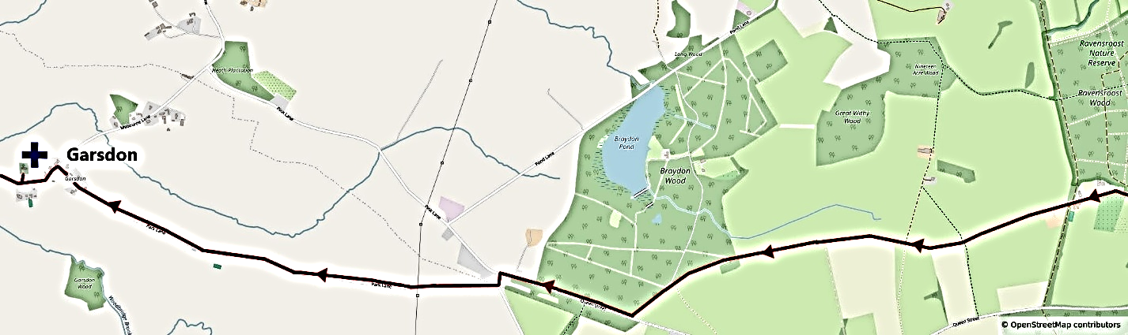
- From the car park, follow the road to the right for around 1.5 miles, to reach a T-junction, with Braydon Wood on the right-hand side.
- Turn right along the road and, at the next road junction, turn left and almost immediately right. Follow this road for around 1.5 miles to a T-junction.
- Turn left and, after a few hundred yards, the driveway to Garsdon Church is on the right-hand side. The church is a good place for a refreshment stop, with a bench outside and a toilet inside (when the church is open). The writer and philosopher Roger Scruton, who died in 2020, is buried on the west side of the churchyard.
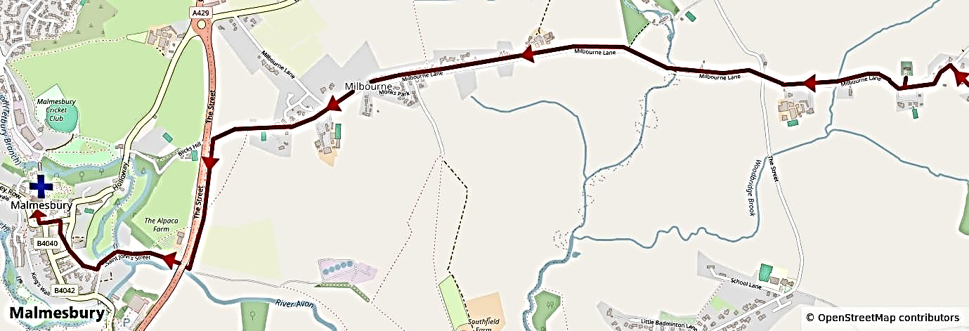
- On leaving Garsdon Church, turn right (with care) at the end of the drive and follow the road to a 4-way junction. Follow the road ahead to reach the village of Milbourne after around half of a mile.
- Follow the road through the village until the road bends around to the right. Instead, follow the road ahead which become a tarmac track.
- Just before the track reaches the A429 main road, take the track on the left which leads downhill at the right of the field. (This track runs parallel with the A429 road.)
- At the bottom of the hill, turn right at the T-junction and follow the track under the A429 road bridge, after which the track becomes a road. Follow the road past the Bowls Club on the right and over a river bridge.
- Continue along the road until you see steps on the right-hand side going up the hill. This is Back Hill. Walk up the steps and follow the road past the disused Ebenezer Chapel on the left-hand side to reach Cross Hayes car park.
- Cross to the opposite side of the car park and along Market Lane at the left-hand side of the Town Hall to reach Oxford Street.
- Cross the street with care and turn left along the pavement to reach the Market Cross.
- Turn right, walk through the abbey gatehouse and follow the churchyard path to arrive at Malmesbury Abbey.

Malmesbury
The site of an Iron Age fort and later an Anglo-Saxon monastery which became a celebrated centre of learning, Malmesbury is reputed to be the oldest Borough in England with a charter dating back to 880. It became one of Alfred the Great’s chain of defensive ‘burghs’, designed to deter Viking attacks. The Domesday Book lists Malmesbury first, indicating it was the most important town in Wiltshire at the end of the Anglo-Saxon period. Aldhelm, the son of a West Saxon king and a pupil of an Irish monk, Maildubh, after whom Malmesbury is named, became the first Abbot of Malmesbury Abbey in 675. His remarkable career made him a hero for Athelstan, the first King of England (died 939), who chose to be buried at Malmesbury Abbey. Malmesbury has a packed subsequent history. It was the place of the first human flight, (by a monk named Eilmer in 1010), the birthplace of the leading political philosopher, Thomas Hobbes of Malmesbury, in 1588, changed hands six times in the English Civil War, experienced continuing allegations and prosecution of witchcraft in the 17th century, and was the scene of the death of Hannah Tywnnoy, the first person killed by a Tiger in England, in 1703. It is a beautiful hilltop town with a thriving high street, remarkable Norman Abbey (part living church, part ruin) and a great choice of cafes, restaurants, pubs and places to stay.

Times and Distances (from St Mary’s Church, Purton)
Ravensroost Wood Nature Reserve | 7 miles | 3 hours
All Saints Church, Garsdon | 11 miles | 4 hours 45 minutes
Malmesbury Abbey | 14 miles | 6 hours

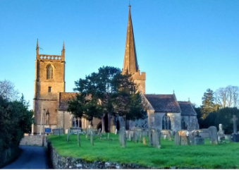  St Mary’s Church, Purton | 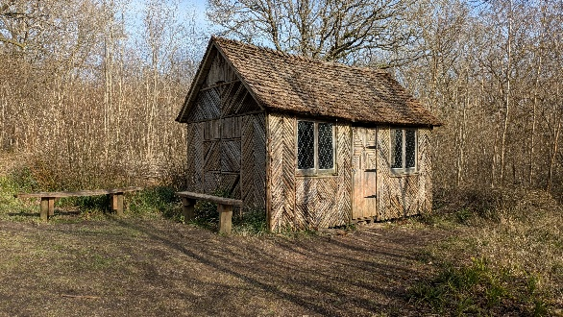  Ravensroost Wood
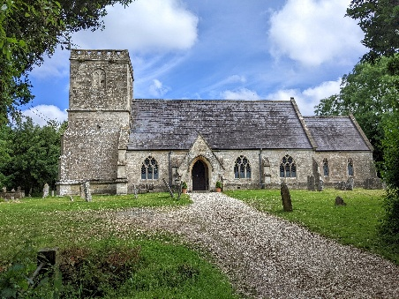  Garsdon Church | 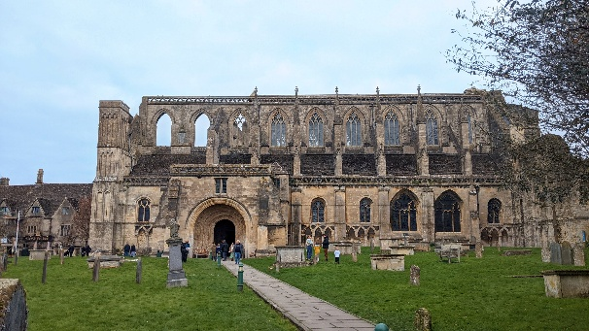  Malmesbury Abbey

