“Come away with me by yourselves to a quiet place and get some rest.” Mark 6.31
How to use this guide:
Choose how long you want to spend – an hour, a morning, a day. If you are going for a longer period think about whether you want to take lunch or buy it, or if you want to fast. Take plenty to drink and perhaps a rug to sit on. If you wish you could take some paper, pens, pencils or paints. Make sure someone knows where you are going.

A day in the wilderness
- Decide in advance where you want to go – whether it is a local park or further afield. Remember this is your day and your time so choose somewhere that speaks to you. Decide whether you want your day to be a silent retreat, or to spend it with a friend.

- Before you go read 1 Kings 19.11-13 and spend some time in quiet reflection on how Elijah heard God and in silence ask the God who loves you to speak to you through the day.

- When you arrive at your chosen location begin by reading Psalm 46.10 – ‘Be still and know that I am God.’ You might want to use the Breath prayers modelled in the February resources as a way of entering silence. Spend some time sitting and observing all that is around you, asking God to speak and listening for his voice. When you are ready, consider writing down or drawing a picture to remind you of what you are hearing from Him.

- Read Psalm 19.1-4. Take a quiet walk through your surroundings – walk slowly, observing the world around you. As you walk think about your life, what you are carrying – physically, emotionally, spiritually. Is there anything you need to lay down or let go? What might God be calling you to surrender?

- In the afternoon, begin by reading John 10.1-4. Read the passage slowly and carefully. Note anything that speaks to you; anything that puzzles you; anything that is new.

- Spend some time offering what you have heard during your day to God. You could use the things around you in nature to create some simple art as an act of worship and praise to the God who loves you. Use your mobile phone to take pictures if you prefer.

- Finally, spend a bit of time giving thanks to God. If you like listening to worship songs or playing an instrument, you might find that helpful.

- End your day in prayer for others and the world to which you will return.

- When you get home, why not write a letter to yourself from God’s perspective reminding you of the day and of his care for you.

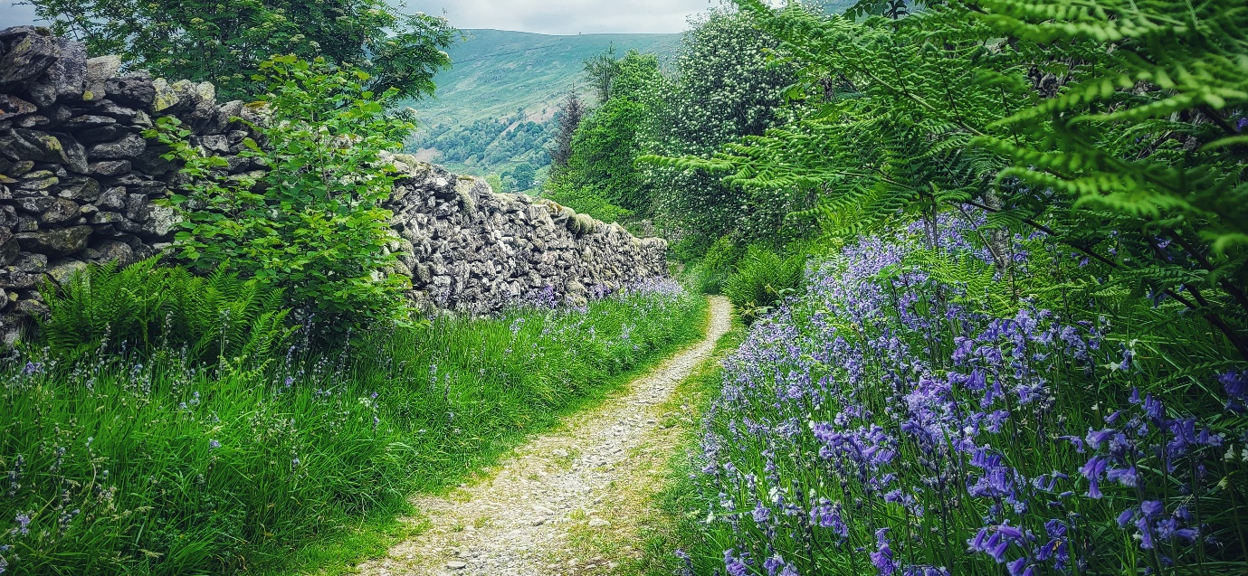

Please use this framework creatively and do choose your own readings if that is more helpful or as it becomes a regular practice.

