See our [Eventbrite page](https://gbr01.safelinks.protection.outlook.com/?url=https%3A%2F%2Fwww.eventbrite.co.uk%2Fo%2Fbristol-schools-connection-16793571838&data=05%7C02%7CAli.Driver%40bristoldiocese.org%7C696c107cc1fc4549dc7308ddfce13c3a%7C6ee494c620c74aec9e32abba30f4059d%7C0%7C0%7C638944766869726105%7CUnknown%7CTWFpbGZsb3d8eyJFbXB0eU1hcGkiOnRydWUsIlYiOiIwLjAuMDAwMCIsIlAiOiJXaW4zMiIsIkFOIjoiTWFpbCIsIldUIjoyfQ%3D%3D%7C0%7C%7C%7C&sdata=m872iev6e0GM%2FlQzQ6smCT%2BlegAc9UPFY9BBSh3kmcA%3D&reserved=0) for the list of training events and to book your place. Summary of events below:

* **Wednesday 1st Oct 1pm – 2.30pm**   
  Connecting with your local school. A session to think through how to connect and deepen your connection (as church) with your local school(s).
* **Wednesday 8th Oct 7.30pm – 8.45pm**   
  Christmas in a Box Training. Click [here](https://gbr01.safelinks.protection.outlook.com/?url=https%3A%2F%2Fwww.bristolschoolsconnection.co.uk%2Fchristmas-in-a-box%2F&data=05%7C02%7CAli.Driver%40bristoldiocese.org%7C696c107cc1fc4549dc7308ddfce13c3a%7C6ee494c620c74aec9e32abba30f4059d%7C0%7C0%7C638944766869740555%7CUnknown%7CTWFpbGZsb3d8eyJFbXB0eU1hcGkiOnRydWUsIlYiOiIwLjAuMDAwMCIsIlAiOiJXaW4zMiIsIkFOIjoiTWFpbCIsIldUIjoyfQ%3D%3D%7C0%7C%7C%7C&sdata=y9lFSTtTWn3C%2Fn5urKrXQuMZjCpYru454S4ZLAuwViA%3D&reserved=0) for more information about this resource.
* **Monday 20th Oct 10am – 11.15am**   
  Christmas in a Box Training.
* **Monday 10th November 7.30pm – 8.45pm** w  
  Praying for your local school.
* **Wednesday 21st January 10am – 11.15am**    
  Jesus Out of the Box Training.   
  Click [here](https://gbr01.safelinks.protection.outlook.com/?url=https%3A%2F%2Fwww.bristolschoolsconnection.co.uk%2Fjesus-out-of-the-box%2F&data=05%7C02%7CAli.Driver%40bristoldiocese.org%7C696c107cc1fc4549dc7308ddfce13c3a%7C6ee494c620c74aec9e32abba30f4059d%7C0%7C0%7C638944766869759970%7CUnknown%7CTWFpbGZsb3d8eyJFbXB0eU1hcGkiOnRydWUsIlYiOiIwLjAuMDAwMCIsIlAiOiJXaW4zMiIsIkFOIjoiTWFpbCIsIldUIjoyfQ%3D%3D%7C0%7C%7C%7C&sdata=aOuRc7FvtqfbxMN11%2BA%2FneVWijDX%2Bi9KISe9AokonXY%3D&reserved=0) for more information about this resource.
* **Wednesday 28th January 7.30pm – 8.45pm**   
   ‘Easter in a Box – The Movie’ Training.   
  Click [here](https://gbr01.safelinks.protection.outlook.com/?url=https%3A%2F%2Fwww.bristolschoolsconnection.co.uk%2Feaster-in-a-box%2F&data=05%7C02%7CAli.Driver%40bristoldiocese.org%7C696c107cc1fc4549dc7308ddfce13c3a%7C6ee494c620c74aec9e32abba30f4059d%7C0%7C0%7C638944766869781090%7CUnknown%7CTWFpbGZsb3d8eyJFbXB0eU1hcGkiOnRydWUsIlYiOiIwLjAuMDAwMCIsIlAiOiJXaW4zMiIsIkFOIjoiTWFpbCIsIldUIjoyfQ%3D%3D%7C0%7C%7C%7C&sdata=cKEzaa6Zfta5OHLFyvtYk1EfV5P7nedQDKvMWctOODU%3D&reserved=0) for more information about this resource.
* **Monday 2nd February 1pm – 2.15pm**    
  ‘Easter in a Box – The Movie’ Training.
* **Tuesday 21st April 1pm – 2.15pm**   
  Praying for your local school.
* **Wednesday 6th May 7.30pm – 8.45pm**  
  Connecting with your local school.
* **Wednesday 3rd June 7.30pm – 8.45pm**   
  Jesus Out of the Box Training.

[Click here to book your place](https://gbr01.safelinks.protection.outlook.com/?url=https%3A%2F%2Fwww.eventbrite.co.uk%2Fo%2Fbristol-schools-connection-16793571838&data=05%7C02%7CAli.Driver%40bristoldiocese.org%7C696c107cc1fc4549dc7308ddfce13c3a%7C6ee494c620c74aec9e32abba30f4059d%7C0%7C0%7C638944766869802965%7CUnknown%7CTWFpbGZsb3d8eyJFbXB0eU1hcGkiOnRydWUsIlYiOiIwLjAuMDAwMCIsIlAiOiJXaW4zMiIsIkFOIjoiTWFpbCIsIldUIjoyfQ%3D%3D%7C0%7C%7C%7C&sdata=%2F8YwR0i0HfXMSfISSdLRcKO4aRZQfqi24vSkRyRJ%2B9k%3D&reserved=0) on any of the training events above.

**Prayer Spaces in Schools In-person Training**   
We are also VERY excited to partner with the national Prayer Spaces in Schools team for a regional day of training.

Whether you’re thinking about your first prayer spaces, or you’ve been running them for years, this gathering is a place to learn, to be inspired and go deeper.

**Date:** 27th February 2026   
 9.30am – 3pm

**Christ Church Downend, Bristol**

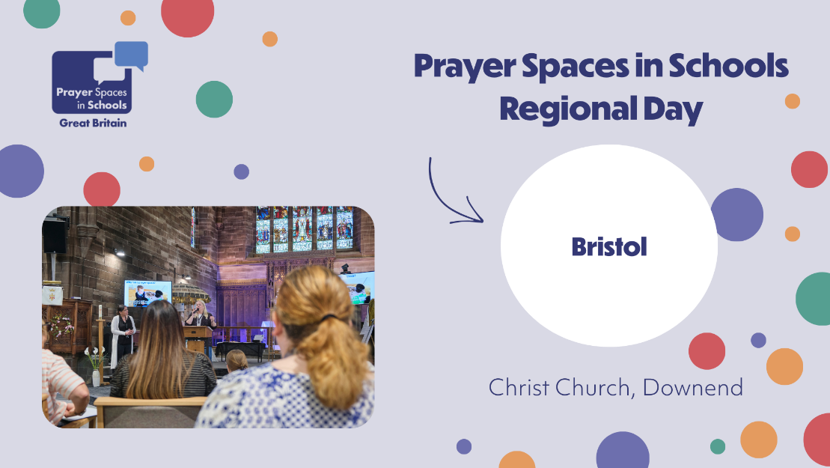

[**CLICK HERE TO BOOK**](https://gbr01.safelinks.protection.outlook.com/?url=https%3A%2F%2Fprayerspacesinschools.org%2Fevents%2Fevent%2Fregional-gathering-bristol%2F&data=05%7C02%7CAli.Driver%40bristoldiocese.org%7C696c107cc1fc4549dc7308ddfce13c3a%7C6ee494c620c74aec9e32abba30f4059d%7C0%7C0%7C638944766869819274%7CUnknown%7CTWFpbGZsb3d8eyJFbXB0eU1hcGkiOnRydWUsIlYiOiIwLjAuMDAwMCIsIlAiOiJXaW4zMiIsIkFOIjoiTWFpbCIsIldUIjoyfQ%3D%3D%7C0%7C%7C%7C&sdata=Fhj6IGk0wAz73Fl%2Bc1wrVe1T3gCKXv0OuVB5pMnsM3A%3D&reserved=0)