**A Month of Being Anglican**

# **Background**

The Church of England was born at a time of political struggle between King Henry VIII and the Pope of Rome in the matter of the King’s divorce (1534). Henry claimed for himself the ‘chief power… whether they be ecclesiastical or civil, in all causes doth appertain’and that *‘*the Bishop of Rome hath no jurisdiction in this realm of England’ (Article XXXVII). Those Articles of Religion (finalised in 1571) which lay down the initial positioning of our denomination made clear that the church was to be belief-driven and head-driven church (Articles VI & XXIV). To this day, assent to these Articles as witnessing the truth of the Gospel is required of those ordained and those licensed to an Anglican ‘Cure of Souls’ in England. Archbishop Cranmer (1489-1556) lay the foundations of its liturgy (the 1549 Prayer Book) and its spirituality. We will consider the effect of these events in week 1.

The pendulum of official Church of England practice (and of persecution) swung between Catholicism and Protestantism in response to shifts in national politics for a century. Gradually, the extremes of the swing lessened as a Middle Way (Via Media) emerged in part through the work of Richard Hooker (1553-1600) and creators of the Book of Common Prayer of 1662. This we will consider in week 2.

John Wesley (1703-1791) was ordained as an Anglican priest in 1762 and lead a revival of ‘inner holiness’ initially centring on Oxford but spreading nationally and internationally. Methodism split away following issues concerning ordinations for the spread of the Gospel in America, but an ‘Evangelical Revival’ took root in England from the eighteenth century onwards. A further revival of piety took a ‘high church’ form in the development of the Oxford Movement beginning in the 1830s. We will consider these ‘revivals’ in week 3.

The decline and diversification of the Church of England during the twentieth century confirmed the fragmentation of its spirituality, leading to a plurality of vibrant spirituality today. This forms week 4.

# **Week 1**

*‘*Holy Scripture containeth all things necessary to salvation: so that whatsoever is not read therein, nor may be proved thereby, is not to be required of any man, that it should be believed as an Article of the Faith, or be thought requisite or necessary to salvation’ (Article VI). ‘It is a thing plainly repugnant to the Word of God, and the custom of the Primitive Church, to have publick prayer in the Church, or to minster the sacraments in a tongue not understanded of the people’(Article XXIV).

The Bible, what you believed, and vernacular services (that is, services in the every-day English of the day were the birthmarks of Anglicanism. The Bible was the touchstone for the proof of belief; and that belief, in the form of one or other of the three Creeds (Nicene, Apostles and Athanasian) was spoken aloud by the people in the congregation in all public worship services.

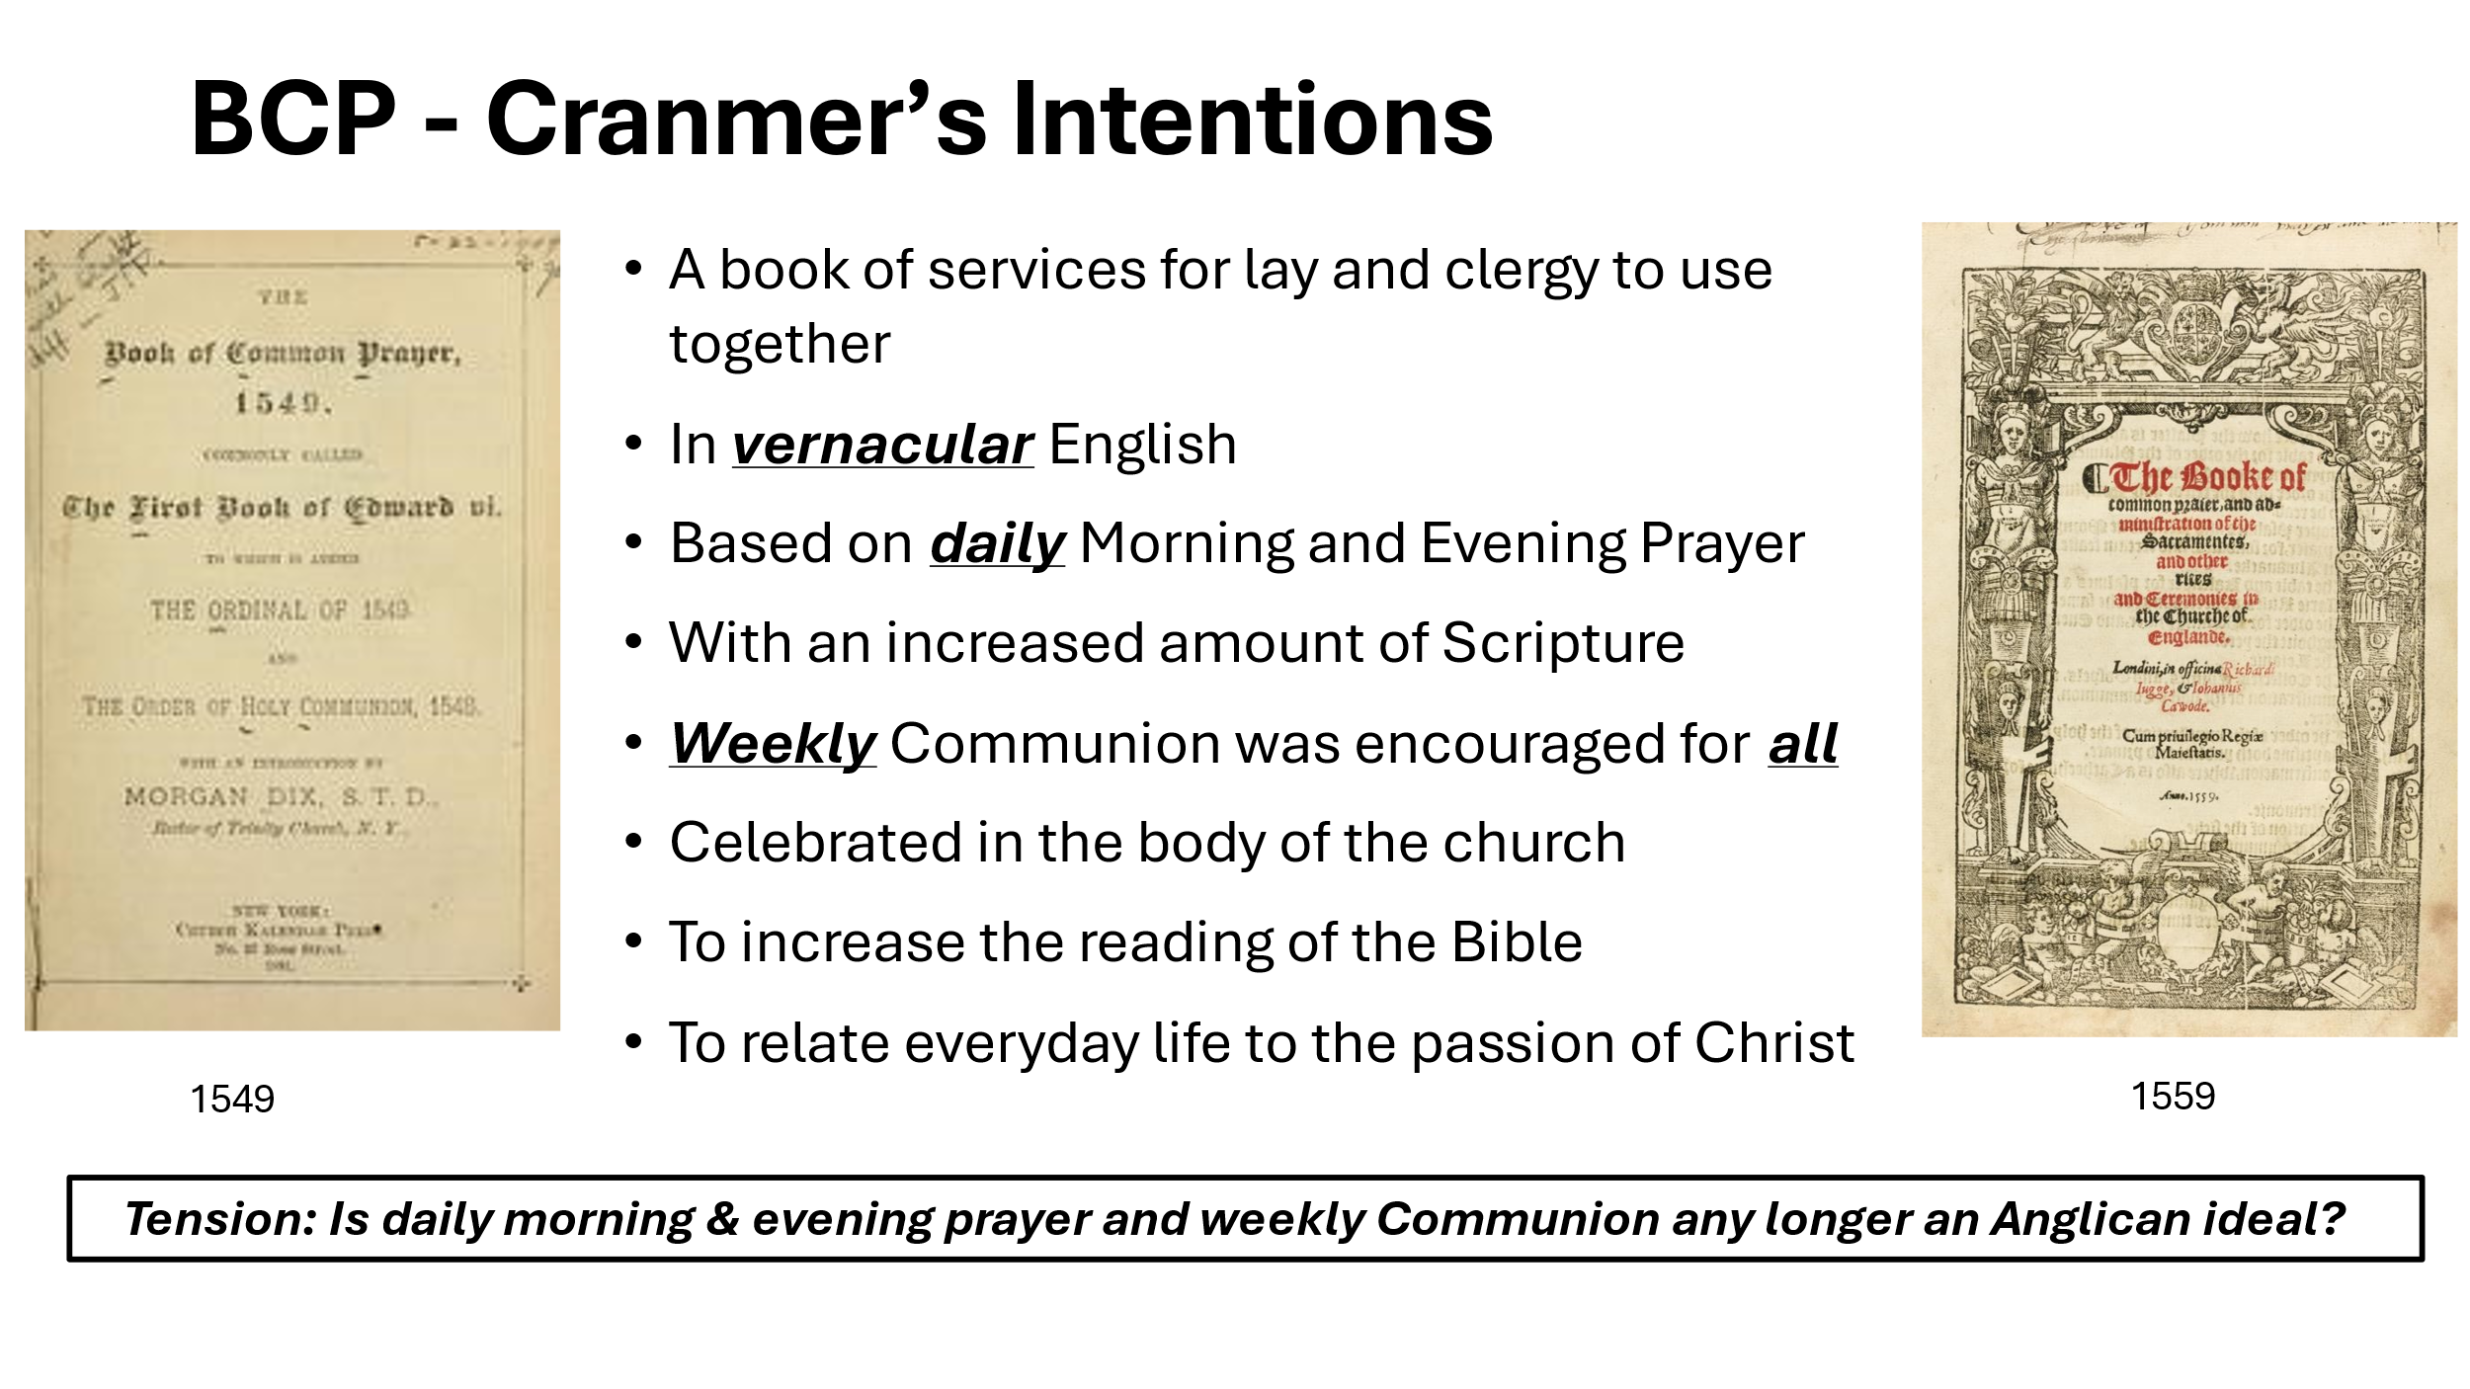

Bishop Gordon Mursell writes:

‘Cranmer wanted to recover the original purity of the age of the Apostles, and to make it accessible to all people of England. Parishioners were to hear the scriptures read aloud in church twice every day, when the parish priest rang the bell and summoned them to join him in Morning and Evening Prayer’ … [p248]. ‘This was to be a genuinely lay spirituality, not a complex monastic or priestly operation duly watered down for simpler tastes’ [p248] ‘...the Book of Common Prayer is nothing if not English, not only in its (arguably over-reverential) approach to the English monarchy and hostility to foreigners, but also in its use of the rhythms and richness of the English language’ [p249].

This week we shall immerse ourselves in 1662 Prayer Book worship. If you are not used to either to using the Prayer Book or to a daily routine of Matins and Evensong, this will be quite a challenge – but a necessary one if we are to see how our church has changed in half a millennium, or hardly changed at all. You will find the Prayer Book service here [the-book-of-common-prayer-1662.pdf (churchofengland.org)](https://www.churchofengland.org/sites/default/files/2019-10/the-book-of-common-prayer-1662.pdf), We suggest you start with daily Matins (in the link, click mp.pdf) OR Evening Prayer (ep.pdf), and extend to both during the week if you feel so drawn. Or, better, you can download the App [Daily Prayer app and podcast | The Church of England](https://www.churchofengland.org/prayer-and-worship/join-us-service-daily-prayer/daily-prayer-app-and-podcast#:~:text=Daily%20Prayer%20is%20the%20official%20app%20to%20help) (opting for the ‘Traditional’ format for weeks 1 & 2 and ‘Contemporary’ for weeks 3 & 4).

During the week, consider how head-driven early Anglican practice was, even if all you had to do was to turn up to church and listen to the cleric saying the office for everyone. How might an ordinary villager have reacted in those days? How do you react now?

Towards the end of this week, consider Mursell’s statements above. Having used the Prayer Book offices, what are your reactions to Mursell’s views?

At the end of the week, ponder how much the daily Prayer Book offices suits your own personality or expression of faith.

# **Week 2**

This week, you might like to extend to both Matins and Evening Prayer, your use of the daily Offices. At the least, continue with one of them!

Richard Hooker (1553-1600) set out a basis for a 'Middle Way’ between the earlier extremes of Catholicism and Protestantism. It was based on an appreciation of Scripture, Tradition and Human Reason. He saw the Christian life in these terms:

*“*the participation of Christ importeth, besides the presence of Christ’s person, and besides the mystical copulation thereof with the parts and members of his whole church, a true actual influence of grace whereby the life which we live according to godliness is His*”.*

We live the life of Christ in his world. Does that resonate with your views?

Hooker also addressed the controversy around the Eucharist:

“In the Eucharist, Christ is really present; but his presence is not restricted to the consecrated bread and wine. Rather ‘the real presence of Christ’s most blessed body and blood is not... to be sought for in the sacrament, but in the worthy receiver of the sacrament’; and that real presence is thus to be carried out into the world at large”.

Christ is *‘*really present’ in the Eucharist, not solely in Bread and Wine but also in those who receive. They take Christ out into the world. Where in this description do your own Eucharistic beliefs lie? Or do you see things very differently from Hooker?

Hooker influenced the authors of the 1662 Prayer Book, which also treads the tightrope between Catholicism and Protestantism, largely through its compromises. A tradition of compromise which lasts to today.

The Prayer Book of 1662 became an enduring political compromise of mixed doctrinal positions. Consider the Absolution prayer in the daily Office:

*‘*The Absolution or remission of sins to be pronounced by the Priest alone, standing: the people still kneeling: “Almighty God, the Father of our Lord Jesus Christ, who desireth not the death of a sinner, but rather that he might turn from his wickedness and live; and hath given power and commandment to his Ministers, to declare and pronounce to his people, being penitent, the Absolution and remission of their sins: He pardoneth and absolveth all them that truly repent and unfeignedly believe his holy Gospel. Wherefore let us beseech him to grant us true repentance and his Holy Spirit, that those things may please him which we do at this present, and the rest of our life hereafter may be pure and holy; so that at the last we may come to his eternal joy; through Jesus Christ our Lord. Amen”.

Ask yourself (i) was anyone absolved? (ii) Who does the pardoning? (iii) Was the claimed ministerial authority used?

How highly do you personally value compromise (or a lack of extremism) in church circles? Is this the Anglican way – or perhaps just the English way?

# **Week 3**

After two weeks of using the 1662 Book of Common Prayer, now switch to the contemporary language of the Common Worship services here: [Daily Prayer | The Church of England](https://www.churchofengland.org/prayer-and-worship/worship-texts-and-resources/common-worship/daily-prayer#na) . Over the next two weeks, notice the differences not just in the texts, but in your degree of comfort using these offices.

We have described early Anglicanism as ‘head-driven’ and ‘belief-driven’. The Anglican priest, John Wesley took a much more holistic approach. Following his religious experience at Aldersgate Street in London where “I felt my heart strangely warmed” [Read ["I Felt My Heart Strangely Warmed" (biblehub.com)](https://biblehub.com/library/wesley/the_journal_of_john_wesley/i_felt_my_heart_strangely.htm) ]. Wesley came to believe that Christians could attain both ‘outward and inward holiness’ where Christ “reigned supreme in their hearts”. Is that your belief or experience?

Wesley argued for the concept of Christian ‘perfection’, contrary to Calvin but aligned with Eastern Orthodoxy: By faith, a believer began to be transformed into the likeness of Christ. Wesley’s evangelicalism was grounded in his sacramental theology. He taught that a systematic use of ‘the means of grace’ (Scripture, Sacraments, prayer and serving others) were a route to the ‘sanctification’ (becoming holy) of the believer – within a methodical rhythm of life. Are you comfortable with these ideals? How are they reflected in your own life practices? Are you ‘methodical’ in your Christianity, as was Wesley?

Wesley recognised that people needed encouragement in this journey to perfection. He founded a ‘Holy Club’ while at Oxford to do this. Later, he organised those affected by his itinerant preaching into a system of local ‘classes’, meeting during the week for study and support, effectively inventing house groups. Careful not to antagonise his fellow clergy, Wesley timed all his Sunday itinerant preaching to follow Matins at the local church, so that people could attend both. Methodist services usually begin later than Anglican to this day. Of what value to you personally are midweek groups? Do they form part of your current rhythm of life?

The Evangelical Revival emphasised experiential Christianity more than liturgical worship. Their theology drew on a broad spectrum of European Reformation thought, with views beyond those expressed in the 39 Articles. Scripture was their supreme authority, and ‘new birth’ and ‘fellowship’ were the cornerstones of their faith expressions. Mission was their goal. Services were led and constructed to be friendly to new attendees and to congregational participation. Prayer and the study of the Bible became the norm, preferably daily. To what extent do the priorities of this form of Evangelicalism reflect your own? To what extent is this how you have been nurtured in the faith, and to what extent it is a deliberate choice? How do you feel when you encounter this form of spirituality today?

The nineteenth century Oxford Movement (an early form of Anglo-Catholicism) drew upon the theology and practice of the seventeenth century ‘Caroline Divines’, who opposed the more extreme forms of Protestantism and Puritanism and who promoted more aesthetic and elaborate liturgy, particularly at the Eucharist. Anglo-Catholicism emphasised the continuity of the church with the Roman Catholic and Eastern Orthodox churches and resisted the Church of England being considered as just a denomination of Protestantism. They emphasised the traditional faith and liturgy of the church, together with Sacraments and a marked commitment to social justice. Both the spectacle and the practical emphasis on social concern rocketed the popularity of Anglo-Catholicism in Victorian times. Ponder the extent to which the priorities of Anglo-Catholicism reflect your own. To what extent is this how you have been nurtured in the faith, and to what extent it is a deliberate choice? How do you feel when you encounter this form of spirituality today?

# **Week 4**

Writing in the 1960s, Martin Thornton wrote:

*“*William Law died in 1761, just a hundred years after the final revision of the Book of Common Prayer. That was nearly, but not quite, the end of Spirituality within the English church. That is not to say that, during the eighteenth and nineteenth centuries, the church was dead, or that its worship and devotion were necessarily unhealthy... But the best of English religion during these centuries was either a continuation of an earlier tradition or a purposeful return to it. The technical point... is that, granting a true greatness to the leaders of the Evangelical Revival and the Oxford Movement, they teach us little that we have not already learned from the medieval and Caroline periods*.”* (in *English Spirituality* 1963, 1986 Edition, Cowley Press).

How do you react to Thornton’s view?

Do you think that there is still a tendency in Anglicanism to look back to previous centuries for solutions to twenty-first century problems and spirituality? Do you personally feel more secure in your faith when using practices ‘hallowed by tradition’ or ‘of contemporary relevance’. To what extent do you feel comfortable with either?

Since the 1960s, liturgical revision and ‘fresh expressions’ of being church have blossomed. At the same time, there has been a great increase in the number of people who describe themselves as ‘spiritual but not religious’ (SBNR), that is, they feel they are (or want to be) spiritual but organised religion is not attractive to them. About 30% of Americans describe themselves in this way when answering census questions – there is no equivalent formal question in UK.

In considering ‘fresh expressions’ of being church, watch:

<https://www.youtube.com/watch?v=jY04HSoskU8> , <https://www.youtube.com/watch?v=Rd5QGM9_xX8> <https://www.youtube.com/watch?v=K1-w_i7mHoA>

each one is only a couple of minutes long!

The starting point here is that spirituality begins with people rather than with institutions or institution-derived practices. How you feel about this attitude? How important is the comforting institution to your own spirituality currently? Will it continue to be so as you build your rhythm of life? [You can follow this up at <https://freshexpressions.org.uk/> ]

The ‘Anglican Communion’ is now a world-wide fellowship of Anglican provinces; see [Anglican Communion Home Page](https://www.anglicancommunion.org/) . Spend the last few days of this week considering your reactions *to* how other Anglicans express their spirituality, notably:

[The Episcopal Church – The Episcopal Church](https://www.episcopalchurch.org/)

[Home - Anglican Church in Aotearoa, New Zealand and Polynesia](https://www.anglican.org.nz/)

[Home - The Episcopal Diocese of Jerusalem (j-diocese.org)](https://j-diocese.org/wordpress/)

[Home (sgcathedral.co.za)](https://www.sgcathedral.co.za/)

Review your month of praying the daily office from Common Worship. What have learned about yourself using them? Do you feel drawn to continue in some format?

Review also your appreciation of the Anglican approach to spirituality down the ages. List what you value personally.

How will you take forward this month’s activities and learning?

**Follow-up Resources**

* Mursell G Ed. (2001) *The Story of Christian Spirituality* Lion
* Wells S (2011) *What Anglicans Believe: an Introduction* Canterbury Press
* Pritchard J (2000) *Beginning Again on the Christian Journey* SPCK
* Butler-Bass D (2012) *Christianity After Religion: the End of the Church and the Beginning of a New Spiritual Awakening* Harper One
* <https://www.episcopalchurch.org/pbfrankgriswold/anglican-spirituality/>
* <https://www.youtube.com/watch?v=mNOKsZICr5c&list=PPSV>
* <https://www.youtube.com/watch?v=VauojyTyA6o&list=PPSV>
* <https://www.anglicancommunion.org/>
* <https://www.churchofengland.org/>

iab/2/10/24 VF