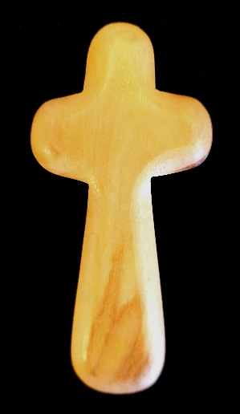
Introducing the Holding Cross
A holding cross is a simple, cross designed to be deliberately uneven and held in your hand while you pray or contemplate. They are often made of olive wood from the Holy Land. The cross offers a physical reminder of Christ's presence and sacrifice. Holding the cross has at times in history been a sign of courage in the face of adversity.
You can buy wooden holding crosses online, here is one option: https://www.eden.co.uk/. Alternatively, you could make your own.
You can use it in a planned prayer time or at moments throughout the day.
Here are some instructions for using a holding cross:
1. Hold the Cross
- Take the holding cross in your dominant hand or both hands.
- The cross is usually small enough to fit comfortably in the palm of your hand. Hold it gently with your fingers wrapping around the body of the cross.
- The natural shape of the cross is meant to fit in your hand, which helps in focusing your mind and prayers.
- While praying or meditating, consider the physical sensation of the cross in your hand. The tactile experience can remind you of God's presence and encourage a deeper connection with your faith.
2. Ways you can use the cross
- When you can’t find the worlds to say, perhaps because of illness, tiredness of depression, simply hold the cross as a prayer
- When you simply need to feel God with you keep it in your pocket and hold onto it at moments when you need to remind yourself of God’s presence.
- To remind you of God’s love for you. ‘For God so loved the world that he gave us his only Son, so that everyone who believes in him may not perish but have eternal life.’ (John 3.16)
- When you need a different perspective. Let the cross remind you that Jesus died out of love for the people you see and for the world you live in.
- To prayer for others. Hold the cross and pray for people you know by name
- When confessing or saying sorry for your sins. The cross is a reminder of the cost of sin and the forgiveness of God
3. End the Time of Reflection
- When you feel ready to finish, give thanks for the time spent in God's presence. You may want to hold the cross for a few moments longer in quiet gratitude before setting it down.
Tips:
- Holding the cross can be done alone, but it can also be used in group prayer settings.
- The cross is not only for formal prayer but can be used during moments of emotional struggle or to help centre your thoughts throughout the day.
Using a holding cross is a simple, yet powerful, way to deepen your spiritual practice and connection to God.



