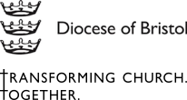
A PLAN FOR TRANSFORMING CHURCH. TOGETHER

An introduction from Bishop Viv
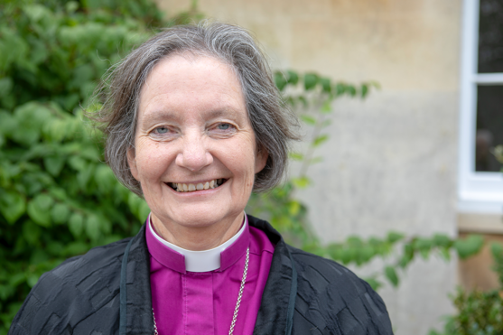

Transforming Church. Together began in January 2021 when I invited everyone in the Diocese of Bristol to join a conversation about our priorities under God for the future. Watch the film here.
There followed months – during the pandemic – of engagement, prayer and discernment within church communities and amongst less-heard groups. We realised that Christ, the Lord of all, was stretching our hearts and minds to respond to the most vivid of visions, that humanity might be reconciled, and creation restored.
We affirmed that the calling of each worshipper in the Diocese of Bristol is to follow Jesus, to serve others and to transform communities. We discerned that, by the power of the Holy Spirit, this diocese has values of openness, generosity, creativity, and bravery which we want to continue to nurture. We will steadfastly live out our commitment to our neighbours and communities to be ‘here with you’ for Christ’s sake.

We now have an outline plan. In the last few weeks, working groups have met and – with prayer and care – contributed to the plan which synod is now to discuss. So in this next stage, Diocesan Synod is invited to contribute to and endorse the direction in which the plan is taking us. The details are emerging, with interdependencies between the elements which need careful thought.
Further work will provide detail for the June Diocesan Synod, and enable preparations both for the budget and for a new start in 2023. Having learnt from the implementation of previous plans, we expect to see considerable change within five years, and that work under the plan will need to continue (learning as we go) at least until 2030. The Bishop’s Council and the Diocesan Synod will contribute to progress at each stage.

Prayer will continue as together we seek Christ’s transformation for each other and our diocese.

OUR CONTEXT

1. There are many signs of hope and evidence of God at work in our diocese. We have welcomed new clergy and leaders, we have ordained many more called to commit their life to Christ. We have responded to a pandemic with innovation, strength and grace, caring for our communities and each other. We have seen new worshiping communities grow and develop, and we have faced many of the major issues in society with courage; working towards net zero, committing to racial justice and engaging with Living in Love and Faith.

2. And yet we are living in a complex and challenging world. Our society is experiencing seismic changes; Covid-19, Brexit, racism, growing inequalities, the climate crisis, the ongoing digital revolution, debates over human identity, and international conflict, are disrupting and changing both society, and communities.

3. The Church of England, beset by numerical and financial decline, reflecting less and less the diversity of English society, has struggled to embody a Christ-centred vision and life to that society. Covid-19 has roused and challenged Christians in new ways at a time when the Church of England is renewing its own vision and shared strategic direction.

4. At the same time, there are signs of opportunity, of people looking for meaning, questioning old ways of working and living, an increasing focus on mindfulness, rest and kindness and a craving for community. We also see people demand more from corporations and leaders around inequality, justice and the environment.

5. Our diocese is diverse and full of challenges and opportunities. This plan is our response. It celebrates and builds on the best of what is, and thinks radically about new ways of working, living and worshipping. We have imagined what can be, and discerned how – in the coming years – together we can better work, serve, and be together in our God-given calling. It is founded on months of engagement, prayer and discernment across the diocese.

6. This plan aligns with the evolving national church strategy, and yet powerfully reflects local realities on the ground in the diocese. It also seeks to live out the five Marks of Mission of the Anglican Communion, and so aims to:

- Witness to Christ's saving, forgiving, reconciling love for all people
- Build welcoming, transforming communities of faith
- Stand in solidarity with people who live in poverty and need.
- Challenge violence, injustice and oppression, and work for peace and reconciliation
- Protect, care for and renew life on our planet

7. Above all, together we are HERE WITH YOU among the communities of and around Bristol, Swindon, Chippenham and Wiltshire where God has placed us. Here with our neighbours who Christ has called us to serve. Here, engaged with the challenges and opportunities into which the Holy Spirit leads us.

OUR VISION

8. Our vision for the future is:

Humanity Reconciled, Creation Restored

OUR MISSION

9. Our mission is to follow Jesus, to serve others, and to transform communities.

OUR VALUES

10. Our values, informed by our understanding of Jesus, underpin everything we do and say, and will play a critical role in delivering the strategy. They are:

Openness
We value openness and are loving and open to all. Our behaviour is welcoming – we want to be a safe, accessible, kind and welcoming space for everyone. We want our communities to feel embraced, their diverse needs met, and for them to benefit from a long-term relationship based on acceptance and love for people as God made them.

Generosity
We value generosity and receive and give sincerely. We give our time and resources to share what we know of Jesus' love. We want our communities to feel supported and cared for in the way Jesus would do, to experience God’s love through our action and an opportunity to journey into faith if they choose.

Creativity
We value creativity and we cooperate with the work of the Spirit. We are faithful, rooted in faith and responsive to the Spirit. Our communities feel inspired - this is bold and joyful faith, work and worship that engages us all. We want our communities to experience a variety in projects and worship styles, celebrating tradition and innovation in connection to God.

Bravery
We value bravery – we are courageous with our voices and our actions. Jesus tells us to “take courage, I have conquered the world” (John 16.33). And so, following the repeated biblical command ‘Do not be afraid’, we acknowledge and learn from our past and actively effect positive change in the world. We want our communities to feel empowered as they are listened to, supported, and partnered with in seeking transformational change. The collective voices and actions of our community will help to bring about transformational change.

STRATEGIC OUTCOMES AND PRIORITIES

11. To deliver our mission, we will work towards four main strategic outcomes.

- To have a form of church in every community, and a church in which all can participate, thrive and belong
- To have people who worship God in every aspect of their lives, and throughout their whole lives
- For the diocese to be recognised as a powerful force for gospel change
- For the diocese to have sustainable finances

STRATEGIC ACTIVITIES

13. More specifically, we will achieve the four strategic outcomes through the following activities:

- Ensure our forms of church best serve our communities
- Better support low-income communities
- Increase under 25’s participation
- Deliver our racial justice commitments and better include under-represented communities
- Build pathways into deep, lived-out Christian faith
- Develop our volunteer community
- Release our clergy and ensure their wellbeing
- Communicate and deliver positive change against injustice
- Deliver net zero
- Generate income
- Build partnerships for gospel change
- Better utilise our church properties

These are described in more detail at Annex A, and can be viewed visually, in this way:

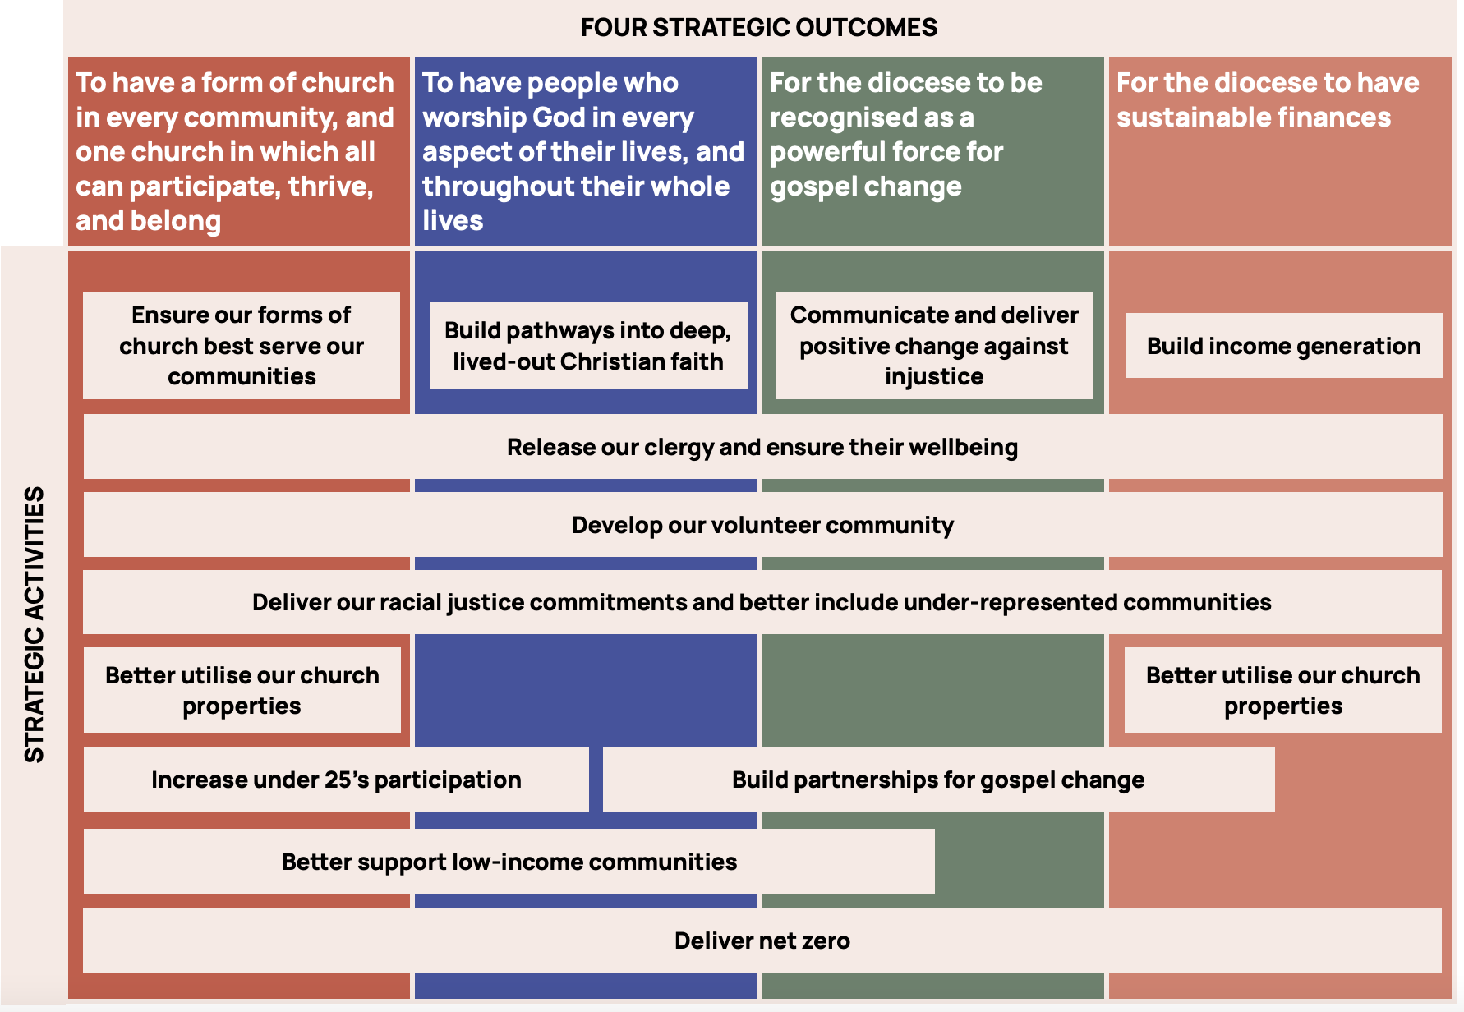

12. These activities are interdependent and so we envisage the following main themes emerging as we deliver the strategy:

- Developing and supporting our clergy and volunteers. We will seek to provide additional resources in the form of coaching and mentoring, to enable people to develop their skills and reflect on their practice. We know that the best learning is done with others, and so we will develop action learning sets and informal reflection groups; which will explore subject areas of importance, such as estates ministry and youth work. We will also resource some specialist areas so that we offer additional capacity to clergy who volunteer their time alongside parish ministry to advise in areas such as disability and racial justice.

- Empowering and enabling our local communities. We will have the different forms of church where they are needed and that are appropriate to specific locations and communities, with clergy who are suited – and supported – to deliver the mission. Resources will be sought to release clergy, in particular, to fulfil their vocation and use their gifts in mission and ministry – these might include administrative support, project management and buildings advice. We want the strategy to have real impact at a local level (parishes, schools and chaplaincies).

- Investing to grow. We must invest financially if we are to grow our income to support our mission. If we are to see more young people and people from under-represented groups in our churches, we will need new resources to do this. And to grow our reach, we need to invest in partnerships – between parishes in areas, between diocese and deaneries and mission areas, and between the diocese and public, private and third sector organisations.
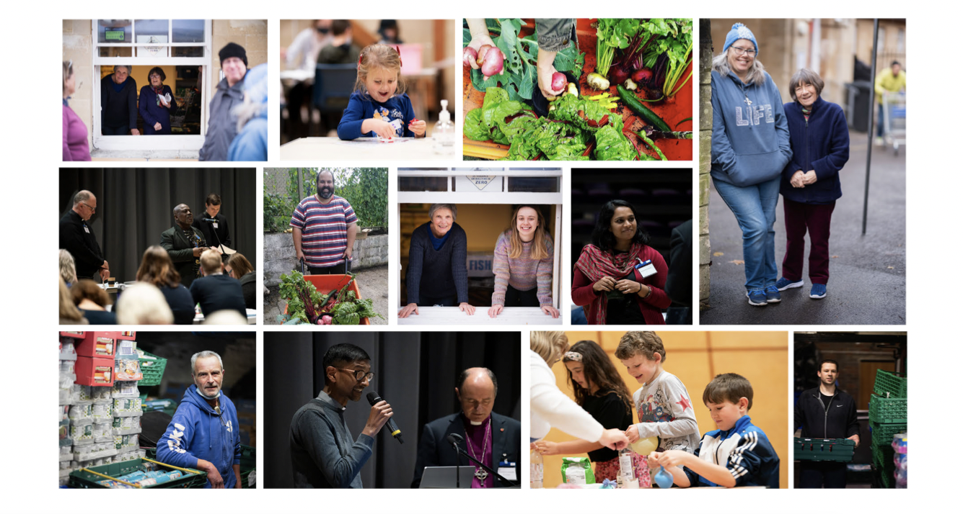

RISKS

14. All new approaches and plans involve some risk. Nationally, society is highly secular and, in many cases, far from the church. In some quarters, some of the church’s theological positions are problematic. This means that for any Church of England strategy, gaining real traction is challenging.

15. In the case of Transforming Church Together, we have identified the following specific risks:

- Will people believe in it? All plans stand or fall on the extent to which the relevant stakeholders are engaged and participative. We have worked hard to ensure this plan has been developed collaboratively and we now need those independent parishes, schools and chaplaincies to continue to energetically contribute to a successful outcome.

- Can we connect and communicate well enough? We must work hard to be more effective at connecting and communicating with the communities around us. Our actions, language, tone, and a desire to ‘do with’ rather than ‘do for’ are vital.

- Funding. This strategy is based on assumptions about Parish Share, new ways to generate income, and some national church investment, the extent of which is not yet clear. A shortfall in any of these areas will directly impact on the pace and depth of our transformation plans.

- National Church Policies. National theological and financial decisions are in process. They will have a positive or negative impact on this strategy depending on where they fall.

- Follow through. It is essential that early energy and initiatives are followed through in order to meet our goals. We will work with God, and one another, to see this strategy, and the associated cultural changes, through to their intended conclusion.

FINANCIAL STRATEGY

16. The diocese has carried significant operating deficits over the last few years. This cannot continue indefinitely, and we aim to resolve this situation by the end of the strategic period, by reaching a point where annual income (from Parish Share and other activities) is in balance with annual expenditure. This is the basis for Strategic Outcome 4.

In broad terms, over the next five years, we will:

- Apply for national church investment support where we are aligned with the Church of England strategy (in particular; financial sustainability, under 25’s, low-income communities, discipleship, and net zero)

- Continue to pray, be thankful and work for increasing generosity of our parishioners, and improve our partnering and communicating with them

- Make some changes to the way in which we manage and invest our reserves to allow us to invest more into our mission

- Make changes to the composition of the Diocesan Support Staff; to shape it to deliver the strategy

- Invest a small percentage of our reserves in the initial years to begin delivering net zero (in anticipation of follow-up support from the national church in later years)

- Invest in activities that generate income, either alone, or with parishes, or with suitable public and private partners

Progress against the plan – and our ability to achieve Outcome 4 - will significantly depend on the level of Parish Share, our success with generating income, and the willingness of the national church to invest in our future and net zero.

CONCLUSION

17. Transforming Church Together is Christ-centred, founded on the Anglican Marks of Mission, the wonderful work and witness of church communities across our diocese, and the need to make changes to ensure we have a thriving church for years and years to come. It envisages a more proactive approach to our work, and a brave excursion into new forms of partnership and income generation. And as we do this, we want to be known for living out our values – even when that is tough and challenging.

18. The plan started with a wide conversation with our communities – and others – and will only conclude successfully with the continued prayers and active support of the same communities. We know that success will only be possible through the power of the Holy Spirit, and the energy of our clergy, parishioners and partners on the ground. The Diocesan Leadership and Support Staff will do all we can to support you in this. We have so much good to build upon, things we need to change, an exciting vision that we are called to, and the joy and challenge of working together to sustain and grow our church in our communities. May God be with us as we embark on this truly exciting phase of our diocesan life.

God of the Way, you call us to leave familiar places and to set out on new paths.
Enlarge our vision of your work in the communities we serve, speak to us through the people we encounter, and open our hearts to your love.
Give us courage and boldness to engage together in this time of prayer and discernment; and by your Holy, life-giving and creative Spirit, renew your church in prayer and service, and in sharing the Good News of Jesus Christ, in whose name we pray. Amen.

Rt Rev Vivienne Faull
Bishop of Bristol 7 March 2022

Annexes:
A. Strategic Activities – Short and Medium term
B. Financial Strategy – Assumptions and Broad Financial Plan
ANNEX A – ACTIVITIES TO DELIVER THE PLAN – SHORT AND MEDIUM TERM
Indicative activities – subject to further clarification and analysis – to deliver the strategy, are listed below. The pace at which we can commence and pursue these activities will be dependent on our success with Parish Share, generating income and national church investment. Each activity therefore has ‘Early Years’ and ‘Later Years’ sections, the exact timing of which cannot be determined at this stage, until funding streams are known.

Strategy activity | Early years | Later years
Ensure our forms of church best serve our communities  Lead:  Archdeacon of Malmesbury, Christopher Bryan  Archdeacon of Bristol, Neil Warwick | - Scope potential for new mission areas  - Existing mission areas join Greenhouse scheme with access to small seedcorn budget  - Appoint Parish Development Advisor role to enable setting up of mission areas and FEC  - New Fresh Expressions of Church (FXC) begin, aim for one or two per existing mission area  - Plant a new church in new Brabazon area of Bristol and South Gloucestershire | - Evolve new mission areas where appropriate. Parishes join voluntarily, so the scale of the programme will depend on local leadership and benefits from early adopters being visible  - As funding allows, increase posts to plant in new communities/areas
Better support low-income communities  Lead:  Bishops Chaplain, Martin Gainsborough | - Apply for national funding (Strategic Development Fund) to invest in a small number of key areas. Investment includes an experienced incumbent; operations management, and more local children’s work  - Establish coaching, support and accountability scheme, using low income community areas as a pilot  - Apply for national funding (Innovation Fund) for two additional places, looking at applying learning from successful areas into different church traditions  - Appoint Estates’ Network leader | - Begin to support role appointments using national funding (Strategic Development Fund and Innovation Fund)
Increase under 25’s participation  Lead:  Director of Education, Liz Townend | - Audit current church and school partnerships and opportunities  - Develop provision between schools and churches using the Growing Faith network  - Develop local Children and Young People workers and lay and ordained school chaplaincy  - Enable support and training networks across parishes where roles with children and young people have synergies  - Develop support networks across similar roles across parishes  - Explore how young people can be involved in governance at all levels  - Promote children and young peoples’ meaningful involvement in worship | - Grow local deployment of Children and Young People workers for parishes and parish groups considering the establishment of joint hub communities where under 25’s development is prioritised  - Pilot a youth bus project for outreach in low income communities
Deliver on racial justice commitments and better include under-represented communities  Lead:  Director of People and Safeguarding, Caroline Jowett-Ive | - Appoint Racial Justice Lead  - Fund Disability and Accessibility Advisor role  - Finance and support for Equality, Diversity and Inclusion (EDI) audits,  - Develop Diocesan EDI policies for all protected characteristics  - Continue to develop training and implementation  - Re-establish Ministry Experience Scheme  - Continue to resource and develop contested heritage work | - Implement and develop audit findings
Build pathways into deep, lived-out faith  Lead:  Director of Ministry Development, Simon Taylor | - Pilot Discipleship Coordinators as deanery or mission area volunteer role  - Develop a diocesan rule of life for everyone in the diocese  - Encourage every church community to develop an evangelism and discipleship plan including how the church engages with work places  - Train and commission ‘Workplace Wayfinders’ as identifiable people who live as Christians in the workplace  - Review chaplaincy cover and investment across the diocese | - Build a full network of Discipleship Co-ordinators/Advisors  - Develop Moodle as a diocesan resource providing access to national and local content  - Have established range of ‘Workplace Wayfinders’ across workplaces of diocese
Develop our volunteer community  Lead: Director of People and Safeguarding, Caroline Jowett-Ive | - Develop volunteering and serving policy, recruiting and development plan and toolkits for church volunteers including wardens, treasurers and other officers. hers Fund central support to lead and coordinate this project  - Complete pilot of worship leaders, reflect on learning  - Fund safeguarding support and automation | - Develop lay ministry for pastoral care, work with children and young people and evangelism
Releasing clergy to flourish and supporting their wellbeing ensure their wellbeing  Lead:  Archdeacon of Malmesbury, Christopher Bryan,  Archdeacon of Bristol, Neil Warwick | - Project group to review clergy working hours, patterns and accountability  - Pilot Operations Manager roles in two local areas  - Roll out coaching, support and accountability scheme, extending learning from low-income communities pilot | - Intentional and creative deployment to deaneries, replacing expectation of generalist incumbent with greater freedom to build on skills across a team  - Appoint a Head of Transitions and Congregational Development  - Work towards widespread culture change  - Operations Managers employed within local areas
Communicate and deliver positive change against injustice  Lead: Director of External Engagement | - Build partnerships with public, private and third sector organisations who share our concerns  - Pilot Citizens UK in a deanery or mission area | - Review learning from the pilot and other dioceses  - Develop a portfolio of partners (including Christian Action Bristol).  - Run a campaign every year  - Develop campaigns resource
Deliver net zero  Lead: Bishops Chaplain, Martin Gainsborough supported by Director of Property | - Appoint specialist staff to co-ordinate and lead projects  - Implement changes within our control especially those with benefits for clergy support and wellbeing, e.g. insulating parsonages, PodPoints, within budget.  - Use reserves to support projects in schools and churches to reduce emissions | - Invest in new technology and conclude the programme with support from national church
Generate income  Lead:  Chair of Diocesan Board of Finance, Andrew Lucas (supported by Director of Finance, Matthew Hall and Director of External Engagement) | - Rapidly conclude accounting, methodology and investment change  - Appoint a Fundraising Officer with targets for role to pay for itself in year 1  - Assess utility and /return on investment of trading  - Maximise grant-funding opportunities  - Develop fundraising and marketing strategy | - Invest in digital, legacy, high level donors, events and capital project fundraising capability
Build Partnerships for gospel change  Lead: Director of External Engagement | - Research and identify potential partners for delivering change, campaigning and generating income  - Support church communities to maximise local opportunities | - Appoint a Partnerships Officer and make partnerships real
Better utilise our church properties  Lead:  Archdeacon of Malmesbury, Christopher Bryan  Archdeacon of Bristol, Neil Warwick (supported by Director of Property) | - Appoint a dedicated Church Buildings Lead (may be commercially funded).  - Determine viable projects/timelines | - Appoint project support to take projects forward  - Post(s) should pay for themselves

ANNEX B – FINANCIAL STRATEGY – ASSUMPTIONS AND BROAD FINANCIAL PLAN

The following broad assumptions underpin the financial basis for this strategy:

- Parish Share will be sustained (and grow with inflation)
- National church funding bids will add to the projections below and accelerate the rollout of new initiatives and delivery of planned activity.
Reserves will be utilised for net zero in the early years
- Savings of £60-100k p.a. recurring will be achieved from reorganisation and better processes
- Income generation of £100k in Year 1 growing to £900k in Year 6 (including up to £500k of investment income)
- No change in national church apportionment

This should result in a balanced budget in 2027/8, and can be broadly represented visually as follows.

